Risks Evaluation of Financial-Economic Activity and Their Management
in the System of Economic Security of the Organization

Shadrin A.S.¹, Leonov P.Y.¹
¹ National Research Nuclear University MEPhI (Moscow Engineering Physics Institute),
Kashirskoe shosse 31, Moscow, 115409, Russia

Shadrin A.S.: ORCiD 0000-0003-4948-5195
Leonov P.Y.: ORCiD 0000-0002-3415-2702
Corresponding Author: Shadrin A.S., E-mail: a.s.shadrin@mail.ru
Abstract: Organizations increasingly need to improve approaches to enterprise management in connection with regularly occurring crisis phenomena in the modern economy. Any business entity must ensure timely reaction to changes in the external environment in order to avoid risks and threats to economic activity and to achieve the set goals. Well-organized management system of enterprise economic security can become a guarantee of this.

Keywords: economic security, risks, financial and economic activity of the organization, audit, accounting, accounting (financial) report.

Introduction
The organization's economic activity in the current market conditions has a certain amount of uncertainty or risk inherent to this system. This uncertainty is expressed in turn in the fact that sooner or later the economic situation can be exposed to accidental impacts both objective (inflation, rising prices, falling living standards) and subjective. As a result, the managerial staff of the organization have uncertainty in obtaining the expected final result, which results in the risk increase, i.е. danger of failure, unexpected losses. Due to the current situation, the organization should be ready to fully respond to changes in the external environment in order to avoid risks and threats to economic activity. To achieve the declared goal there must be a well-established management system of enterprise economic security in the organization.
Risks in financial and economic activity as an integral element of the economic security of an organization
The existence of a system of economic security in the organization is expressed by the presence of the so-called system of accounting and analytical information of economic security, which ensures the issuance of managerial decisions for the security of the enterprise.
Accounting, management financial planning, control and audit are most often identified as the elements of this system. If one of the elements is absent, it can be concluded that this system does not have integrity. All elements of the system are interrelated, since financial management planning is based on credentials, while control and audit are based on accounting and analytical data. Reports and conclusions on the results of monitoring and auditing can serve as extra-account information for conducting economic analysis, for improving accounting at the enterprise.
Based on the experience of such authors as A.G. Goryunov [1], N.L. Belorusova and P.E. Rezkin [2], L.Ts. Badmakhalgayev and E.V. Deldyuginova [3], A.E. Suglobov, S.A. Khmelev and I.V. Boyarskaya [4], L.V. Gnilitskaya and E.P. Datsko [5] the following definition can be formulated. The Accounting and Analytical System of Economic Security (AASES) is a set of interrelated elements of accounting, analytical, control and audit information necessary for making management decisions to prevent risks and threats in order to achieve planned (threshold) enterprise development indicators in the current and prospective period.
For AASES it is necessary that all processes provide information on risks and threats, achieve planned (threshold) values ​​of indicators that characterize the development goal. In this case, the outcome of the AASES coincides with the definition of the goal of economic security. The presence of feedback contributes to the adaptation of the system to the constantly changing environmental conditions, and the unification of all sources of information to ensure economic security.
It should be noted that the objects of economic security are resources, sales, costs, risks, profits and liabilities of the enterprise. Conducting an analysis of economic security objects allows us to determine the direction of the organization's development, the growth or decline of the production process, as well as the overall trend of the enterprise development. One of the main objects of economic security is the financial state that provides disclosure of information on the profitability, solvency, liquidity and financial stability of the organization.
When conducting an analysis of the organization's economic security, special attention is paid to the analysis of risks (threats) of economic activity. This analysis is necessary to collect information on the risk of deterioration in the state of the organization, when there is a possibility of absence of demand for products, shortfall in profits or the incurrence of additional costs as a result of the deterioration of economic activity.
The basis of the accounting and analytical system is management information. Obtaining incomplete or unreliable information about the state of affairs in the organization can lead to incorrect management decisions made by the manager intuitively, and, consequently, to the emergence of new threats and risks.
In the scientific literature, the risks based on the extent of the damage (which is very important for economic security) are divided into acceptable risk, critical risk and catastrophic risk (Figure 1) [6].
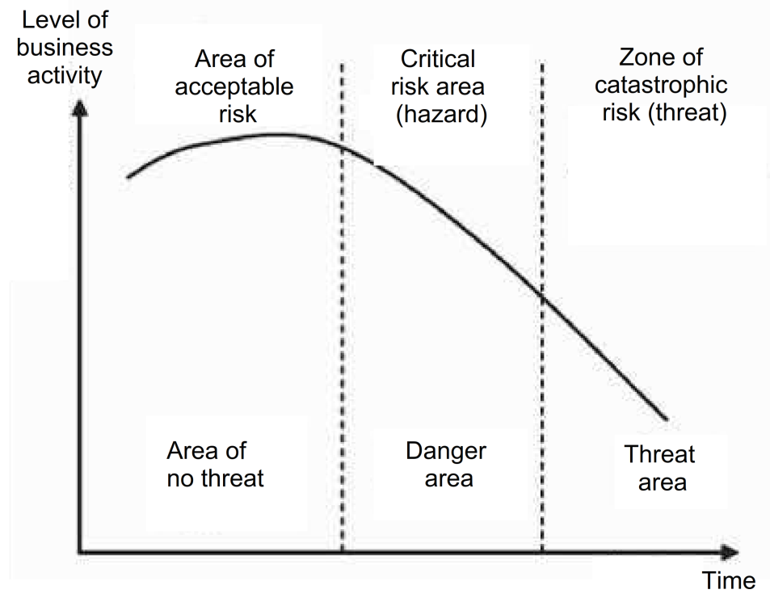
Fig. 1 - Zones of risks and threats in the development of the crisis phenomena of the enterprise.
In Fig. 1 it can be seen that the threat of the enterprise activity rises in the zone of catastrophic risk. Therefore, the threat is a stage of risk development. Along with this, we note that the analysis and assessment of the risk of economic activity are dictated by the need to take this factor into account when making managerial decisions to ensure economic security. And since management decisions are generally accepted on the basis of accounting and analytical information, it is strange that accounting and analytical risks are not reflected in any risk classification.
Developing the approach of risk distribution by zones of acceptable, critical and catastrophic risk, we will study the possible risks of accounting and analytical support.
Area of acceptable risk:
- risk of failure to reach planned (threshold) development indicators. The risk is connected with the weak organization of operational accounting, analysis and control (early warning system) and with attention to these issues the risk can be eliminated in the following reporting periods;
- risk of incorrect evaluation of short-term development factors that caused certain failures in the work of the enterprise, this risk can be eliminated in the process of their detection.
Critical risk area (hazard):
- risk of incorrect evaluation of medium-term and long-term development factors. The risk arises when the negative factors of development which curtail production and lead to crisis conditions are not detected. Disregard of development factors can lead to errors in planning and aggravate the economic situation at the enterprise;
- risk of incorrect evaluation of the development trend. If a number of key indicators have negative trends, then we need to identify the reasons for this and correct the situation. Continuation of the enterprise activity in terms of negative trends in indicators can lead to catastrophic risk;
- risk of underestimation of development reserves. The risk may arise if the calculation of the increase in the efficiency of the activity has not been made taking into account the production reserves involvement or lack of financial resources for the implementation of activities related to the use of reserves;
- risk of making unreasonable management decisions. It occurs particularly in the absence of complete accounting, analytical and control information and in deformity of the accounting and analytical system of economic security of the enterprise as a whole.
Zone of catastrophic risk (threat):
- risk of loss of liquidity of the enterprise. The risk will be manifested if the enterprise does not conduct a qualitative analysis of the financial condition;
- risk of bankruptcy of the enterprise. The complex manifestation of risk factors, which causes the company to fail settling accounts with its creditors. In this case the failure to fulfill obligations is chronic.
As it has already been noted, the risk in commercial activity is inevitable, and the task of risk management is one of the most significant. However, despite the numerous experiences in the field of risk assessment, a single point of view on understanding this phenomenon has not been formed. The organization should formulate a policy aimed at reducing risks and reducing their consequences. Methods are most often very diverse, which is related both to the type of activity of the organization, and to the presence of internal and external factors.
Risk management involves their identification, classification and evaluation. Recognizing the risk, management of the organization chooses management methods that include: risk avoidance, risk localization, risk diversification and risk compensation.
So in the system of accounting and financial reporting the facts of economic life and management decisions related to risk management are reflected.
It is well known, that in accounting, not only actual facts of economic life are reflected, but also possible events related to uncertainty and probability. At the same time, the risk associated with actual events is recognized as decrease in sales, additional costs, losses, unproductive expenses and other consequences that lead to decrease in financial results, as well as to violation of the economic security of the enterprise.
The simplest and most acceptable direction for neutralizing risks is for a commercial organization to refuse to conduct financial transactions connected with high risk, in other words to evade the risk. In such cases, the results that could be achieved are not always obtained, but this allows a company to completely avoid potential losses. But, unfortunately, it is not always possible.
Decisions to evade certain risks can be made both at the preliminary stage of decision making, and in the future. But it happens more often at a preliminary stage, because refusal to continue commercial activity can lead to large financial and other losses. Therefore, risk avoidance is used under the following conditions:
- if aversion of one type of risk does not entail the emergence of other types of risks;
- if the level of risk is much higher than the level of possible revenue of a commercial transaction;
- if the enterprise cannot compensate financial loss for a given type of risk from its own financial resources because of its large size
However, a trading enterprise cannot avoid all types of commercial risks, for the most part, it deliberately takes risks and is engaged in commercial activities. Some types of risks are accepted as inevitable, other risks are taken because they have the possibility of profit.
The main directions of the risk management policy are:
• risk avoidance policy;
• risk acceptance policy;
• risk reduction policy.
The risk avoidance policy consists of the development of such measures that completely exclude a specific type of economic risk. Basically, it is achieved by refusing to carry out such economic operations, the level of risk of which is excessively high. This policy is most simple but not always effective, because when avoiding risks, the company simultaneously loses the opportunity to get a sufficiently high profit.
A risk acceptance policy means the willingness and ability to cover risks at their own expense. Such a policy is appropriate in the case of a stable financial condition of the enterprise, a desire to expand its activities, but it can lead to large unjustified losses.
The risk reduction policy implies reduction in the probability and volume of losses. There are methods and techniques by which you can reduce the risk of commercial activity. The most widely used and effective methods of preventing and reducing risk are:
• insurance (internal and external);
• diversification;
• limitation.
The assessment of risks of economic activity within the framework of the AASES is entrusted to audit.
The auditor should identify and assess the risks of distortion at the level of financial reporting and at the level of prerequisites for types of transactions, account balances and disclosure to form the basis for the development and implementation of further audit procedures.
This task is formulated on the basis of analysis of the requirements of auditing standards [7, 8] and includes the following tasks:
- identify risks throughout the entire process of studying the organization and its environment, including controls related to these risks, by analyzing the types of transactions, account balances and disclosures in the financial statements;
- assess the risks identified and determine whether they are more relevant to financial reporting in general and whether they can potentially affect many of the assumptions;
- match the identified risks and possible errors at the level of the prerequisites, taking into account the appropriate control indicators that the auditor intends to test;
- analyze the likelihood of distortion, including the possibility of multiple distortions, as well as whether the potential distortion is so important that it can lead to significant distortion.
When assessing risks, it is necessary to rely on ISA 315 "Identifying and assessing the risks of material misstatement by examining the organization and its environment" [7] and ISA 330 "Audit procedures in response to the assessed risks" [8].
In accordance with ISA 315, the auditor must perform risk assessment procedures in order to create a basis for identifying and assessing the risks of material misstatement at the level of financial reporting and at the level of prerequisites. Procedures for risk assessment should include the following:
- sending requests to management, relevant internal audit staff (if any), as well as to other persons in the organization who, in the auditor's opinion, may have information that helps to identify the risks of material misstatement due to fraud or error;
- analytical procedures;
- observation and inspection;
In conducting the assessment, the auditor should determine whether any of the identified risks, in his opinion, is a significant risk. When forming such a judgment, the auditor should exclude the influence of the identified controls relevant to this risk.
After receiving a statement of what risks are significant, the auditor should consider the following:
- whether the risk is a risk of fraud;
- whether this risk is related to recent significant events in the economy, accounting or other circumstances, and therefore whether it requires special attention;
- how complex the operations are;
- whether the risk relates to significant transactions with related parties;
- what is the degree of subjectivity in assessing the risks associated with financial information, especially those estimates that involve a wide range and uncertainty;
- whether this risk is associated with significant transactions that go beyond the normal activities of the organization, or transactions that seem unusual on other grounds.
With respect to significant risks, the auditor should develop and execute subsequent audit procedures, the nature, timing and extent of which are determined by taking into account and in response to the assessed risks of material misstatement at the level of the prerequisites for the preparation of financial statements.
Conclusion
The problem of ensuring the economic security of an enterprise requires a systematic approach. Increasing the effectiveness of economic security management is possible, if the AASES, providing an opportunity to assess the impact of risks and threats in the long term is established.
The results formulated in the article in terms of assessing the level of risk and zones of economic security threats make it possible to choose the analysis tools, formulate requirements for the formation of information in accounting. A definition of audit tasks to identify risks that may pose a threat to economic security is a prerequisite for drawing conclusions for end-users.
Acknowledgements
This work was supported by Competitiveness Growth Program of the Federal Autonomous Educational Institution of Higher Education National Research Nuclear University MEPhI (Moscow Engineering Physics Institute).

References
[1] Goryunov A.G. Features of the enterprise's accounting and information system // Vector of science of TSU. 2009. N 7 (10).
[2] Belorusova NL, Rezkin P.E. The concept of a comprehensive accounting and information system for ensuring the economic security of the organization // Bulletin of the Polotsk State University. Series D, Economic and legal sciences: a scientific and theoretical journal. Novopolotsk: PGU. 2013. N 6.
[3] Badmakhalgaev L.T., Deldyuginova E.V. Model of the integrated accounting and information system for ensuring the economic security of the enterprise // Bulletin of the Kalmyk University. 2014. N 1 (21).
[4] Suglobov AE, Khmelev SA, Boyarska IV Development of modern models for ensuring the economic security of an enterprise on the basis of an integrated accounting and information system // Bulletin of the Academy of Economic Security of the Ministry of the Interior of Russia. 2014. N 2.
[5] Gnilitskaya LV, Datsko E.P. Accounting and analysis in the context of ensuring the economic security of the enterprise / / Almanac of modern science and education. 2014. N2 (81).
[6] Pozdeev V.L. Theory of economic analysis: A course of lectures. Yoshkar-Ola: Publishing house of the State Technical University, 2009. 212 p.
[7] International Standard on Auditing 315 "Identification and assessment of risks of material misstatement through the study of the organization and its environment" (put into effect on the territory of the Russian Federation by Order No. 192n of October 24, 2016).
[8] International Standard on Auditing 330 "Audit Procedures in Response to Estimated Risks" (put into effect on the territory of the Russian Federation by Order of the Ministry of Finance of Russia No. 192n of October 24, 2016).

