Early Detection Modelling of Credit Institution License Withdrawal
A.V. Barysheva, D.V. Domashova, Е.Е. Pisarchik
National Research Nuclear University MEPhI (Moscow Engineering Physics Institute),
Kashirskoe shosse 31, Moscow, 115409, Russia

Barysheva A.V. : ORCiD 0000-0003-0681-2715; barysheva.anna.v@gmail.com
Domashova D.V.: ORCiD 0000-0003-1987-8553; janedom@mail.ru,
Pisarchik Е.Е.: ORCiD 0000-0002-7213-1750; EEpisarchik@mephi.ru
Abstract: The paper considers credit organizations as the pivotal elements of the state's economic and financial system. Credit institutions license withdrawal probability is estimated on the basis of binary choice models. A methodology for processing and analyzing credit institutions data based on regression analysis and multi-criteria optimization methods has been developed and used to identify bank groups potentially threatening the stability of the Russian banking system and the integrity of anti-money laundering and terrorist financing system (AML/CFT).

Keywords: credit institution license withdrawal, binary choice model, anti-money laundering and terrorist financing.
Introduction
The stability of the banking system is a necessary condition for national financial and economic security. Therefore, banking supervisors should ensure sustainable development and appropriate regulation of banking system. Due to its inherent characteristics: a multitude of financial services and large number of transactions, the modern banking sector is one of the main channels used by criminals to launder money and finance terrorism.
The number of credit institution license withdrawals illustrates the scope of money laundering (ML) in the banking sector is (Fig. 1).
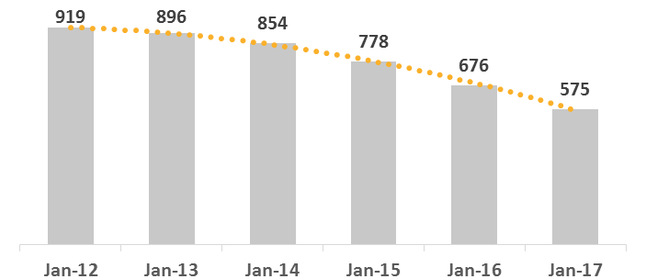
Fig. 1 — Operating Russian banks
In 2015, the number of credit institutions actively involved in money laundering, in illegal funds transfers abroad, as well as in transit operations accounted for approximately 36% of the total number of banks that were closed in 2015 [1]. The characteristic of damage caused by the activities of unscrupulous banks in monetary terms is the volume of identified suspicious financial transactions and the amount of money flowing from the Russian Federation for doubtful reasons. According to Rosfinmonitoring reports, these amounts increased from 39.6 trillion rubles in 2013 to almost 5.37 trillion rubles in 2015 [2-3]. In addition, the volume of insurance payments made by the State Corporation Deposit Insurance Agency (DIA) can be another indicator. For the period from January 2014 to September 2016, the volume of DIA payouts totaled 957.7 billion rubles [4].
License withdrawals from banks providing services to higher-risk customers and involved in conducting suspicious transactions provokes an "inflow" of unscrupulous clients to other financial institutions. Thus, in 2013 Rosfinmonitoring identified a scheme for migrating shadow schemes from Dagestan to the Samara region following the revocation of licenses from AKB Express, AKZB Derbent-Credit, Trust Bank, Transenergobank [5]. Besides, some unscrupulous clients become clients of the largest financial institutions with a goal to "get lost" in branch networks, large customer databases and voluminous transactions.
New and increasingly sophisticated risk-based methods used by the supervisory authorities are an essential in ensuring an effective and efficient national AML / CFT system. Therefore, development of a remote analysis method used to identify "risk groups" - banks whose state may cause concern, and audit of their activities becomes a priority issue. Though, remote methods and predictive models cannot unambiguously ascertain bank's reliability, possible risks of early detection will allow to either timely initiate credit institution recovery measures, or to significantly reduce the costs of liquidating as well as terminate the withdrawal of capital from the country.
Material and Theoretical Bases of Research
To predict the license withdrawal probability, the binary choice models were used (1).
$$P_{y=1}=F\left(x\right)=F({}_{0}+{}_{1}x_{1}+…+{}_{m}x_{m})$$ | (1)
Most common function F () uses the logistic distribution function (Logit model) (2). and the standard normal distribution function (Probit-model). (3).
$$P_{y=1}=F\left(x\right)=\frac{1}{1+e^{-x}}=\frac{1}{1+e^{-({}_{0}+{}_{1}x_{1}+…+{}_{m}x_{m})}}$$ | (2)
$$P_{y=1}=F\left(x\right)=\frac{1}{\sqrt{2π}}\int_{-∞}^{x}{e^{-\frac{k^{2}}{2}}}dk$$ | (3)
Decision can be taken in accordance with rule (4).
$$y=\left\{\begin{aligned}1, if P_{y=1}≥0,5 \\ 0, if P_{y=1}<0,5\end{aligned}\right.$$ | (4)
The probability of closure of commercial banks in the United States was analyzed based on logit models in [6-7]. In [8] logit models were applied to assess the risk of bank failures in the member countries of the Economic Community of Central African countries. A comparison between the effectiveness of probit models, logit models, proportional risk models, and neural networks for forecasting changes in bank credit ratings was presented in [9]. Research of prediction of the probability of bankruptcy of credit institutions in the Russian Federation was done by Golovan S., Karminsky A., Peresetsky A. [10-12]. In this paper, the logit model was chosen as a research tool, as the adequacy of its application was repeatedly proved to determine the probability of bank failures, as well as the advantage over other methods.
Credit institutions 2013 - 2016 performance data from their mandatory reporting as well as information on licenses revocation published by the Bank of Russia were used for the analysis. The following financial indicators were used to build the model: highly liquid assets, investments in securities, investments in the equity of other organizations, Interbank credits raised, loans to individuals, loans to enterprises and organizations, fixed assets and intangible assets, other assets, deposits of individuals, deposits of enterprises and organizations, Interbank credits granted, bonds and promissory notes issued, net profit, equity.
Prior to building a model the major knowingly reputable and systemically important banks, VTB 24 and the Bank of Moscow, were removed from the data set as anomalous objects. The Figure 2 demonstrates the number of banks examined in the annual sections after these transformations.
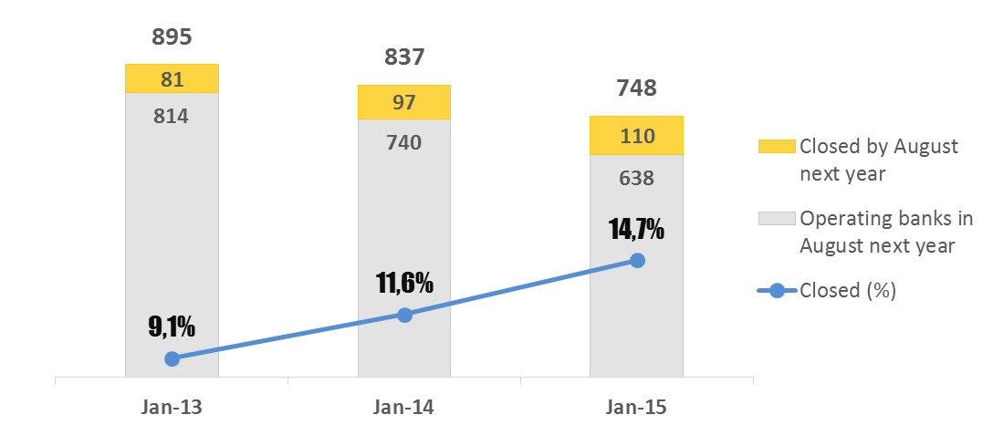
Fig 2. — The number of bank in annual cross-sections
A preliminary analysis of the data showed that the largest variation in the average values in each of the sections was observed in the following indicators: investments in securities, Interbank credits raised, Interbank credits granted, investments in the equity of other organizations, bonds and promissory notes issued, loans to individuals.
The construction of binary selection models based on 2013 data was carried out using the statistical analysis medium R. Since the number of banks closed for the year is much less than the total number of banks, stratified samples with an increased number of closed banks were formed during the construction of the model. On the basis of each formed stratified sample, a logit model was constructed, with the help of which a calculation of the predicted values was made for the full data of each of the annual cross-sections considered.
The analysis of the indicators significance is presented in Table 1. Table 1 provides information on the percentage of models in which the indicator was significant at 99% and 95% confidence interval. Further analysis shows that out of five most frequently significant at 99% confidence interval of indicators four had the greatest difference in the mean values for banks, which will be closed by August next year, and the banks that will continue to operate.
Table 1— Indicators significance in models
Indicators | 99% Conf. Interval | 95% Conf. Interval
Highly liquid assets | 23% | 25%
Loans to enterprises and organizations | 14% | 31%
Interbank credits raised | 10% | 21%
Interbank credits granted | 8% | 23%
Investments in the equity of other organizations | 8% | 20%
Fixed assets and intangible assets | 7% | 21%
Deposits of enterprises and organizations | 6% | 19%
Deposits of individuals | 5% | 16%
Bonds and promissory notes issued | 5% | 16%
Investments in securities | 5% | 15%
Loans to individuals | 5% | 15%
Equity | 4% | 19%
Net profit | 4% | 10%
Other assets | 2% | 12%

The predicted strength of the constructed models was estimated by applying them to the full data set for 2013 and calculating the percentage of correctly predicted closed (criterion K1) and open (criterion K0) banks.
In this study, for each model, its own threshold was determined and used to identify bank status on the basis on the logistic model. The best threshold for the model will be the one which ensures forecast accuracy at the level of at least 50% for both closed and open banks.
Further on, pairwise comparison of the criteria from the whole set of constructed models was used to choose non-dominant models, i.e. incomparable by quality criteria. Figure 3 visualizes the set of all constructed models in the context of the criteria K1 and K0 with not dominated by their characteristics of forecasting quality models in red.
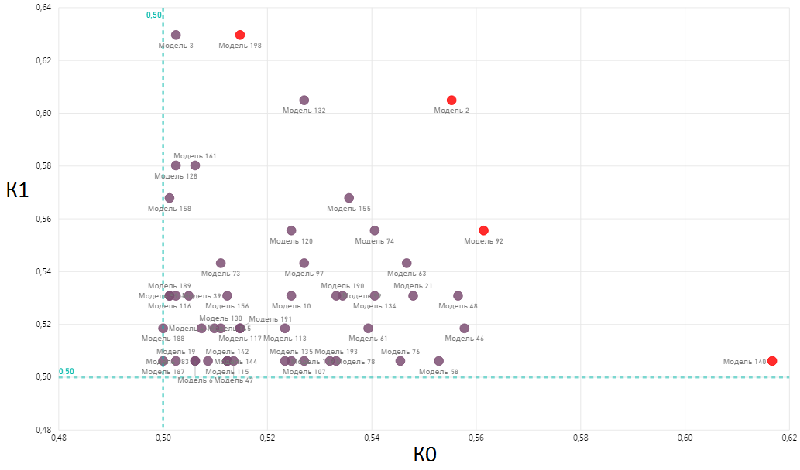
Fig. 3 — Criteria K0 and K1 for binary choice models
Table 2 summarizes the results of non-dominant model application to 2013 data.

Table 2 — Multitude of non-dominant models
Model | Suspicious |  | Correctly predicted |  | К1, % | К0, % | К,  % | α
 | count | % | closed | operating
Model 198 | 445 | 49,8% | 51 | 419 | 63,0 | 51,5 | 52,5 | 0,75
Model 2 | 410 | 45,9% | 49 | 452 | 60,5 | 55,5 | 55,9 | 0,63
Model 92 | 401 | 44,9% | 45 | 457 | 55,6 | 56,1 | 56,0 | 0,45
Model 140 | 352 | 39,4% | 41 | 502 | 50,6 | 61,7 | 60,6 | 0,58

Models application results prove that out of all non-dominant models, model 198 for predicting bank closure has the greatest predictive power: a closed bank is recognized in 63% of cases. The best in terms of excluding banks from the priority consideration with a low probability of revoking the license is model 140 - the initial sample can be reduced down to 40%.
Selected models test results for 2014 and 2015 data are presented in Table 3.

Table 3— Models performance verification against 2014 - 2015 data
Model | Suspicious |  | Correctly predicted |  | К1, % | К0, % | К, % | α
 | count | % | closed | operating
2014
Model 198 | 469 | 52% | 38 | 404 | 39,2 | 54,7 | 52,9 | 0,75
Model 2 | 277 | 31% | 21 | 579 | 21,6 | 78,5 | 71,8 | 0,63
Model 92 | 423 | 47% | 38 | 450 | 39,2 | 61,0 | 58,4 | 0,45
Model 140 | 397 | 44% | 33 | 471 | 34,0 | 63,8 | 60,3 | 0,58
2015
Model 198 | 441 | 49% | 49 | 354 | 44,5 | 55,7 | 53,9 | 0,75
Model 2 | 409 | 46% | 45 | 382 | 40,9 | 60,1 | 57,2 | 0,63
Model 92 | 365 | 41% | 34 | 415 | 30,9 | 65,3 | 60,1 | 0,45
Model 140 | 338 | 38% | 30 | 438 | 27,3 | 68,9 | 62,7 | 0,58

As can be seen from Table 3, as a result of application of the constructed models against 2014 data, the model 198 became dominated by the forecast quality criteria by the model 92. However, when used against 2015 data, this model again showed the best result in determining credit institutions whose licenses will be withdrawn and not dominated by either the other models under consideration. Therefore, it was decided not to choose one model for ranking banks according to the level of suspicion, but to take into account the forecast of each of the non-dominated models.
Each bank was ranked with rank meaning the number of non-dominated models that predicted a revocation of a license from this bank. The higher the rank, the higher the degree of suspicion of the credit institution. In one group, banks with the same rank will be included.
Table 4 presents the results of ranking of credit institutions on 2013 data.

Table 4 — 2013 ranking results
Rank | Number of banks | Closed by August 2014 | Operating in August 2014 | Out of them:
 |  |  |  | Closed by August 2015 | Closed by August 2016
4 | 157 | 22 | 135 | 16 | 10
3 | 191 | 23 | 168 | 18 | 28
2 | 127 | 10 | 117 | 17 | 14
1 | 157 | 9 | 148 | 17 | 25
0 | 263 | 17 | 246 | 23 | 32

Conclusion
In the course of the study, it was established that the quality of bank closure risk early detection models was improved through constructing models on the basis of training samples formed according to the principle of approximate equalization of the number of banks of each type (closed and open).
To assess the quality of forecasting, criteria were formulated for determining the threshold for binary choice models. According to these criteria, for each model, the threshold was chosen that allows to determine not less than 50% of the objects of each type.
In the multitude of constructed models the ones that were incomparable with respect to preferences were selected. The average number of banks, whose licenses will be withdrawn was correctly identified by binary models and constituted 57% in 2013 data set, 34% and 36% in 2014 and 2015 data sets, respectively.
As a result of building models and analyzing the results of forecasting, a methodology for processing and analyzing data on credit institutions using regression analysis methods, as well as multi-criteria optimization methods and decision theory was developed. The methodology makes it possible to identify groups posing potential danger to the integrity of the Russian banking system and AML|CFT efforts in credit institutions. Based on this methodology, a list of credit organizations ranked by the degree of suspicion was formed.
The results of this study are aimed at improving the efficiency of early detection of credit institutions that threaten the stability of the country's banking system and can be used by supervisory federal executive bodies to prevent abuse of legislation in the field of combating money laundering and terrorist financing.
Acknowledgements
This work was supported by Competitiveness Growth Program of the Federal Autonomous Educational Institution of Higher Education National Research Nuclear University MEPhI (Moscow Engineering Physics Institute).

References
- Liquidation of credit organizations (01.01.2016). Central Bank of the Russian Federation. URL: https://www.cbr.ru/credit/likvidbase/information_01012016.pdf.
- The Federal Financial Monitoring Service. 2014 Annual Report. URL: http://www.fedsfm.ru/content/files/activity/annualreports/посл.вер.%20отчет%202014.pdf.
- The volume of funds withdrawn from Russia for doubtful reasons was almost not increased in 2015, 08.02.2016. Russian new agency «TASS». URL: http://tass.ru/ekonomika/2647465.
- The State Corporation Deposit Insurance Agency. URL: https://www.asv.org.ru/agency/
- The Federal Financial Monitoring Service. 2013 Annual Report. URL: http://www.fedsfm.ru/content/files/activity/annualreportsпубличный%20отчет_2013.pdf.
- Markus Vilen Predicting Failures of Large U.S. Commercial Banks. Aalto University School of Economics, Master’s Thesis, 2010.
- Jartiani J., Early warning models for bank supervision: Simper could be better / Jartiani J., Kolari J., Lemieux C., Shin H., Federal Reserve Bank of Chicago, Economics Persrectives, 2003, Vol. 27(3), 49-60.
- Soudmo Badjio D., A Warning Model for Bank Default in CEMAC countries, 2010.
- Stefan van der Ploeg, Bank Default Prediction Model: A Comparison and an Application to Credit Rating Transitions, Erasmus University Thesis Repository, 2010, р.48.
- Peresetsky A., Karminsky A. M., Golovan S. V. Probability of default models of Russian banks // Economic Change and Restructuring. 2011. Vol. 44. No. 4. P. 297-334.
- Karminsky, A. M., Kostrov, A. V. (2013). Campfires modeling the probability of default of Russian banks: advanced facilities. Journal of the New Economic Association], 1 (17), 63-86.
- Peresetsky, A. A. (2013) Model causes the revocation of licenses of Russian banks. Influence factors unaccounted. Journal of Applied Econometrics, 32 (2), 49-64

