Development of a risk-oriented approach to supervision in the segment of non-credit financial organizations in the field of AML / CFT.

K. T. Parutov, I. S. Kadrul, V. D. Ivankiv
Faculty of Risk Analysis and Economic Security named after Professor V. K. Senchagov.
Financial University under the Government of the Russian Federation
K. T. Parutov: ORCiD 0000-0001-5091-4415; parutov.k@yandex.ru
I. S. Kadrul: ORCiD 0000-0001-6421-4508; ilya-i-kadr@yandex.ru
V. D. Ivankiv: ORCiD 0000-0002-4729-3037; vasilisaivankiv@mail.ru
Abstract: The article considers the development of a risk-oriented approach in the supervision of non-credit financial organizations in the field of AML / CFT. The main stages of the formation of the ROA (risk-oriented approach) in all spheres of activity are considered. Suggestions (innovations) for improvement of control and supervision activities in the field of non-financial financial organizations are presented on the example of the creation of the Unified State Register of AML / CFT Law Detection.

Keywords: risk, control, risk-oriented approach, supervision, state, AML / CFT.

Introduction
Modern economic relations are no longer just production, distribution and consumption. A new round of economic thought development forces outstanding scientists in this field to expand the horizons of research, creating new directions.
One of these areas has become a fairly young science aimed at studying the content of risk, the limits of its justification, methods for analyzing, assessing and managing risk, as well as problems associated with collective and individual risk perception - riskology (1970s) [1] .
In connection with the continuous development of market relations, any economic activity exists under the conditions of increasing uncertainty, constant and atypical threats to the external and internal environment. As a result, a doubt arises about obtaining a positive result from the decisions taken. Hence the concept of risk arises, as the uncertainties about the coming of any (positive or negative) event as a result of activity. A risk is an integral part of any enterprise. It occurs in a variety of forms and can manifest itself in all areas of the company.
The reason for the emergence of a new science is associated with technological shifts in the economy, increased consumption of energy resources, exacerbation of crime situation [2], etc.
Attempts to manage risks led to the creation of a mechanism for conducting control and supervisory activities - a risk-based approach. The essence is to analyze all possible risks, assess and create a full-fledged strategy to confront them, in order to maximize the effectiveness of the organization and reduce the likelihood of negative events. Thus, ROA helps identify all risk factors before they are possible, and then level out all potential losses, increasing productivity.
However, the problem lies in the complexity of identifying the risk, since it can be both an event and a factor influencing other events.
Currently, the active work is underway to widely introduce a risk-based approach to the work of government agencies. Certain steps to introduce ROA in the control and supervision activities of government agencies are reflected in Figure 1.
Having carefully studied this image, we see that the risk-oriented approach is widely used in many state structures and has proved its worth in controlling and supervising activities in various fields of activity.
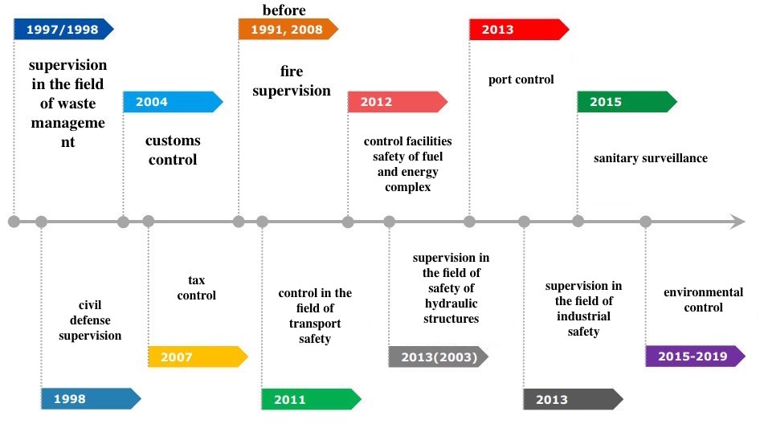
Fig. 1 — Certain steps to introduce ROA in the control and supervision activities of government agencies
Since the implementation of the ROA in the area of ​​waste management in the late 1990s, the ROA has been applied in other areas of the economy. Active use led to an increase in the number of employees, which created additional monetary burden on the Central Bank of the Russian Federation (additional jobs, material maintenance, wages to employees). The burden on economists analyzing endless information flows has increased many times. As a consequence, an increase in the human factor has also increased the possibility of employee error.
And that is the context in which the operation of this mechanism should be adjusted.
We propose the division of risks into hazard levels and the further distribution of powers among employees and other persons who are looking for ways to reduce the negative consequences.
Thus, our initiative group received the following table, based on statistical methods and possible options for monitoring activities (Table 1).

Table 1 — Risk categories and classes (categories) of hazards
risk categories | classes (categories) of hazards | features of the control measures
Extremely high risk | 1 class | scheduled inspection is carried out once during the period provided for by the regulation on the form of state control (supervision)
high risk | 2 class
significant risk | 3 class
average risk | 4 class | scheduled inspection is conducted no more often than once in the period provided for by the regulation on the form of state control (supervision)
moderate risk | 5 class
low risk | 6 class | Scheduled inspections are not carried out

In the 1-3 risk categories, we have included a risk in the event of which the loss will force the economic activity to cease, as the losses will exceed all available property.
To 4 and 5 categories, we propose to attribute risks, the magnitude of which will exceed the profits of the organization.
The 6th category, with the lowest level of probable losses (less than the estimated profit), will not need to be inspected.
The frequency of inspections will also depend on the hazard category, the higher the risk - the more often the planned checks.
However, when assessing the 6th category, it is inappropriate to spend the efforts of the Central Bank staff. We believe that the third and fourth year students of undergraduate studies, master's studies and postgraduate studies are able to conduct an analysis of this class.
Since it is not possible to obtain information freely, the leading universities will cooperate with the Central Bank.
The benefit is quite significant for both the Central Bank and universities. The Central Bank itself will reduce the burden on its employees, stopping assessing and analyzing low-risk information.
Universities will receive places for sending their students to an internship. And the directions will be absolutely transparent, as only those who will efficiently and effectively study the sixth category of risk will be able to get it.
The probability of a student's error is minimized, since an experienced teacher, being an employee of the university department, will monitor the progress and results of the work.
Speaking of statistical methods of separating categories, it is possible to assign an event more objectively to a certain group.
For example, analyzing the losses and profits of the organization, we will be able to identify the magnitude of economic returns and make the most probable forecast. Thus, we get a mathematically expressed value and the probability of an event, based on objective data.
Further, relying on certain values ​​within each group, we distribute events sequentially. It is necessary to rely on the theory of probability, and it will be with the help of it that the boundaries of our categories will be exposed.
Also, the search for the magnitude of financial risk will eventually reduce to the application of probability theory in solving economic problems, where the definition of the probability for the occurrence of events will depend on the greatest value of the mathematical expectation (the absolute magnitude of the event multiplied by the probability of its occurrence)
In order to quantify the amount of financial risk, it is necessary to know all possible consequences of any particular action and the probability of the consequences themselves. With regard to economic problems, the methods of the probability theory reduce themselves to determining the values ​​of the probability for the occurrence of events and to the choice of the most preferable from the largest value of mathematical expectation, which is equal to the absolute value of this event, multiplied by the probability of its occurrence.
But how exactly are things with non-credit financial organizations (NFO), how do they conduct control and surveillance activities based on the ROA?
NFO are a type of financial institutions that are designated by the Central Bank, including the securities market, or rather the majority of its participants, as well as insurance entities, microfinance organizations, consumer credit cooperatives, housing funded cooperatives, credit history bureaus, organizations that carry out actuarial activities, rating agencies , agricultural credit consumer cooperatives, pawnshops. Of course, most of the NFO is the securities market, so we should pay more attention to it, providing control over the NFO. This is due to the fact that if we take, for example, pawnshops, then they operate in their field, and if we consider the participants of the securities market, the financial turnover and interaction occur both within each participant and in the whole in the securities market, so this particular block (the securities market) is at greater risk.
Therefore, we are faced with the question: how to ensure the sustainable development of the financial market, the effective management of financial risks, the protection of the rights and interests of investors in financial markets, of insurers, of insured persons and beneficiaries, as well as of insured persons in mandatory pension insurance, of depositors and participants in a non-state pension fund on private pension provision and of other financial services consumers. Answering this question, there is only one answer: to create such a system, through which it will be possible to control, supervise and regulate this sector, spending at least a minimum of resources, minimum funds and a minimum of time.
Considering how the state bodies exercise control, we noticed how much they spend time, money and effort to carry out all sorts of controls, because even when they receive the data they still have to process them and enter them into the database. But they are not considering: how to optimize this process. If we take any block of organizations from the NFO, and analyze it, we will notice how many inspections are carried out by state structures, and the data received by different structures are interrelated and in places are homogeneous and identical. And so the data for different state structures in places come into contact, then they do just double work. It turns out that one state structure carried out the audit, processed the received data, some of them sent to another state structure that carries out more inspections, and so on. Undoubtedly, the fact that differentiated responsibilities between different structures is great, even A. Smith said that specialization (division of labor) leads to the development of economy.
Realizing this whole situation, we thought, with this development of the Internet, why not simplify the state's life and save money. We came to the fact that we should create an electronic register, which will contain all the data on organizations, thereby this sector will begin to self-regulate. What does it mean? The fact that now the organizations themselves will enter their data into the electronic register, where and how much they spent, how much they received, confirming it with electronic checks from the bank, thus the state structures will immediately see where and where the cash flow of the enterprises comes from. Of course, only the organization will have access to the financial part of the organization, in order to enter its data, and of course the government structures that can reduce the number of checks, since all the data will be in their hands and they will not have to wait until they will be processed.
This register may not be limited to the NFO, and it is possible to include all the organizations that exist in the country.
What is the electronic register?
A special system placed on the Internet network, where the state structures will see different sections (classifications of organizations), passing through this hierarchy, they can get to the organization they need (you can find it in another way: enter the name of an organization on this site in the search engine.
Also, with time, you can bring this system to automaticity, that is, the program itself will find flaws in these organizations, for example, not the reliability of information, not the combination of costs and checks amounts for these costs, etc. And by going into this electronic system, state structures will spend less time searching for unscrupulous firms and enterprises, but there will be a separate folder in which all organizations in which these inconsistencies are revealed will be shown.
Thus, we will also get rid of the corruption accompanying these checks.
Of course, every step towards creating a stable and qualitative Unified State Register of Detection of Offenses in the AML / CFT field will be difficult and long. Having legalized the system of risks, their classification, having reduced as much as possible all financial expenses, we can achieve the emergence of a complete risk management system. And only after these steps, the register will be able to function effectively and identify violations in the field of AML / CFT.

References

- Investigation of the essence and content of risk - [electronic resource] - [access mode] - https://studfiles.net/preview/6217484/ (circulation date 9.11.2017).
- Avdijsky V. I., Bezdenezhnykh V.М. Theory and practice of risk management of the organization .- Moscow: KnoRus, 2017.

