Creating a Prototype of the Information-Analytical System of Rating Countries in the Field of AML/CFT for Compliance with 40 FATF Recommendations
Davydenko V. I., Burmistrov M. I, Kulakova M.V.
National Research Nuclear University MEPhI (Moscow Engineering Physics Institute),
Kashirskoe shosse 31, Moscow, 115409, Russia
Davydenko V. I.: ORCiD 0000-0003-1396-8363; VIDavydenko@mephi.ru
Burmistrov M. I.: ORCiD 0000-0001-9209-4187; bane55577@gmail.com
Kulakova M.V.: ORCiD 0000-0001-8140-0177; Veber.maria-ksky@ya.ru
Abstract: The article provides an example of implementing the cluster analysis algorithm for an information and analytical system in order to identify various patterns in the participating countries, basing on the process of assessing the effectiveness and technical compliance of the FATF member countries and FATF-style regional groups.
Keywords: FATF, information and analytical system, FATF recommendations, efficiency evaluation, technical conformity assessment, cluster analysis, data mining.
Introduction
At present, the problem of money laundering and the financing of terrorism is acquiring an increasingly global scale: under the impact of international security, the integrity and stability of the world financial institutions, public welfare is getting worse. Many countries cannot sufficiently prevent, detect and suppress money laundering and terrorist financing. The situation is complicated by the involvement of criminals in the world financial systems, the participation of financial organizations of different types, the movement of capital between countries and the continuous introduction of modern technologies.
Therefore, it is necessary to organize an international systematic counteraction to money laundering and the financing of terrorism, which will cover all administrative, legal and financial institutions. This task can be solved by information and analytical systems, the essence of which is the collection of information and the discovery of absolutely new data on the investigated object in the form of generalized information from collected materials that are characterized by such features as: non-systematicity, irrelevance, incoherence, etc.
The development of standards for monitoring the implementation of AML/CFT measures is carried out by the FATF group through 40 Recommendations. Evaluation of the success of the countries in the organization and the effective application of the AML/CFT system is carried out by the FATF group, as well as the FATF-style regional groups: ATG, ECAAMLG, GAFISUD, EAG, MENAFATF, MANIVEL [1]. At the same time, it is necessary to conduct a comprehensive analysis to find out the problems that countries are experiencing when setting up an AML/CFT system, to analyze the most successful and most backward countries on the basis of mutual assessment reports [2].
Conceptual approach to the problem
Consider the components of the process of the information system which are necessary to solve the task:
1. Analysis of management objectives and formulation of tasks of information and analytical work.
The goal of implementing this system is to organize an international systematic anti-money laundering and combating of terrorist financing, which would cover all administrative, legal and financial institutions.
2. Data collection for management tasks.
Before performing any of the existing types of analysis, it is necessary to collect an array of data. In our case, these are estimates and types of mutual evaluations.
Currently, two assessments of national systems for combating money laundering and the financing of terrorism are being conducted [3]:
- assessment of technical compliance with the FATF Recommendations;
- evaluation of the effectiveness of the national AML/CFT system.
The technical conformity assessment is conducted to determine the compliance of the competent authorities, legal, administrative, financial and other structures that are the basis of the national AML/CFT system, the FATF Recommendations.
Estimates of effectiveness also determine the sufficiency of the measures applied in accordance with the risk-oriented approach and the achievement of the results, without which it is impossible to create a full-fledged AML/CFT system. They indicate to what extent the national AML/CFT system reduces the risks and threats of money laundering and terrorist financing [4].
Thus, the evaluation of the anti-money laundering and terrorist financing system, approved by the FATF in 2012, is based on a comprehensive review of two mutually complementary components: technical compliance and efficiency.
In carrying out the Mutual Evaluation, experts make a conclusion about the country's technical compliance or non-compliance with the Recommendation Standard.
There are five variants of such evaluation of the Recommendation [5]: corresponds to (C), largely corresponds to (LC), partially corresponds to (PC), does not correspond (NC), not applicable (N/A). The "corresponds" rating indicates that there are no shortcomings in the implementation of the Recommendation.
Research methodology
Mutual evaluation reports are publicly available on the FATF official website, as well as on the websites of regional groups such as the FATF. Many countries at the time of the study have not yet conducted a mutual evaluation based on the 2012 FATF Recommendations.
The study collected data on mutual assessments of countries according to the 2012 FATF standards: the FATF regional group, the country, the year of the report, and the evaluation of the Recommendations, the number of factors for each Recommendation and the Efficiency Assessment. The data set comprised the estimates of 28 countries.
A methodology was developed to convert estimates into numerical equivalents, including a number of factors. When analyzing such a large number of variables and a relatively small sample size, it is advisable to convert the estimates of Recommendations and Efficiency to continuous values, and in the evaluation of the Recommendations, take into account the number of comments (factors) made in the mutual evaluation. The estimates were converted as shown in Tables 1-2.

Table 1 — Number of evaluations recommendations
Evaluation of Recommendation | The numerical representation of evaluation
C | 1,000
LC | 0,999
PC | 0,666
NC | 0,333

Table 2 — Number of evaluations efficiency
Efficiency Evaluation | The numerical representation of evaluation
H | 1,000
S | 0,666
M | 0,333
L | 0,000

To calculate the number of factors in the evaluation of the Recommendations, additional calculations were made. From the tabular value of the estimate, the assessment range (0.333) was subtracted, multiplied by the number of factors and divided by the maximum value of the factors for this Recommendation among the entire sample (Formula 1).
${C_Rnn}_{i}={Rnn}_{i}-0,333*\frac{{F_{Rnn}}_{i}}{MAX\left({F_{Rnn}}_{k}\right)}$ (1)
At the same time, for the estimation of C (fully consistent), the numerical representation of the estimate will always be 1.0, since such an estimate has no comments (factors).
Graphically, the methodology for calculating estimates can be presented as shown in Figure 1.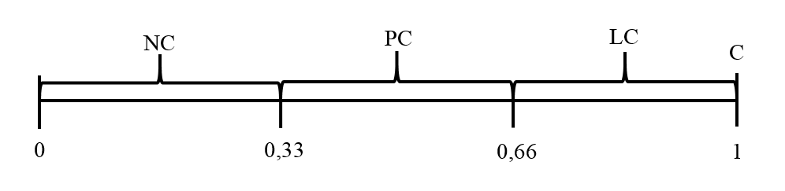
Fig. 1 — Graphic representation of calculated estimates recommendations
Describing the algorithm of the cluster analysis of the mutual assessments of the FATF countries
The tasks of this study to the full extent allow solving clustering methods. Clustering consists in dividing a set of objects into clusters according to their parameters. The difference from the classification problem lies in the fact that the number of clusters and their parameters may not be known in advance, and clustering will carry out the association of objects into clusters by the proximity of all parameters.
The Analysis Services clustering algorithm uses iterative methods, during which it determines the relationships between objects, and then clustering. The Analysis Services clustering algorithm (Microsoft Clustering) is implemented by two clustering algorithms: K-means (hard clustering) and maximization of expectations (soft clustering) [11]. With hard clustering, an element can belong to only one cluster. With soft clustering, an element can belong to several clusters, and for all possible variants of elements with clusters, probabilities are calculated.
In the method of maximizing expectations, the algorithm in each iteration refines the initial model and determines the probabilities of the point belonging to clusters. In the case of empty clusters or clusters with the number of elements below the threshold value, the algorithm is started again and a new filling of the little filled clusters takes place. Since the method of maximizing expectations is an algorithm of soft clustering, the number of elements in clusters can be greater than the number of elements in the sample. Assessments of technical compliance and performance evaluation have been clustered separately for more correct analysis.
Results of the survey
Figure 2 shows the level of distribution of countries across clusters by the method of maximizing expectations. The figure illustrates the interception graph of the cluster elements for evaluating technical compliance and efficiency, where 1R, 2R and 3R clusters for 1, 2 and 3 of the evaluation of Recommendations respectively, and 1E, 2E and 3E are clusters for 1, 2 and 3 of the evaluation Efficiency.
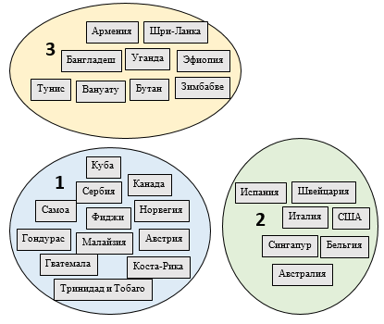
Figure 2 — Distribution of country clusters by the k-middle method
Below are tables 3-5 of the most typical values of parameters for clusters with indication of their probability.

Table 3 — Most typical values of cluster 1 parameters
Variables | Values | Probability
C_E4 | 0,333 | 100 %
C_E6 | 0,666 | 88 %
C_E1 | 0,666 | 75 %
C_E3 | 0,333 | 75 %
C_E5 | 0,333 | 63 %
C_E9 | 0,666 | 63 %
C_E10 | 0,333 | 50 %
C_E7 | 0,333 | 50 %
C_E11 | 0,333 | 50 %

Table 4 — Most typical values of cluster 2 parameters
Variables | Values | Probability
C_E11 | 0 | 90 %
C_E7 | 0 | 86 %
C_E10 | 0 | 77 %
C_E1 | 0,333 | 74 %
C_E3 | 0 | 64 %
C_E6 | 0 | 62 %
C_E5 | 0,333 | 60 %
C_E8 | 0 | 52 %
C_E9 | 0 | 52 %

Table 5 — Most typical values of cluster 3 parameters

Variables | Values | Probability
C_E1 | 0,333 | 100 %
C_E3 | 0,333 | 100 %
C_E6 | 0,333 | 95 %
C_E5 | 0 | 93 %
C_E4 | 0,333 | 77 %
C_E2 | 0,666 | 76 %
C_E11 | 0 | 71 %
C_E7 | 0,333 | 69 %
C_E9 | 0,666 | 52 %

It can be seen from the tables that cluster 1 most accurately describes a low assessment of Efficiency 1 (application of the risk-based approach), Efficiency 3 (impeding the use of financial institutions and DNFBPs for criminal purposes), Efficiency 4 (reducing the risk of financial institutions and DNFBPs), Efficiency 5 (ensuring transparency of institutions).
Cluster 2 is characterized by high performance indicators 1 (risk-based approach), Efficiency 6 (financial data collection), Efficiency 9 (penalties for FT crimes), Efficiency 11 (sanctions for crimes of proliferation of weapons of mass destruction). At the same time, cluster 2 can be characterized by low Efficiency 3 scores (an obstacle to the use of financial institutions and DNFBPs for criminal purposes) and Efficiency 4 (reducing the risk of financial institutions and DNFBPs).
Cluster 3 is characterized by extremely low performance indicators 4 (reducing the risk of financial institutions and DNFBPs), Efficiency 7 (sanctions for ML offenses) and Efficiency 8 (confiscation of proceeds of ML/FT crime).
Figure 3 shows that not all the countries, which are successful in assessing technical compliance, have also succeeded in evaluating performance.
Based on the results of the analysis of the technical conformity assessment, it was found that the greatest success was achieved by the countries of cluster 1. The countries of cluster 2 are characterized by low scores, while the countries of cluster 3 generally received average assessments of technical compliance.
Based on the results of the analysis of effectiveness assessments, it was found that the countries of cluster 1 achieved the greatest success, as in the case of assessments of technical compliance. The countries of cluster 2 are characterized by low scores, and the countries of cluster 3 generally received average efficiency ratings.
From the results of the analysis, it can be concluded that the countries, where clusters 1R and 1E intercrossed, organized the most effective AML/CFT system that complies with the FATF standards. The countries of the intersection of clusters 1R and 1E are: Belgium, Canada, Cuba, Malaysia, Norway, Singapore, the USA, Spain, Italy, Switzerland.
The countries of the intersection of clusters 1E and 3R are characterized by high efficiency ratings, but at the same time average estimates of technical compliance. The countries of the intersection of clusters 1E and 3R are Australia and Guatemala.
The countries of the intersection of clusters 3E and 1R are characterized by high assessments of technical compliance and average efficiency estimates. The countries of the intersection of clusters 1R and 3E are Armenia and Bangladesh.
The countries of the intersections of clusters 3E and 3R are characterized by average values of both efficiency estimates and technical conformity assessments. Among the countries of cluster 3E and 3R is Fiji.
The countries of the intersections of clusters 3E and 2R are characterized by average values of efficiency estimates and low values of technical conformity assessments. The countries of clusters 3E and 2R are Costa Rica and Honduras.
The countries of the crossing of clusters 2E and 1R are characterized by high assessments of technical compliance and low efficiency ratings. The countries of the intersection of clusters 1R and 2E are Ethiopia and Austria.
The countries of the intersection of clusters 2E and 3R are characterized by low efficiency ratings and average estimates of technical compliance. Cluster countries 2E and 3R include Bhutan, Vanuatu, Zimbabwe, Serbia, Trinidad and Tobago, Tunisia, Uganda, Sri Lanka.
The countries of the crossing of clusters 2E and 2R are characterized by low efficiency ratings and technical conformity assessments. Clusters 2E and 2R belong to Samoa.
The absence of countries in the crossing of clusters 2R and 1E suggests that it is impossible to build an effective AML/CFT system without FATF standards. At the same time, the entry of countries into the intersections of clusters 1R and 2E indicates that compliance with the FATF standards is not a sufficient condition for achieving the effectiveness of the AML/CFT system.
Conclusion
By searching in open sources of information, it was possible to form an array of data on assessments of the efficiency and technical conformity of countries. The array formed served as the basis for the calculated estimates that were loaded into the database for subsequent structuring and analysis.
As a result of the cluster analysis, groups of countries with similar problems were identified, the level of influence of each type of assessment on the quality of the international AML/CFT system was assessed.

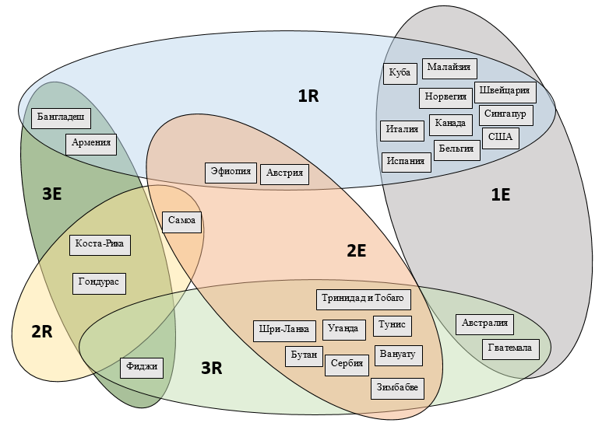
Fig. 2 — Cross-cutting of cluster elements for technical conformity assessments and efficiency assessments

Acknowledgements
This work was supported by Competitiveness Growth Program of the Federal Autonomous Educational Institution of Higher Education National Research Nuclear University MEPhI (Moscow Engineering Physics Institute).

References
- The Financial Action Task Force (FATF) [Electronic resource]. -Official site - Access mode: http://www.fatf-gafi.org/ (visited on: 03.09.2017).
- Eurasian Group on Combating Money Laundering and Financing of Terrorism [Electronic resource] Access mode: http://www.eurasiangroup.org/ (visited on: 03.09.2017).
- Asia / Pacific Group on money laundering [Electronic resource]: Official website - Access mode: http://www.apgml.org/ (visited on: 03.09.2017).
- Eastern and Southern Africa Anti-money Laundering Group: Official website - Access mode: http://www.esaamlg.org/ (visited on: 03.09.2017).
- The Financial Action Task Force of Latin America [Official site - Access mode: http://www.gafilat.org/ (visited on: 03.09.2017).
- Middle East and North Africa Financial action Task force: Official website - Access mode: http://www.menafatf.org/ (visited on: 03.09.2017).
- Committee of Experts on the Evaluation of Anti-Money Laundering Measures and the Financing of Terrorism: Council of Europe - Access mode: http://www.coe.int/t/dghl/monitoring/moneyval/ (visited on: 03.09.2017).
- Caribbean Financial Action Task Force [Official website] - Access mode: http://www.cfatf-gafic.org/ (visited on: 03.09.2017).
- The Inter-Governmental Action Group against Money Laundering in West Africa [Official website] - Access mode: http: // www.giaba.org/ (visited on: 03.12.2016).
- MSDN [Electronic resource]: Microsoft - Access mode: https://msdn.microsoft.com (visited on: 03.09.2017).
- National Open Institute INTUIT [Electronic resource]: Portal - Access mode: http://www.intuit.ru/ (visited on: 03.09.2017).
- Revenkov, P.V. Laundering of illegal proceeds: analysis of the problem and some recommendations / P.V. Revenkov, A.N. Voronin // Money and credit. - 2014. - №4. С.30 - 35.
- Methodology: Assessments of technical compliance with the recommendations of the FATF and the effectiveness of AML / CFT systems. - 2016. - 148 p.

