Analysis of Compliance Services in Banks of the Republic of Kazakhstan
in Current Situation
N. B. Zhampeiis¹
¹ National Research Nuclear University MEPhI (Moscow Engineering Physics Institute), Master, Kashirskoe shosse 31, Moscow, 115409, Russia
Zhampeiis N. B.: ORCiD 0000-0001-6477-6973
Corresponding Author: Zhampeiis N. B., E-mail: nazerkezhampeiis@gmail.com
Abstract: the article highlights and describes the specifics of compliance in regulated banks of the Republic of Kazakhstan. Comparison of economic indicators, regulatory documentation, violations and sanctions for internal control, as well as a survey of the studied banks were conducted. Particular attention is paid to problematic issues in compliance control activities and recommendations for improving the AML/CFT system.

Keywords: banks, Republic of Kazakhstan, AML/CFT system, compliance service
Introduction
Currently, the issues of compliance with the established norms in the anti-money laundering and combating financing of terrorism (hereinafter - AML/CFT) legislation by the regulated banks are quite acute, due to the fact that they are all reporting entities. The banking sector in Kazakhstan is the most important part of the financial system of the state, occupies a key position in conducting both domestic and international payments, and provides a wide range of other financial services. In this regard, the requirements of the AML/CFT legislation should be primarily performed by commercial banks. Any bank, which does not have the effective AML/CFT program, is exposed to high risk of money laundering and financing of terrorism. Often, so-called compliance risk and negligent attitude to them lead to huge financial losses, loss of reputation and even criminal liability of managers.
The functions of the compliance control service are very diverse and cover a wide range of issues related to the activities of the bank. However, this research is focused on one of the most important of its functions, namely, the prevention of money laundering and financing of terrorism.
Relevance
Despite the available numerous publications of domestic and foreign scientists on the related subjects, there is no research on the analysis and assessment of compliance control of regulated banks in the Republic of Kazakhstan. This is caused by the relevance of research in this field.
Results of the study
So, in January 1, 2017, 33 banks and 8 organizations perform separate types of banking operations, including three mortgage organizations, functioned in the Republic of Kazakhstan.
For the purposes of this research we take the following 6 banks, including one subsidiary of a foreign Bank: Kazkommertsbank JSC, "Halyk Bank of Kazakhstan", "Bank CenterCredit", "ATF Bank", "ForteBank", "SB "KZI Bank".
In order to assess the financial situation of these banks based on their financial reports and official data of the National Bank of the Republic of Kazakhstan the ranking by assets was created (as shown in table 1).
Table 1. Ranking of banks by assets in 01.12.2016
N | Bank | Assets (billion KZT) | Change assets (at year-end)
1 | Kazkommertsbank | 5 045 | -0.12%
2 | Halyk Bank of Kazakhstan | 4 294 | 5.94%
3 | ATF Bank | 1 308 | 9.06%
4 | Bank CenterCredit | 1 302 | -9.57%
5 | ForteBank | 1 202 | 12.79%
6 | SB "KZI Bank” | 5 10 | -11.51%

In accordance with Table 1, Kazkommertsbank is the leader in terms of assets with an aggregate amount of 5,045 billion tenge. [1,2,3,4,5,6]
For the period under review, the balance sheets of Halyk Bank, ATF Bank, ForteBank are increased, and accordingly balance sheets of Kazkommertsbank, Bank CenterCredit, SB KZI Bank decreased.
According to the rating assigned by the international agency Moody's Investors Service, most of the studied banks have an “E” rating, which means very limited independent financial stability. The results are shown in Table 2. [7,8,9]

Table 2 — International ranking of the studied banks
Rating | Standard&Poor's | Moody's Investors Service | Fitch Ratings
ATF Bank | - | E/«Stable» | В-/«Stable»
Bank Centercredit | B+/Stable | E+ | B/«Stable»
Halyk bank | ВВ/ Stable | D- | ВВ/«Stable»
Kazkommertsbank | В-/ Negative | Е | В-/« Stable»
ForteBank | В/ Stable | - | -
KZI Bank | B-/ Stable | - | -

Standard & Poor and Fitch Ratings agencies ratings assess the ability of the issuer to fulfill its debt obligations on time. Most of the banks have a B rating, which in turn indicates a higher vulnerability in unfavorable commercial, financial and economic conditions, but currently has the ability to perform the debt on time and in full. The rating outlook shows the possible direction of the rating movement in the next two-three years. The forecast "stable" means that the change is unlikely.
Within the research, the author conducted a remote survey among the studied regulated banks to assess the current state of compliance in AML/CFT.
There were issues associated with the regulation of the compliance control, efficient organization of service, the automated systems of monitoring of customer transactions, facts of dismissal of employees and/or management of banks due to non-compliance with AML/CFT legislation, the most vulnerable to ML products and services, as well as frequently used lists for identification.
According to the survey results, the following similar responses of all respondents were obtained:
- The internal documents regulating AML/CFT issues are the AML/CFT Policy, as well as the Internal Control Rules, which determine the establishment of an internal control system in the bank and its subsidiaries for AML/CFT purposes. Responsible for the implementation of this policy are the Chief Compliance Officer and the Compliance Control Department appointed at the management level;
- no correspondent relations with shell banks;
- in case of customer identification and monitoring of operations, a risk-based approach is applied;
- it is possible to identify unusual customer transactions in automated systems;
- there is no difficulty in obtaining information from foreign sources;
- the most vulnerable customers for money laundering are legal entities than individuals;
- all new employees are subject to a mandatory AML/CFT course when they are employed in the Bank, and courses for all employees are conducted on an annual basis;
- there are no facts of dismissal of employees/management of the organization due to non-compliance with AML/CFT legislation.
According to the results of the survey, the most problematic areas were:
- insufficient number of employees to implement the AML/CFT policy (figure 1);
- the inability to identify foreign politically exposed persons in automated system (figure 2);
Thus, 66.7% of respondents noted that an average of 2-6 employees work in the compliance service of each branch of the bank. According to respondents' answers, this number of employees is not sufficient to implement an effective AML/CFT policy for the following reasons:
- significant volume of transactions through the bank;
- a huge amount of management reporting;
- constant changes and additions of the law on AML/CFT.
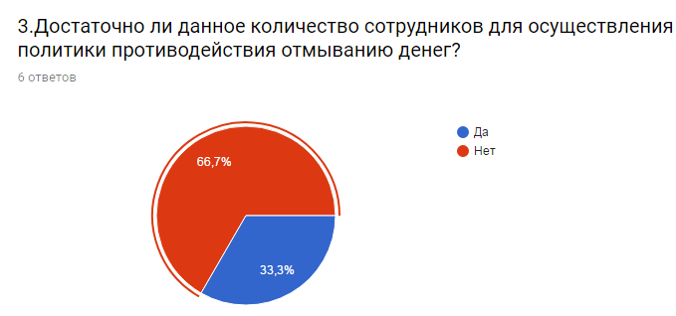
Figure 1- Diagram according to the results of the answers to question №3
According to respondents' replies, banks use the following automated systems for monitoring customer transactions:
- Colvir: Colvir-AML is used for identification; SironAML identifies suspicious transactions during monitoring;
- Other AML are systems, including scenarios on threshold and scenarios for suspicious transactions.
However, one respondent indicated that it is not possible to identify foreign politically exposed persons in the Bank's automated system (figure 2).

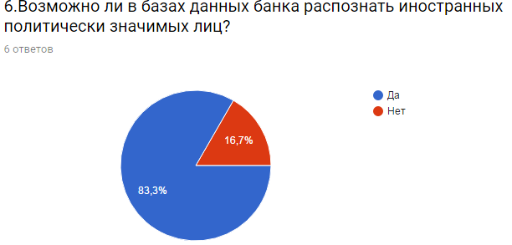
and financing of terrorism
5. W-8BEN-E is a certificate on the status of beneficial owner for the US Internal Revenue Service and accountable organizations.
Concerning violations of AML/CFT legislation by banks, the National Bank of the Republic of Kazakhstan carried out 20 inspections and 10 documentary checks of regulated banks in 2016. These checks were carried out for compliance with the requirements of AML/CFT legislation.
According to the results of inspections of banks, the total size of administrative fines imposed to, reached 148.4 million tenge, including 89.7 million tenge for 227 administrative cases submitted to the courts (for violations of the Law of the Republic of Kazakhstan "On combating legalization (laundering) of proceeds obtained in a criminal way and financing of terrorism"). [10]
In addition, for the first quarter of 2017 the National Bank of the Republic of Kazakhstan carried out inspections in respect to six regulated banks, including four studied banks: Kazkommertsbank, ForteBank, ATF Bank, Halyk Bank of Kazakhstan. As a result, AML/CFT violations were detected and retaliation was applied to two banks (Table 4).
Table 4 — Results of inspections on AML/CFT for the first quarter of 2017
Bank | Number of inspections for the I quarter of 2017 | Administrative fine  (number, amount) | Brief description of the revealed violations (indicating the violated norms of the AML / CFT Law, subordinate acts)
Bank A | 06.02.2017 | 4 protocols  (12 726 000 tenge) | violation of the law of the Republic of Kazakhstan on AML/CFT regarding the suspension and refusal to conduct operations subject to financial monitoring and providing information on transactions subject to financial monitoring  (Part 1 of Article 214 of the Code of Administrative Offenses)
Bank B | remote supervision | 2 protocols  (sent for consideration in the СМАС  Almaty) | based on the results of a documentary audit conducted within the framework of execution of a particular resolution, the bank's actions revealed an offense, the essence of which is the bank's failure to comply with the Regulations on Internal Control Rules for AML / CFT purposes approved by the decision of the Bank's Board of Directors

Conclusion
Based on the results of the study of financial regulations and the activities of the compliance service received from open sources on the website of the studied banks, as well as the results of the survey, the following conclusions can be drawn.
1. The results of the research showed that the positions of the researched banks in the field of AML/CFT are clearly defined in the policy and internal AML/CFT documents. All banks have these documents on their official websites.
2. Appointed by the Board of Directors of the bank, the Compliance Controller has all necessary qualifications and experience to implement properly the bank's internal rules and procedures.
3. At the same time, 66.7% of respondents noted that the number of employees working in the compliance service and responsible for the implementation of the AML/CFT policy is currently insufficient. This position is confirmed by the analysis of the ratio of the number of banks’ branches and employees. The main reasons for this phenomenon is a large volume of transactions and reporting. In turn, this defect can be negatively affect to the amount of sent messages about suspicious transactions to the Financial Intelligence Unit. In this connection, the researched regulated bank is recommended to consider the issue of increasing the staff of the compliance service.
4. Special software in automated systems allows timely and effectively identify and monitor customer’s transactions. However, 16.7% of respondents are encouraged to improve the automated information systems for effective performance of their duties by compliance officers.
5. There is a three-level system of training courses on AML/CFT in banks. Training is conducted on an annual basis for all employees of the bank.
6. It is worth noting that there were no cases of dismissal and / or criminal prosecution of employees / management of the bank due to non-compliance with AML / CFT legislation in the studied banks.
7. According to respondents, legal entities are the most vulnerable clients for money laundering and terrorist financing, and money transfers and operations that are carried out without personal contact indicates the most vulnerable bank services.
8. Based on the results of inspections conducted by the National Bank of the Republic of Kazakhstan regarding compliance with the AML/CFT legislation requirements for banks in 2017, the retaliation was applied to the three studied banks. The total amount of administrative fines imposed was 13,107 million tenge, and one administrative case was submitted to courts for consideration.
9. Summarizing all the above, it is essential to note that for the present stage, compliance control in the banks of the Republic of Kazakhstan is in the process of active development. In this regard, special attention is paid to the quality implementation of the AML/CFT policies of regulated banks should be given.
Acknowledgements
This work was supported by Competitiveness Growth Program of the Federal Autonomous Educational Institution of Higher Education National Research Nuclear University MEPhI (Moscow Engineering Physics Institute).

References:
[1] The official website of Kazkommertsbank www.kkb.kz
[2] The official website of Bank CenterCredit www.bcc.kz
[3] The official site of the Halyk Bank of Kazakhstan www.halykbank.kz
[4] The official website of ATF Bank www.atfbank.kz
[5] Official website of ForteBank www.fortebank.com
[6] The official site of the SB KZIBank www.kzibank.com
[7] The international rating agency Fitch Ratings www.fitchratings.com
[8] The international rating agency Moody's Investors Service https://www.moodys.com
[9] The international rating agency Standard & Poor's http://www.standardandpoors.com
[10] The official website of the National Bank of the Republic of Kazakhstan http://www.nationalbank.kz

