The Usage of Analytical SAS Tools in the Audit Practice for Risk Assessment
Leonov P.Y.¹, Kazaryan S.G.¹
¹ National Research Nuclear University MEPhI (Moscow Engineering Physics Institute),
Kashirskoe shosse 31, Moscow, 115409, Russia

Leonov P.Y.: ORCiD 0000-0002-3415-2702
Kazaryan S.G.: ORCiD 0000-0002-3186-9425
Corresponding Author: Kazaryan S.G., E-mail: sur1994@yandex.ru
Abstract: In a situation when the level of risk increases every day, and regulatory requirements are becoming more stringent, to monitor illegal activities, it is necessary to use advanced analytical tools. Automation of the processes for risk assessment in the era of the digital economy is the key of success for any audit firm, as this will reduce labour and time costs and constantly improve its system for the risk detection of any kind and the submission of reliable information as a result of its activities. SAS offers the best-of-a-kind solution that includes high-performance analytics and combination of detection methods of irregularities, which help to monitor a larger number of risk factors, particularly analyzing large data volumes – in minutes instead of hours.

Introduction
For the financial industry risk has always been an integral part of the business, but in recent years to implement mechanisms for the legalization of funds gained by illegal ways, criminals use more high-tech technologies, money laundering schemes became more complex, number of corporate offences has increased in different industries and it has become more noticeable market volatility because of economic and geopolitical crises. All of the above led to an increase of general risks. The steady increase in the volume of transactions carried out by companies, increased control measures for the accompaniment of transactions have resulted in an increase in the cost of possible risk losses.
The problem of increasing risks, primarily important for the audit companies because dated from 01.01.2017 on the basis of the Federal Law № 307-FZ [1] and orders of the Ministry of Finance of the Russian Federation № 192n [2] and [3] 207 on the territory of the Russian Federation (RF) Auditing Standard № 315 (ICA 315) became applicable International [4]. In consequence of these changes the auditing companies are forced to spend more time and manpower at the preliminary stage of validation for the drafting of an effective audit programs and, as a consequence, authentic expressions of opinion about the correctness of the compilation of published financial statements. Optimizing risk assessment procedures is a determining factor in assessing the effectiveness of auditing companies and their competitiveness, so this theme is one of the most relevant in the context of modern realities.
The purpose of this work is a development of the concept of system that will optimize risk assessment procedures due to the usage of analytical tools developed by SAS Company.
To achieve this goal it is necessary to solve the following tasks:
- Justify the necessity of analytical tools usage in the audit firms practice;
- Explore SAS products;
- To look into the examples of cooperation between the audit company KPMG and SAS in data quality management area;
- Develop the concept of system that will optimize the risk assessment procedures at the preliminary stage of the audit.
Prerequisites for application of new analytical tools for auditing companies
“Big four” is the world four largest companies providing auditing and consulting services: KPMG, Deloitte Touche Tohmatsu, Ernst & Young and PricewaterhouseCoopers.
In the materials published by the representatives of the “Big Four” [5-8] states that a priority for the company is the risk assessment and optimization procedures for their assessment, because every year these processes become more complicated, and in the same proportion increase time and labor costs. The provision of increased time for standard procedures of risk assessment because of the processed information growth makes the operational implementation of new standards and procedures impossible, and overall risk evaluation becomes less reliable.
Thus, the Association of Chartered Certified Accountants (ACCA) in one of its reports [9] argues that the growth of economic risks undermining investors confidence in potential projects in China, Europe and in the UK. This factor was one of the starting points for the revision of the international auditing companies in its policy of risk assessment and, with the rapid development of the digital economy, the maximization of the automation operations number. As a result the automation of processes will give more time to study new types of risks; develop and implement new procedures faster and more effectively which will improve the accuracy of risk assessment.
SAS – the leader in science and risk management
SAS is an American private company, a developer of software and applications in Business Intelligence, Data Quality and Business Analytics.
Independent agency Forrester in its report [10] recognized SAS as a leader in predictive analytics and machine learning solutions for Quarter 1 of 2017 (see picture 1).
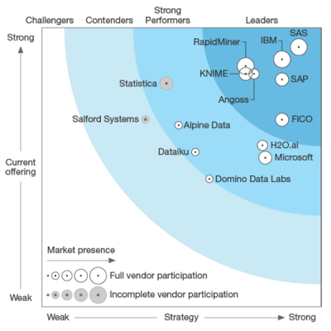
Picture 1. Top software companies-suppliers for predictive analytics
The company leadership in the area of platform developers with in-depth analytics is also confirmed by the assessment of the independent agency Gartner [11] (see picture 2).
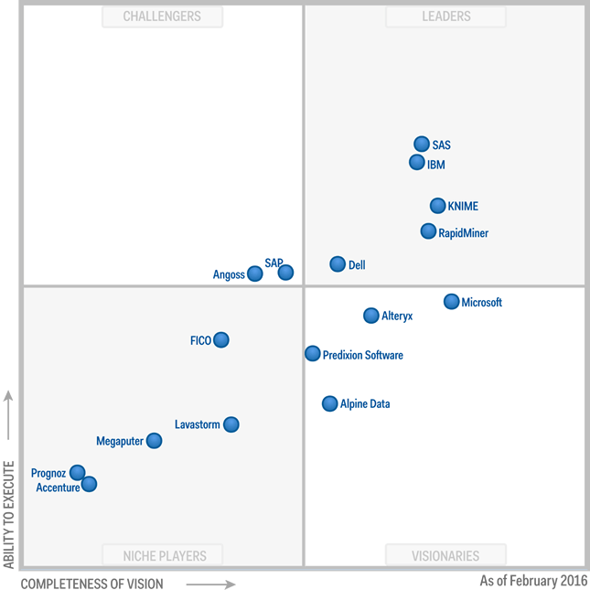
Picture 2. Top companies-developers of advanced analytics platforms
In its report [12] about success strategies, the agency conducted a comparison of various products of companies working in the sphere of information technologies and highlighted their strengths and weaknesses in comparison with each other. For a example SAS strengths are:
- Product reliability and stability. These qualities, along with synergistic capabilities establish SAS data integration technology as steadfast and mature;
- Broad and integrated portfolio. The breadth and completeness of SAS core functions and the integration of components position it well to complete with larger and more established vendors;
Through a variety of analytical tools used in a new generation of High-Performance SAS Analytics, computation of any indicators, modelling, analysis and decision-making process became much faster, more accurate and, as a result, more effective. More and more companies use SAS products for performing analytical procedures. In Russia all of the 10 largest banks are among SAS clients, many other real companies of finance sector and others, for example RZD, MTS, MGTS.
Picture 3 presents architecture of four analytical tools of SAS company which were submitted to the analytical center of the Government of the Russian Federation in January 27, 2017 [13].
Information from various sources is being uploaded into one of the following tools:
- SAS High-performance Analytics is used when you have a large amount of incoming data (more than 10 million objects, more than 1000 risk indicators and more than 100 Gb of analytical data);
- SAS LASR Analytics is used to interactively explore the data in real time and provides the possibility to multithread data processing;
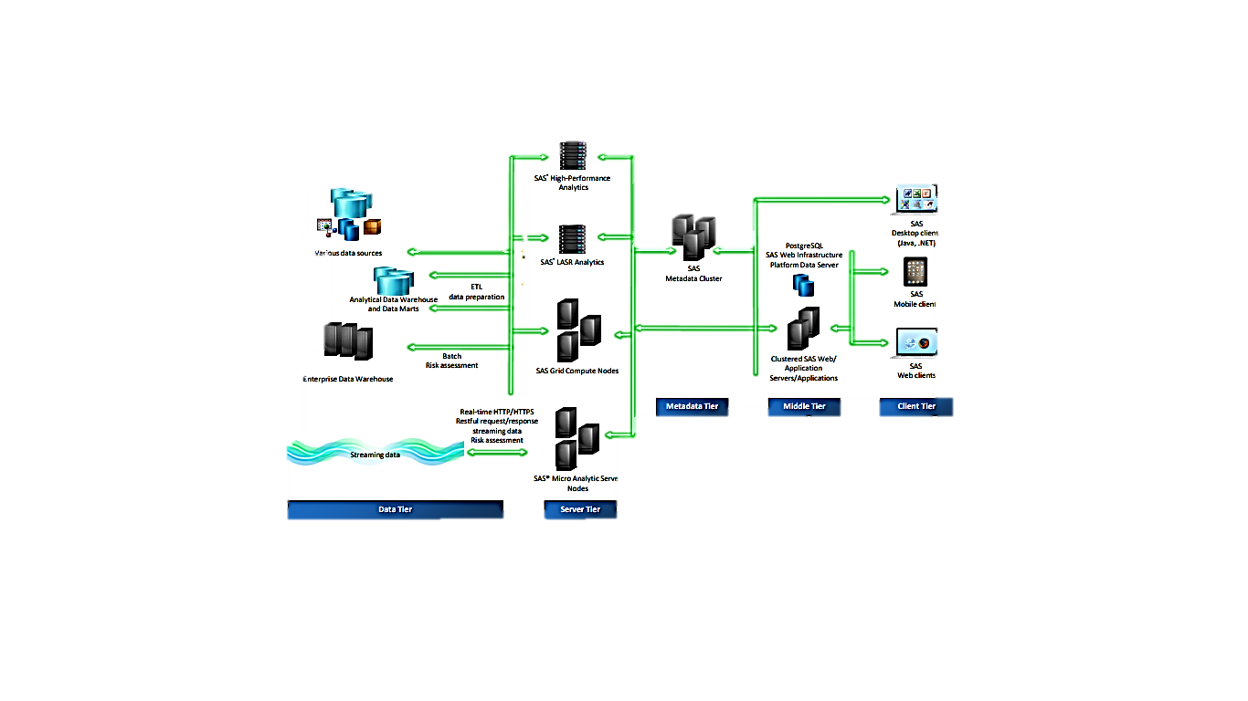
Picture 3. Architecture of information-analytical instruments of SAS company
- SAS Grid Compute Nodes are used to handle the large numbers of concurrent computing sessions, balancing the load among servers;
- SAS Micro Analytics Server Nodes are used to apply analytical models to handle streaming data with the frequency of requests more than 500 per second.
Thus one can see that the company has developed a number of products with similar sets of analytical tools, specialized for their specific business needs and conditions.
Cooperation between SAS and KPMG
In the report, prepared by the Agency of Forrester Research Inc. for the first Quarter of 2016, under the title “The Forrester Wave (tm): consulting services in the area of information security” [14], KPMG Global is recognized as a leader: it scored the maximum number of points for their existing offers and strategy. The company achieved such high result, mostly due to the improvements in cybersecurity services. Cybersecurity has been declared as one of the six global strategic growth initiatives of KPMG worldwide. For the successful achievement of ambitious goals in this direction, the company has expanded the range of services offered and invests considerable resources in research. Moreover KPMG invests funds into the companies working in this area [14].
Such high rating of the company activity in the field of risk management was achieved as a result of all the innovations that took place in the company in 2015, and that became the basis for further changes in company policy [6]. In 2015 some new laws issued by the Central Bank of Russia (CBR) were published, related to the banking institutions and other companies of the financial sector. Particularly, the order of calculating the credit risk on the basis of the internal ratings was changed [15], there some new requirements for risk management and capital of credit institutions and banking groups appeared [16]. Previously the regulations on the procedure for calculating the short-term liquidity were issued ("Basel III") [17].
KPMG actively cooperates and works with companies of the financial sector and all new regulatory standards set for the company authority the important task, that is to develop and implement data quality management processes at banks, because in the absence of the confidence in the quality of the data it is impossible to build a model with high prediction capability.
For solving this task KPMG attracted SAS to the cooperation and together they have developed a solution for data quality management system, which is a key element in corporate data management system.
As a result there have been identified and rectified systemic problems, developed and introduced a new quality control system, data and business rules have been developed for additional controls. All embedded controls meet both regulatory requirements and internal customers needs, moreover, a continuous process of data quality management by the various levels of management was organized.
Development of the concept of system optimizing risk assessment procedures at the preliminary stage of the audit
Great experience in making deals with organizations from different sectors and industries enabled SAS to create a variety of platforms to solve all sorts of analytical tasks, and all of them have demonstrated their effectiveness and reliability on numerous occasions in the past two years. However, one of the downsides of SAS products is their narrow focus for a specific task, as it was stated in the guidance of Gartner [12]. Moreover, all platforms are designed with one common prerequisite – the existence of complete and comprehensive source of information. It can be the client base of banks with a detailed list of information about all transactions, information about the manufacturing process in industrial company, the results of audit over the last few years to identify trends, etc. But none of the available products has been developed for the analysis of risks in the face of failure, lack of information.
This problem is mainly faced by the audit firms when verification must be obtained from a new customer, or in the case of radical changes in the management structure of other clients. Risk assessment process is a very time-consuming and expensive so its considerable automation means and specialists are actively involved in the field of information technology.
For maximum efficiency in the use of such system, its flexibility and adaptability to various situations it is necessary to develop a new mechanism on the SAS platform because of these issues, as it has the largest set of analytical tools.
At the preliminary stage of the audit different procedures for assessing the risk of distortion of financial statements are carried out [18]. The amount and the number of audit procedures depend on the level of risk, so it is very important to undertake this assessment thoroughly and reliably. The distortion of accounting can be both premeditated, in this case, the fraud is detected; and unintentional, resulting from errors of the employee. If there is a high probability of distortion, it must be identified even at a preliminary stage and an appropriate action should take place. The mechanism which allows using SAS to perform this assessment and find the distortion is the following:
1. The auditor, using his professional judgment based on experience identifies potentially risky zones by analyzing the primary data and the information obtained from the open sources;
2. Then he downloads the information from client accounting systems (1C, SAP, etc.) in accordance with previously made selection;
3. In SAS program an algorithm shall be drawn up which contains a list of criteria, rules, and constraints, based on common rules, regulations or regulatory standards. For example, when assessing the risk in a company that operates in Russia as benchmarks the statements of CB [15-17] or the law about the AML/CFT combating the legalization of income obtained by criminal ways can be used [19]. Also the user can add other criteria deemed as necessary;
4. Using the analytical and statistical SAS tools based on established criteria, he analyses the uploaded data;
5. The results are analyzed by the auditor, and he can quickly assess the risk extent in a particular area and then design the further actions.
The advantage of such mechanism is its versatility. It is an open source system that allows you to make changes to all users and to use this algorithm for any situation quickly and inexpensively. Also it will reduce data processing time compared to conventional method and will decrease the possibility of errors in the processing of raw data.
Conclusion
Automation of the processes of risk assessment in the era of the digital economy is the key to success for any audit firm, as this will reduce labour and time costs and constantly improve its system for the detection of risks of any kind and the submission of reliable information as a result of its activities. SAS offers the best-of-a-kind solution that includes high-performance analytics and combination of methods of detection of irregularities, which help to monitor a larger number of risk factors, analyzing large data volumes – in minutes instead of hours in particular. But the company products do not allow you to fully realize the potential of analytical tools and do not meet all the requirements of risk assessment under conditions of limited information. Developed concept allows implementing a new tool on SAS platform that meets these requirements.
Acknowledgements
This work was supported by the Competitiveness Growth Program of the Federal Autonomous Educational Institution of Higher Education National Research Nuclear University MEPhI (Moscow Engineering Physics Institute).

References
[1] Federal law № 307-FZ, dated 30 December 2008, “About audit”;
[2] Order of the Ministry of Finance of the Russian Federation, dated 24 October 2016 № 192 n “About implementation of the international standards on auditing on territory of the Russian Federation” (registered in the Ministry of Justice of Russia in November 10, 2016 № 44299);
[3] Order of the Ministry of Finance of the Russian Federation, dated 09 November 2016, № 207 n “About implementation of the international standards on auditing on territory of the Russian Federation” (registered in the Ministry of Justice of Russia in November 17, 2016 № 44354);
[4] ISA 315 (REVISED), “Identifying and assessing the risks of material misstatement through understanding the entity and its environment”;
[5] Deloitte – 2017 Global corporate treasury survey URL: https://www2.deloitte.com/us/en/pages/risk/articles/global-corporate-treasury-survey-2017.html;
[6] KPMG – Cyber security: A failure of imagination by CEOs
URL: https://home.kpmg.com/xx/en/home/insights/2015/12/cyber-security-a-failure-of-imagination-by-ceos.html;
[7] PWC – Global Annual Review 2017
URL: https://www.pwc.com/gx/en/about/global-annual-review-2017.html;
[8] EY – Digital and business 2017
URL:http://www.ey.com/ru/ru/services/advisory/ey-digital-and-business-2017;
[9] ACCA – RESEARCH & INSIGHTS: GLOBAL ECONOMIC CONDITIONS SURVEY: Q4, 2016;
[10] The Forrester Wave™: Predictive Analytics and Machine Learning Solutions, Q1 2017
[11] Gartner, 2016 Gartner Magic Quadrant for BI and Analytics report;
[12] Gartner, eGuide: Expert Strategies and Successes, p. 15-16;
[13] Report of the Director of the Department of public sector solutions SAS in Russia and CIS “Risk management system. The best information and analysis tools for 2016”;
[14] The Forrester Wave (tm): consulting services in the area of information security. Martin Uitvort;
[15] Order of the Bank of Russia, dated 06 August 2015 № 483-P “About the procedure for calculating credit risk based on internal ratings” (with amendments and additions);
[16] Instruction of the Bank of Russia from 15.04.2015 N-3624 (ed. at 03.12.2015) “About the system requirements, risk management and capital of the credit institution and the Bank Group” (registered in the Ministry of Justice of Russia in May 26, 2015 N 37388);
[17] Order of the Bank of Russia, dated 30 May 2014 N 421-p “The regulations on the procedure for calculating short-term liquidity (“Basel III”)”;
[18] Suyts V.P., Leonov P.Y., Shadrin A.S. The analysis of big data and the accuracy of financial reports. – 2017 5th International Conference on Future Internet of Things and Cloud Workshops. – p.53-56;
[19] FEDERAL LAW NO. 115-FZ, DATED AUGUST 7, 2001 ON COUNTERING THE LEGALISATION OF ILLEGAL EARNINGS (MONEY LAUNDERING) AND THE FINANCING OF TERRORISM

