014
Social Enterprise Concept in Sustaining Fruit-Based- Processing Agro-Industry Development in Indonesia (Study Case: Fruits Up Social Business)

Koko Iwan Agus Kurniawan*, Dwi Purnomo, Anas Bunyamin Department of Agroindustrial Technology, Faculty of Agro-industrial Technology, Padjadjaran University, Jl. Raya Bandung-Sumedang 45363, Indonesia.
Email: koko11001@mail.unpad.ac.id

Abstract

This research discovers that the model of empowerment of Fruits Up SMEs highlights the empowerment of fruit farmers in Ciayumajakuning village as well as the housewives in Bandung. Done from February to June 2016, it obtains a unique business model description with the social business platform. In the mapped out business model, it is found a host of advantages such as
(1) community interdependency, (2) technology mastery, (3) capital rise, (4) significant increase of investment, (5) strengthened collaboration, and (6) the improvement of social impact capable of being replicated in other enterprises. The method used in this research is that of analytical- descriptive with the design thinking approach as well as of qualitative and quantitative with the AHP (Analytical Hierarchy Process) method. Based on the results, the development of the enterprise’s process is highly affected by (1) community with the point of 0.216 out of 1, being the most valuable variable for the existence of the enterprise. It is followed by (2) university (0.178), (3) supplying farmers (0.153), (4) business actors (0.128), (5) government (0.100), (6) distributor (0.092),
(7) technopreneurship laboratory (0.069), (8) banking (0.033), (9) NGO (0,031).

Keywords: Agro-industry, AHP, Business Model Canvas, SMEs, Social Business

INTRODUCTION
Fruits Up, an agro-industry-based IKM operating in an industry of puree (mashed) drink extracted from mangoes in Cirebon, Indramayu, Majalengka, and Kuningan, possesses a unique business model with the social business platform rooting on the empowerment that combines many upstream agricultural activities. These activities develop agricultural and plantation products to be processed with premium price in sale. Therefore, this enterprise is categorized as a social one, for its based management is developed with the collaboration of various stakeholders by integrating variety of resources and communities [2]. For the last 2 years, it has indeed undergone a significant progress, directing it to a continuous improvement on technology mastery, capital rise, knowledge share, independency, social impact improvement, a significant increase of investment,

strengthened collaboration, and the continuity of enterprise development as well as of ability to replicate the process in other similar enterprises.

FRUITS UP AS A SOCIAL ENTERPRISE PLATFORM ENTERPRISE
The development of Fruits Up is based on the Fruters Model (Figure 1) [3] that is, a model of chain of technopreneurship-based empowerment in which the technology of the research results is designed as products with high added values and is implemented as a locomotive for a wider collaborative empowerment.
It uses the collaboration model (Figure 2), similar to that used by Mrs. Popon [2], collaborating such various stakeholders as universities, business actors, technopreneurship laboratories, regional and central government, community, institution, and banking.

EXISTING BUSINESS MODEL
The canvas of the existing business model is based on the social business platform. The empowerment process departs from farmers and a group of female workers in
the upstream (village) to a group of female marketers in the downstream (city). Besides, a chain of benefits lurks within the farmers, government, universities, communities, and society that play a role to significantly foster the bond of collaboration and added values.

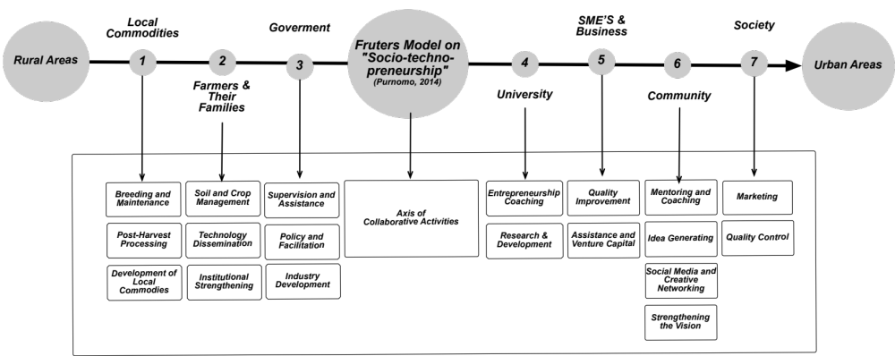
Figure 1. Fruters Model [3]

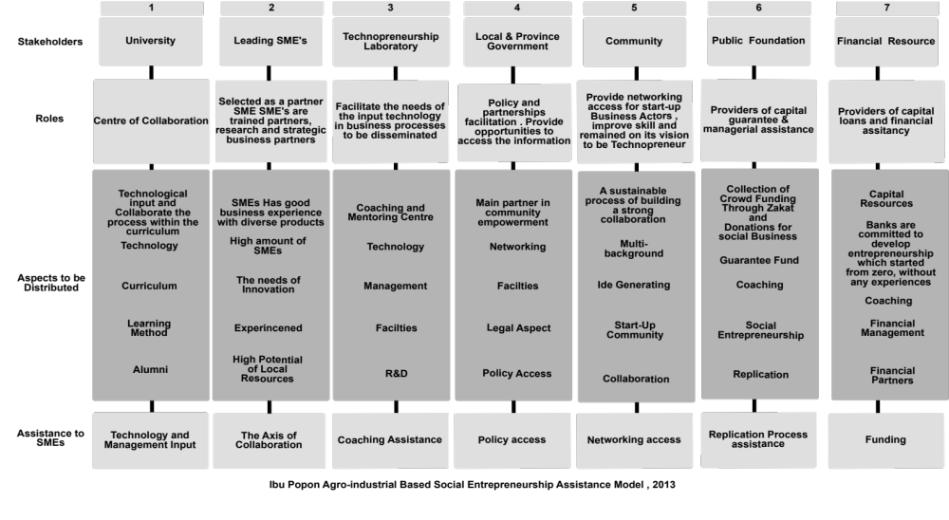

Figure 2. The Collaboration Model [2]

Figure 3. Fruits Up Business Model

MEASUREMENT OF SUCCESS ON THE USE OF FRUTERS MODEL AND COLLABORATION MODEL
The use of AHP [5] shows that the Fruters Model consists of value propositions, customer segments, channels, customer relationships, revenue streams, key resources, key activities, key partners, and cost structure [1], whose results are as follows (Figure 3):
The most influential value propositions in Fruits Up are (1) brand story (narrating the business process) with the score of 0.371 out of 1, being the most influential on the fulfillment of customers segments’ needs or requirements. This is followed by (2) innovative (0.168), (3) design (0.135), (4) benefit (0.099), (5) customization (0.082), (6) price (0.055), (7) accessibility (0.052), and (8) brand (0.039).
The main targets of customer segments of Fruits Up are (1) the segmented market with the score of 0.390 out of 1, in which Fruits Up customizes itself more with the customer segments’ needs who are mostly middle class society. This is followed by (2) niche markets (0.309), (3) mass market (0.152),
(4) diversification (0.089), and (5) multisided platform (0.069).
The most influential distribution channels in Fruits Up are (1) online sales with the score of 0.314 out of 1, highly affecting the communication, distribution, and sale channel as to afford the customers segments and give them value propositions. This is followed by (2) distributors (0.236), (3) retail sales (0.219), word of mouth (0.162), and transportation partner (0.069).
The most influential customer relationships in Fruits Up are (1) personal assistance with the score of 0.223 out of 1, based on the interaction between Fruits Up and its customers as well as the communication throughout the selling process and post-selling, creating a sense of loyalty within the customers. This is followed by (2) reward (0.209), (3) communities (0.201), (4) co-creation (0.161), (5) supermarkets (0.072), (6) special personal assistance (0.070), and (7) automatic service (0.064).
The most influential revenue streams in Fruits Up are (1) asset selling with the score of 0.213 out of 1, stemming from effective value propositions fairly acceptable and consumable by customers segments. These streams are later used to fund the cost structures

necessary to reduce the income as to produce more of it. This is followed by (2) subscription fee (0.167), (3) intangible benefit (0.106), (4) advertising (0.106), (5) leasing/renting (0.100), (6) saving (0.098), (7) paper (0.086), (8) training (0.061), (9) investors (0.042), and (10) license (0.021).
The most influential key resources in Fruits Up are (1) human resources with the score of 0.371 out of 1. Their investments are crucial for the progress and development of the business process. This is followed by (2) materials (0.219), (3) method (0.218), (4) machine (0.117), and (5) money (0.075).
The most influential key activities in Fruits Up are (1) production with the score of 0.318 out of 1; this is necessary to create and contribute value proposition, afford channels, and maintain relations with customers so that revenue streams are achieved. This is followed by (2) distribution (0.201), (3) networking (0.131), (4) marketing (0.117), (5) assistance (0.097), (6) training (0.073), and (7) replication (0.063).
The development of the enterprise is highly affected by (1) communities with the score of 0.216 out of 1, followed by (2) universities (0.178), (3) supplying farmers (0.153), (4) business actors (0.128), (5) government (0.100), (6) distributors (0.092), (7) technopreneurship laboratory
(0.069), (8) banking (0.033), and (9) NGO (0.031).
Lastly, the most influential cost structure in Fruits Up is (1) fixed cost with the score of 0.547 out of 1, affecting the whole structure and budgeting details necessary to operate the business, e.g., negotiating and offering values to the customer segments. This is followed by (2) variable cost (0.228), (3) economic scope (0.123), and (4) economic scale (0.102).
From the results of AHP above, it should be noted that the sustainability of Fruits Up as a social business should be seen from the collaboration among its stakeholders involving academicians, business actors, communities, government, farmers, banking, and NGOs. Each role of which should be able to significantly foster the bond of collaboration and added values. Furthermore, the most influential role in the business process of Fruits Up is communities, running hand in hand with the above measurements.

SUSTAINING FRUITS UP SOCIAL BUSINESS
The business sustainability of Fruits Up is a result of collaboration (Figure 4) among the stakeholders. As explained earlier, each stakeholder has its own role to create a chain of benefits throughout the entire process [4]:

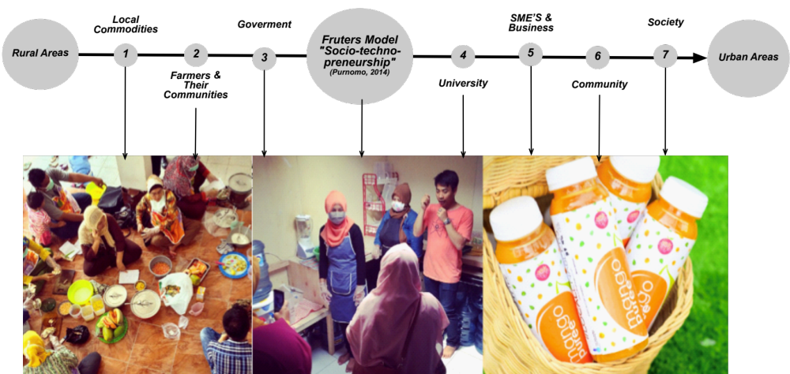

Figure 4. Collaboration Pattern among Stakeholders

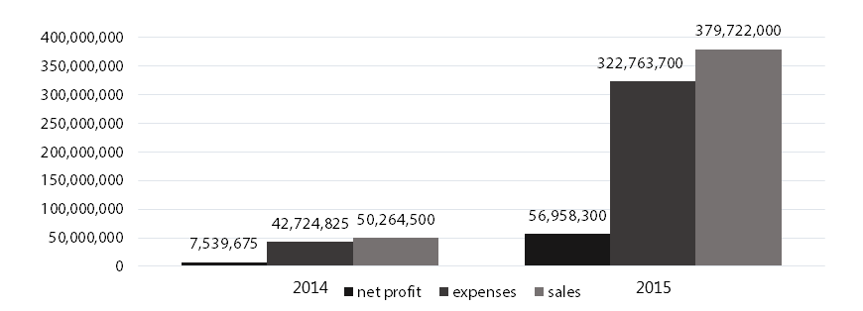
Figure 1. Increase of turnover of Fruits Up from 2014 to 2015

THE LEARNING ORGANIZATION
Fruits Up has a variety of well-growing characteristics such as: community- focused, mediator of societies and community transformation, showing a high level of empathy. These are suitable with the expected characteristics for those in the empowerment of entrepreneurship social areas. Not only that, the impacts are bigger on the benefit rise given to not only the society and local products but also actors along the chain of Fruters Model. In the last two years (Figure 5), Fruits Up has become a pioneer producing five research topics, spreading out the spirit of entrepreneurship among common people and making them the main actors of the collaboration axis from upstream to downstream areas. Moreover, it has also exemplified its learning organization and role model for academician partnership, business actors, community, and the government, positioning itself to be a platform for many researches to apply.

7. CONCLUSSIONS
This enterprise, in fact, replicates the collaboration model of Mrs. Popon [2], retaining a particular pattern as the model for learning and for improving entrepreneurial skill that enhances the level of independence and leads to the sustainability and the success of the enterprise. Moreover, this model proves that resources exchange with various key partners enables the acceleration of enterprise’s success, value
addition, and sustainability level, to work along the way.

8. ACKNOWLEDGEMENT
This research was conducted at the Department of Agro-industrial Technology Faculty of Agro-industrial Technology, Universitas Padjadjaran and Financed by West Java Board of Research, Development and Aplication of Science and Technology (BP3IPTEK).

9. REFERENCES
[1] Osterwalder, A., & Pigneur, Y. 2010. Business Model Generation, New Jersey: John Wiley & Son.
[2] Purnomo, Dwi, 2015. Unpad-Ibu Popon Collaboration; A Best Practise In Sustainable Assistance Model For Social Entrepreneurship In Agro- Industrial Based SME’s. Agriculture and Agricultural science procedia 3 (2015). 206-210
[3] Purnomo, Dwi, 2014. The Fruters Model; Model Pemberdayaan Berbasis Techno- preneurship. Anugerah Prakarsa Jawa Barat 2014.
[4] Purnomo, Dwi. 2011. Karakteristik, Penerapan, dan Pengembangan Agroindustri Hasil Pertanian di Indonesia. Universitas Padjadjaran. Bandung. 2-3
[5] Saaty, T.L.2011. The Analytical Hierarchy Process. Planning, Priority Setting, Resource Allocation. Mcgraw-Hill, New York.

