032
Reduce Loss during Transportation:
A Case Study of Fresh Vegetables in Thailand

Ananya Rattanawong, Pornthipa Ongkunaruk*
Department of Agro-Industrial Technology, Faculty of Agro-Industry, Kasetsart University
50 Ngam Wong Wan Rd. Lad Yao, Chatuchak, Bangkok 10900, Thailand
Email: pornthipa.o@ku.ac.th*

Abstract
The cold chain management is the temperature control process which is essential for maintain the quality of fresh produce from upstream to the consumer in the supply chain so that the loss is minimized. Our objectives are to monitor the temperature during transportation, analyses and identify the problem cause loss of fresh vegetables by using causal-loop diagram. We monitor the temperature during transportation of fresh vegetables from a farm in Northern Thailand to a packing house in the central Thailand around 750 kms. for 17 to 18 hours. The fresh vegetables are packed in a stereo foam box with the cool packs and pile up on the back of a truck. At the packing house, fresh vegetables are bruised and rotten and loss about 30-40 percent by weight. The temperature is monitored by the data loggers. The result showed that the temperature inside the box during transport is 20ºC-30ºC where the range of external temperature is 20ºC-40ºC. Then, we suggest how to reduce loss by using proper management such as suitable material to control the temperature during transportation, location of box in the truck and packing method.

Keywords: Cold Chain Management; Fresh Vegetable; Loss Reduction; Transportation

1. INTRODUCTION
In 2015, the domestic transportation volume in Thailand was estimated at 493,773 thousand tons, including air, rail, and road modes at 59, 11356, and 482,358 thousand tons, respectively [8]. Fresh vegetables are one of the products being transported by road. In Ethiopia, the assessment of post-harvest loss and deterioration of agricultural crops showed that the main loss occurred during harvesting, transportation and storage, approximately 15-45% [4]. Similarly, from our interview with the loss of vegetables in Thailand, the loss is about 20-50%. Since respiration and transpiration processes of fresh vegetables continue after harvest, and they occur until their reserved starch and water are exhausted so they will be deteriorated by time. The respiration converses starch to sugar, then change it to energy; hence, the temperature will be increased. In addition, the high temperature results in high respiration rate. Hence, vegetables tend to have huge loss in summer. The transpiration results in the loss of water which occurs after harvest. [4, 5].
The cold chain management is the temperature controlled process essential to maintain the quality of fresh vegetables from upstream to the downstream supply chain. There are two reasons for control the temperature. First, low temperature reduces the physiological activities, such as respiration which cause softening, pigment loss, ripening, or discoloration. Thus, it can prolong the shelf life of fresh vegetables. Second, low temperature decreases the growth rate of spoilage microbial and delays the microbial deterioration. For example, the rots of fresh vegetables are caused by Erwinia coratovora, which has an optimal growth at 30ºC. Maintaining low temperature can decrease its growth [6]. The proper temperature of fresh vegetables is at most 5ºC; however, it is difficult to control at these temperatures along the cold chain [3, 6]. Ubonluck and Ruchira [9] investigated the quality during storage fresh vegetables at 4ºC and 10ºC. They found that keeping fresh vegetables at 4ºC resulted in better quality than at 10ºC. The shelf life of fresh vegetables that kept at 4ºC and 10ºC were 27 days and 21 days, respectively.
A causal loop diagram is the model used to analyse and identify causes and effect in their systems. Sarriot et al. [7] used the causal loop diagram to identify the major causes of severe diseases malaria, such as pneumonia and diarrhea of integrated Community Case Management (iCCM) sustainability program. Then, they suggested the strategies according to the analysis from the diagram. In addition, there was an implementation of the causal loop diagram for pollution prevention in the dairy processing facility. The causal loop diagram identified the mechanism of the internal dairy processes and the impact from inefficient use of resources. Hence, the causal loop diagram can be used as the tool for enhancing the decision making about the pollution prevention throughout dairy processing and can be implemented in other industries. [1]
Our objective of this study is to analyse the current cold chain management of fresh vegetables based on temperature monitored and the loss amount of vegetables during transportation from a farm in Northern Thailand to a packing house in the central Thailand. Next, to identify the causes of vegetable loss based on our experimental data and interview using the causal loop diagram. Finally, we propose the suggestion to reduce loss by using proper management during transportation.

2. MATERIAL AND METHODS
First, we collect the related information of current cold chain management from the manager and staff. Next, we monitor the temperature during vegetables transportation from a farm in Northern Thailand to Central Thailand and calculate the loss occurred. Then, we select the new red fire lettuce due to high volume. The equipment for this experiment is the temperature data logger (Track-it TM Data Loggers: Rugged Temperature, Monarch Instrument and EL-USB-1-PRO, Lascar). The data logger is set to record every 1 minute with temperature range of -40 to +125ºC (-40 to +257ºF).
After harvest, the staff cut some leaf, measure the weight (W₁) and pack vegetables in a stereo foam box (63 cm x 63 cm x 54 cm) with the cool packs. In the foam box, the cool packs are placed on bottom of the box and they are covered by cloths to prevent the direct contact to vegetables. Then, vegetables are placed on the cloths and stacked almost full of a foam box. The data logger is attached on the internal lid of the foam box so that it can monitor the inside temperature of the boxes. Then, the boxes are stacked in the back of the 22 wheel loaders for paddy delivery covering with tarp. Then, temperature profile during transportation is recorded for further investigation. We perform four replications due to low volume of vegetables and limitations of time and equipment.
At the packing house, the spoiled fresh vegetables are removed, weighed (W₁) and calculate the loss as the following equation (1).

Loss (%) = (W₁ - W₂) × 100 /W₁ (1)
where W₁ and W₂ are the weight of vegetables (kgs) before and after transportation.

Next, we used the causal loop diagram to analyses and identify the causes of loss based on the temperature profile. Causal loop diagrams are the illustration that construct from the rational and dynamic system method. It can describe the qualitative characteristics of the system by analysing the relationships of cause and effect among variables and feedback structures. Causal loop diagrams consist of the establishment of feedback loop and time delays among variables. There are two forms of feedback loop, reinforcing loop and balancing loop. Reinforcing feedback loop rises the effect of study variable, but balancing feedback loop decreases the impact of study variable. Additionally, each arrow in the causal loop diagrams is label with a plus or minus sign. A plus sign implies the change in one variable causes the variation in another one variable in the same way, while a minus sign implies the change in a one variable causes the variation in another one variable in the opposite way. [1, 7]

3. RESULTS AND DISCUSSIONS
3.1 Measuring loss of fresh vegetables
At the packing house in the Central of Thailand, after cutting damage, the loss of vegetable is calculated. Table 1 shows the loss (%) of fresh vegetables and temperature inside and outside the box. The external temperatures (Text) are the average temperature of every province in the route obtained from Thai Meteorological Department. Then, the internal temperature (T_{int}) in the box is the temperature inside the box. Table 1 shows that the loss of fresh vegetable is 27%-42% and the difference between internal and external temperature is lower than 5ºC. The internal temperature is 22ºC-30ºC, which is the high temperature to maintain the freshness or delay the biochemical activities of fresh vegetable during transportation.

Replication | T_{ext} (ºC) | T_{int} (ºC) |  |  | T_{ext}-Min T_{int} (ºC) | Loss (%)
Replication | T_{ext} (ºC) | Min | Average | Max | T_{ext}-Min T_{int} (ºC) | Loss (%)
1 | 27.6 | 17.4 | 22.7 | 24.4 | 10.2 | 39%
2 | 27.3 | 20.3 | 26.2 | 27.9 | 7.0 | 27%
3 | 30.1 | 23.5 | 26.3 | 27.5 | 6.6 | 37%
4 | 31.5 | 25.7 | 29.7 | 31.6 | 5.8 | 42%
Table 1 the loss of fresh vegetable during transportation

3.2 Temperature profile during transportation
The data logger starts recording the temperature at 10 a.m. (day 1) when the staff finishes packing vegetables into a box and the truck reaches the destination at around 4 a.m. (day 2). Figure 1 represents the temperature profile and Figure 2 represents the cumulative temperature changing rate ($\sum_{i=1}^{n}{(T_{\text{i+1}}{\text{-T}}_{i})}$) during transportation. Initially, the temperature is increased for about eight hours, then it is slightly decreased or stable. Likewise, Figure 2 shows that the cumulative temperature changing rate in the box is increasing within 8-9 hours. After that the changing rate is negative, so the cumulative temperature changing rate is decreased. The maximum cumulative temperature changing rates of each box are 7.0ºC, 7.6ºC, 4.0ºC and 6.0ºC, respectively. It implied that initially, the internal temperature is still increased due to the energy from vegetables respiration since a cool pack gradually decreases the temperature from the bottom of the box. Until the respiration rate is reduced after eight hours and the cool pack releases the cool air from itself to the top of the box, then the temperature tends to be dropped afterwards. However, the current ratio of vegetables and cool pack could not reduce the temperature to below 10ºC which is the suitable temperature for vegetables.

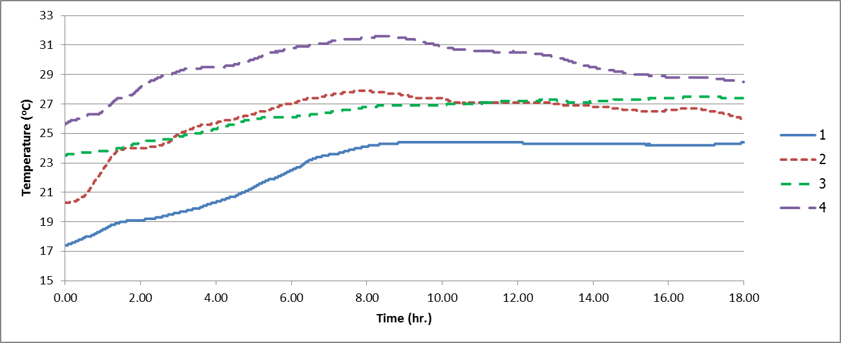
Figure 1. The temperature profile during transportation

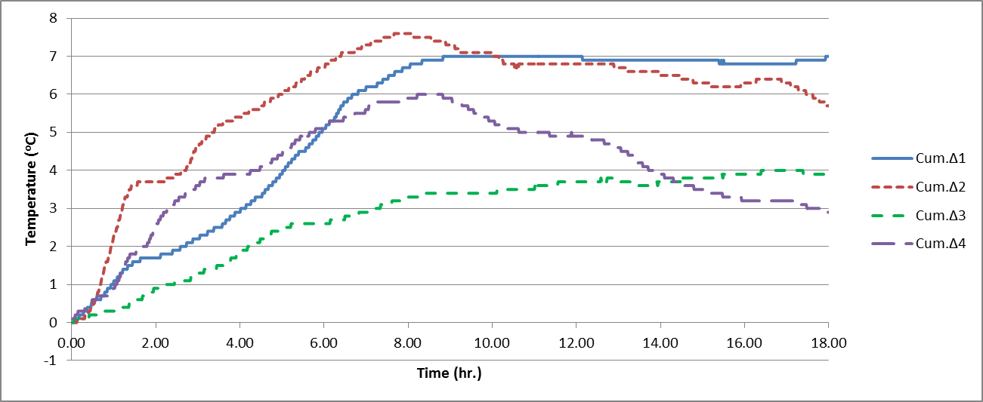
Figure 2. The cumulative temperature changing rate during transportation

3.3 The causal loop diagram
After gathering the current practice and the above results, we investigate the causes of fresh vegetable loss by creating the causal loop diagram. (Figure 3) There are three mains causes of the loss of vegetables. First, the good original quality of vegetables reduces the loss. The original quality of vegetables depends on the harvest and post-harvest methods. Next, if the proper harvest method is applied, the proper post-harvest method should be applied as well. Then, the training of labor could lead to proper harvest and post-harvest methods. Then, the loss of vegetables causes lower profit and service level. Second, high temperature causes high loss of vegetables. There are several causes of high temperature such as improper types of container, low ratio of temperature controlled material to vegetables, low air flow inside the container and the weather or season. More space in the container causes high air flow inside the container. Finally, the compression and impact causes the loss of vegetables. There are four main causes of these compression and impact such as location of container in the truck, loading method, types of vehicles and road condition. The upper location of truck, the few axle vehicle and poor road condition can increase the compression and impact while the proper loading method reduces the compression and impact. From the diagram, the proper management and handling are the key factors to control the temperature and reduce the compression and impact during transportation and can reduce the loss of vegetable.

Figure 3. A causal loop diagram for the loss of fresh vegetables cause identification

3.4 The Suggestion of the Cold Chain Management
Since the farm is a medium sized and the owner is not ready to invest in temperature controlled truck due to lack of economy of scale. Vegetables will be sold out within 7 days since harvesting. Thus, the temperature ranges of 4ºC-10ºC are suitable [9]. Hence, we suggested the proper instruction for the worker as follows. First, the container should be designed so that the air flow is reached to vegetables in the box. If cool packs are placed only on the bottom of the box, then the vegetables in the middle and top of the container will be blocked to the cold temperature exchange. Second, the quantities of cool pack and vegetables must be rational so that the temperature can be reduced to the optimal temperature. Next, the container must be cooled to below the optimal temperature before packing. For example, using the plastic board as a layer to keep vegetable inside the container can increase the air flow and reduce the compression and impact due to full packing. In addition, the worker should put delicate vegetable on the lower position in the back of the loaders to avoid the damage from the vibration of the truck [2].
4. CONCLUSION
In this study, the temperatures profile of fresh vegetables were not in the suitable ranges and the minimum temperature inside the container of vegetable is around 17.4ºC-25.7ºC. This temperature ranges related to at least 27% loss of fresh vegetable. Moreover, the high loss results from long transportation time and high compression and impact from the 22 wheel loader. To reduce loss during transportation, we suggest that the proper handling of vegetable must be applied so that there is high air flow inside the container. Especially, the proper cold chain management must be applied starting from training the worker for proper harvest and postharvest and using the proper type and quantity of temperature controlled materials which needs further experiment. In the future, if the volume of vegetables is increasing such that the investment of temperature controlled truck is feasible. Then, the company can reduce high loss. In summary, we hope that this study will benefit for a small and medium sized company who transports low volume of perishable products. Then, in the future, the experiment of proper type and quantity of temperature controlled material and the design of the proper container of vegetable for transportation should be performed.

5. ACKNOWLEDGEMENT

The authors would like to thank the owner of fresh vegetable farm in Northern Thailand who kindly provided the data for this research.
6. REFERENCES
[1] Aikenhead, G., K. Farahbakhsh, J. Halbe, J. Adamowski. 2015. Application of process mapping and causal loop diagramming to enhance engagement in pollution prevention in small to medium size enterprises: case study of a dairy processing facility. Journal of Cleaner Production, 102: Page 275-Page 284.
[2] Aliasgarian, S., H.R. Ghassemzadeh, M. Moghaddam, H. Ghaffari. 2013. Mechanical damage of strawberry during harvest and postharvest operations. World Applied Sciences Journal, 22: Page 969- Page 974.
[3] Hsiao, H.I., K.L. Huang. 2016. Time-temperature transparency in the cold chain. Food Control, 64: Page 181- Page 188.
[4] Kasso, M., A. Bekele. 2016. Post-harvest loss and quality deterioration of horticultural crops in Dire Dawa Region, Ethiopia. Journal of the Saudi Society of Agricultural Sciences.
[5] Miller, T. 2006. Fresh fruit and vegetables. Carefully to Carry.
[6] Rediers, H., M. Claesa, L. Peetersa, K. A. Willemsa. 2009. Evaluation of the cold chain of fresh-cut endive from farmer to plate. Postharvest Biology and Technology, 51: Page 257– Page 262.
[7] Sarriot, E., M. Morrow, A. Langston, J. Weiss, J. Landegger, L. Tsuma. 2015. A causal loop analysis of the sustainability of integrated community case management in Rwanda. Social Science & Medicine, 131: Page 147- Page 155.
[8] Thailand Transport Portal. 2015. Domestic Shipping.(http://www.news.mot.go.th/motc/portal/graph/np/index.asp). Accessed on August 25, 2016.
[9] Ubonluck, P., R. Taprapand. 2011. Effect of plastic type and packing method on hydroponic vegetables during storage. Agricultural Sci. J, 42: Page 627- Page 630.

