007
Production of Nata De Coco Using Soaked Soybean Water as the Alternative Usage of Zwavelzuur Ammoniak (ZA)

Yessica Gracia Maloringan, Darmawan Ari N*
Department of Agro-Industrial Technology, Faculty of Agricultural Technology, Gadjah Mada University, Jl. Flora No.1 Bulaksumur 55281, Indonesia.
Email: ari.nugroho@gmail.com*

Abstract

Nata de coco is a biomass composed of cellulose, gelatin shaped and white, in which the mass is derived from the fermentation of Acetobacter xylinum in coconut water. During the fermentation, Acetobacter xylinum needs nutrients such as carbon and nitrogen to grow, where the carbon source is obtained from sugar and nitrogen source is obtained from ZA. The recently emerged case regarding the use of ZA fertilizers has raised many polemics in the urban community because of its nature for plants, making it a non food grade products. Therefore the alternative is needed to replace the role of ZA in nata de coco making process. The existence of nitrogen in soaked soybean water from Tempe “Kweni”, an industry in Bantul, has been proven through laboratory results, in which there is a 0,05% content of nitrogen, which had qualified the subtitutes of ZA. Soybean soaked water is also acidic (pH 4-
5) so the addition of acetic acid in nata de coco production is unnecessary. The purpose of this study is to determine the formulation of helping materials as a replacement for ZA for making nata de coco, identify the characteristic of nata de coco without ZA from the sensory test results and determine the technical and financial feasibility of nata de coco without ZA production.

In this research, trial production of nata de coco without ZA will use 5 variations of waste water concentrations, which is 20%, 25%, 30%, 40% and 50%. Results showed that after 8 days of fermentation the best concentration is obtained from 30% soaked soybean water adding, with 1,2 – 1,3 cm nata thickness. According to sensory response (aroma, texture and flavor) nata de coco without ZA had a better result compared to nata de coco with ZA

Keywords: nata de coco, soybean, Zwavelzuur Ammonia

INTRODUCTION
Nata de coco is a dietary fiber that produced from coconut water through fermentation process which involved microorganism, hereinafter known as nata seed. The ability of coconut water to produce nata de coco is caused by rich and relatively complete nutritional content, as well as suitable for Acetobacter xylinum [1]. Nata seed is actually a group of bacteria named Acetobacter xylinum. Nata de coco making process is usually mixing boiled coconut water with sugar, ZA and acidic acid, and after the temperature decreased, it then mixed with Acetobacter xylinum and fermented for ± 7 days. After the fermentation process, nata de coco sheet is ready for further processing.
ZA or Zwavelzuur Ammoniac ((NH4)2SO4) is needed as nitrogen source for Acetobacter xylinum’s nutrition. However the use of ZA in food needed to be fully controlled, especially regarding the concentration of ZA that being added to the food. Furthermore, the used ZA must be food grade. The use of ZA fertilizers in nata de coco production has risen polemics in the urban community, where one of the risk is affecting human health. The impurities on its compound could be heavy metals such as lead, which if consumed by human can lead to fatal effect. Unfortunately, food grades ZAs are expensive. The price comparison can be seen in the table 1.1.

Table 1.1 ZA food grade price vs ZA fertilizer

Product | Price(per kg)
ZA food grade | Rp 290.000,00
ZA fertilizer | Rp 2.500,00

Moreover, the mindset of the nowadays urban community that tends to “back to nature” also prompted the search of alternative natural ingredient that can replace the role of ZA to produce nata more fit for consumption, leave no residue or toxic material from the fermentation process, without changing time nata fermentation’s time length.
Previous research has tried to replace ZA for nata de cassava production using sprout extract. The extracts are obtained from boiling 100 grams of sprouts in 200 cc water for 30 minutes [2]. However the use of sprout extracts will increase the cost of production, as well as producing more waste water from the process.
A high natural nitrogen source can be obtained from leguminoseae. Legume variety that is mostly found in Indonesia is soybean, in which soybean often consumed as tempeh. Tempeh industry in Indonesia is quite developed, in Yogyakarta there are approximately 500 tempeh makers. These large number of SMEs are followed by high industrial waste water that is being thrown away. Waste from tempeh industry still contain reducing sugar (1.4%), Nitrogen (7.6%), total solids (4.55 mg / l) and pH = 5 [3]. The waste water in tempe industry are usually thrown in the river without passing a treatment, making an air and water pollution to the surrounded environment, whereas after the boiling and soaking process, the soybean soaked water still contain dissolved material, one of which is nitrogen. This is due to the boiling process caused the release of the bond structure of the protein so that the protein component dissolved in water [5]. This waste when discharged into the environment without going through any treatment can pollute the environment, because nitrogen is difficult to be degraded by microorganisms [6], causing a buildup of waste which will result in the growth of bacteria disease that can disrupt the environmental balance.
The existence of nitrogen contained in soaked soybean water on both the immersion process has been proven through laboratory test results, i.e., there is the content of 0.05%, where it has qualified ZA substitute requirement, which must have a nitrogen content, and also acidic with a pH of 4-5, so the adding of acetic acid in nata production

is unnecessary. Quality and The highest amount of nata is produced on coconut water medium having pH 4.5 [4]. Besides soaked soybean water is also an outcast whose existence is not desirable in the industry, so that if taken, it would not affect the tempeh making process. The authors will conduct research related to the production of nata de coco without ZA ranging from adjuvant formulations and production processes.

MATERIAL AND METHOD
2.1 Materials
This study focused on substituting ZA in nata de coco making process with soaked soybean water from tempeh making industry. Soaked soybean water samples was taken from Tempeh Kweni Industry, Bantul, Yogyakarta. Coconut water obtained from traditional market around Yogyakarta.

2.2.Method
The process of making nata de coco without ZA begins with taking soaked soybean water samples tempeh industry, which will be used as a substitute for ZA. Samples are then analyzed for levels of nitrogen in the laboratory. After obtained the levels of nitrogen, the result was compared with the amount of ZA added to make a regular fermentation of nata de coco. Various concentrations of soaked soybean water are conducted and then tested in the laboratory in order to get the right amount of how much soaked soybean water needs to be added in order to form thick layer of nata de coco, approximately 1 cm thickness. Fermentation period are limited to the period of regular fermentation of nata using ZA by 7-8 days.
The next activity is the production of nata de coco without ZA. In general, the stage of making nata de coco without ZA equal to the stage of making nata de coco. The process begins with the material preparation. Next, the coconut water filtered from dirt, and the sugar and soaked soybean water are added to the coconut water. The mixture then get stirred and boiled, and after it is boiled then the mixture were poured into trays and then sealed with paper and rubber band. The tray then cooled for 24 hours, and the starter were added. After the starter was added, the tray are closed again and fermented for 8-10 days.
Based on laboratory test results, there is the content of nitrogen in the soaked soybean water from Tempe Kweni, Bantul

50 mg / 100 ml, or a total of 0.05%. With these results it is assumed that nitrogen requirements are equivalent to the addition of 6 grams/liter of ZA on nata de coco is as much as about 25% of soaked soybean water. Through these assumptions, a preliminary study on the characteristics of nata de coco without ZA was done, by using some variation of the concentration of soaked soybean water: coconut water, which is 20:80, 25:75, 30:70, 40:60 and 50:50. The addition of sugar is assuming needs as much as 6 grams of sugar per liter of coconut water. The best formulation for this experiment was concluded from statistical calculation using Tukey’s Test. This formulation later analyzed with sensory test.
The sensory evaluation conducted by preference/acceptance test, using 35 persons as a panels, whom all were categorized as untrained panels. In this test, the panels would have to give their personal preferences about the given-samples. Their preferences will be delivered in the form of scale inside the questionnaire, using the Likert scale 1 to 5, scale 1 representing extremely dislike and scale 5 representing extremely like.

3. RESULT AND DISCUSSION
Production of nata de coco without ZA conducted by 5 variations (sample A,B,C,D,E) and 1 control (ZA), and 6 repetitions on each variations, and 8 days of fermentation the results are as follows in Table 2.1.

Table 2.1. Evaluations of nata de coco without ZA production
Variations | Layer’s thickness (cm) |  |  |  |  |  | Avg
Variations | I | II | III | IV | V | VI | Avg
A (20%) | 0,72 | 0,74 | 0,74 | 0,73 | 0,81 | 0,82 | 0,76
B (25%) | 1,14 | 1,25 | 1,26 | 1,3 | 1,29 | 1,26 | 1,25
C (30%) | 1,3 | 1,27 | 1,33 | 1,22 | 1,27 | 1,3 | 1,28
D (40%) | 0,5 | 0,43 | 0,49 | 0,5 | 0,48 | 0,45 | 0,475
E (50%) | 0,34 | 0,36 | 0,4 | 0,42 | 0,41 | 0,39 | 0,39
ZA | 1 | 1,12 | 1 | 1,03 | 1,11 | 1,1 | 1,06

From the table above, statistical calculation is done using the Tukey’s test. From the test results it can be concluded that the best concentration for soaked soybean water are on variation B, which is 25% of soaked soybean water and variation C, which is 30% of soaked soybean water. The nata formation as seen on Figure 2.1.
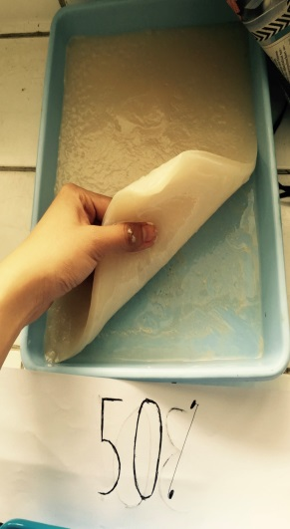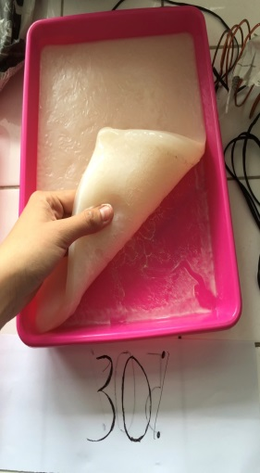
(a) (b)
Figure. 2.1. Nata de coco without ZA after the fermentation process,
(a) 30% of soaked soybean water,
(b) 25% of soaked soybean water
There are no soaking soybean water remain after 8 days of fermentation, which mean this fermentation has a potential benefit to reduce volumetric amount of waste derived from soaked soybean water in tempeh industry.
The next step is to see whether the public can receive nata de coco without ZA and to see if there are any difference of characteristics of nata de coco using ZA and without ZA using a sensory test. The nata characteristics mentioned on the questionnairewill be based on SNI 01-4317-1996, such as color, smell (aroma), texture and flavor. Samples for sensory test consisting of 3 samples A, B and C, where the sample A is nata de coco with the addition of ZA, the sample B is nata de coco fermented with 30% of soaked soybean water and sample C is nata de coco fermented with 25% of soaked soybean water.
The results of the sensory evaluation on those characteristics were described in mean and median data on Table 2.2.

Table 2.2. Sensory evaluation result
 | Characteristic | Concept
 | Characteristic | A |  | B |  | C
 | Characteristic | Mean | Median | Mean | Median | Mean | Median
1 | Color | 3,9 | 4 | 3,5 | 4 | 3,2 | 3
2 | Aroma | 3,4 | 3 | 3,5 | 3 | 3,2 | 3
3 | Texture | 3,3 | 3 | 3,5 | 4 | 2,9 | 3
4 | Flavor | 3,2 | 3 | 3,6 | 4 | 3,2 | 3

According to the table above, concept A (nata de coco using ZA) and concept B (nata de coco using soaked soybean water 30%) showed the highest preferences. These 2 samples then compared using non parametric test (using Mann-Whitney), because the data distribution was abnormal. Therefore, the Mann-Whitney method was used for comparing concept A and B only.
From the statistical data processing, it can be seen that there is a significant difference between the concept of A and B on the characteristics of color, and there is no significant different between the concept of A and B on the characteristics of aroma, texture and flavor. Data mean from sensory analysis as seen on Figure 2.2.
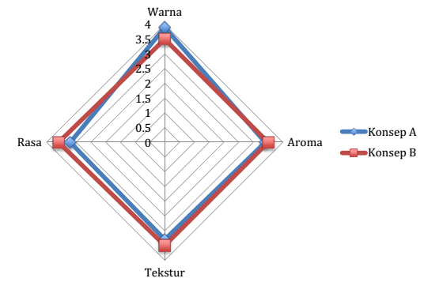
Figure 2.2. Comparison of the results of the sensory test for the data mean between concepts A and B
The results then calculated using Mann-Whitney methods. The results is nata de coco without ZA 30% coconut water is better from the other concepts whether in flavor, aroma, and texture.
4. CONCLUSION
The best formulation for nata de coco without ZA making process is by adding soaked soybean water in the concentration of 30%, sugar 6 grams/ litre mixture. The test results showed that nata de coco without ZA is able to meet the sensory criteria (better that nata de coco with ZA). The characteristics of nata de coco without ZA are as follows: after 8 days of fermentation has 1.2 to 1.3 layer thickness, pH 4-5 (acidic), according to sensory test results (aroma, texture and flavor) nata de coco without ZA had better response compared to nata de coco with ZA.
5. REFERENCE
[1] Alaban, C.A. 1962. Studies On The Optimum Conditions for Nata de Coco Bacterium or Nata Formation in Coconut Water. Philipinex Agricultrue. 45: 490-515.
[2] Naufalin, Rifda dan Condro Wibowo. 2003. Penambahan Sukrosa dan Ekstrak Kecambah pada Kualitas Nata de Cassava. Jurnal Pembangunan Pedesaan Vol III. No I. ISSN: 5611-9250.
[3] Nurhayati, Siti. 2006. Kajian Pengaruh Kadar Gula dan Lama Fermentasi terhadap Kualitas Nata de Soya. Dalam Jurmal Matematika, Sains dan Teknologi, Volume 7, Nomor 1, 40-47.
[4] Rizal, Hardi Mey, Dewi Masria Pandiangan dan Abdullah Saleh. 2013. Pengaruh Penambahan Gula, Asam Asetat dan Waktu Fermentasi terhadap Kualitas Nata de Corn. Dalam Jurnal Teknik Kimia No.1, Vol 19 hal. 34-39.
[5] Sundarsih dan Yuliana Kurniaty. 2009. Pengaruh Waktu dan Suhu Perendaman Kedelai pada Tingkat Kesempurnaan Ekstraksi Protein Kedelai dalam Proses Pembuatan Tahu. Makalah Penelitian Jurusan Teknik Kimia Fakultas Teknik Universitas Diponegoro year 2011
[6] Yuwanto, Adi Nurhayati dan Hermawan. 2011. Pengolahan dan Pemanfaatan Limbah Cair Industri Tempe. Jurnal Ilmiah Universitas Satya Negara Indonesia Vol.4 No.2 December 2011 Hal 42-50

