Sixth Engineering, Science and Technology Conference “Tendencies and Challenges in Engineering, Science and Technology” (ESTEC 2017) October 11 - 13, 2017 Panama City, Panama.

Sensor Networks for Monitoring Metro-de-Medellín System Infrastructure

Gustavo Meneses
Universidad de San Buenaventura, Medellín, Antioquia, Colombia, gustavo.meneses@usbmed.edu.co

Abstract
Structural health monitoring systems rely on electronic instrumentation and telemetry for improving maintenance tasks, preventing catastrophic failures and following the behavior of critical variables for infrastructure works such as tunnels, highways, bridges and buildings. A proposal for the development of sensor networks for monitoring Metro-de-Medellín system infrastructure is presented. The adopted approach is based on the deployment of generic sensing units that can operate either individually or by constituting wireless personal area networks un-der the MiWi P2P protocol from Microchip. Different transceivers can be added to monitoring units that can act as gateways in order to allow collected data reach other networks, ranging from local area to metropolitan area coverage. Several sensors, digital and analog, can be attached to the generic units depending on the particular requirements of specific situations and monitoring locations. The results obtained from performed tests and the options considered for graphical user interfaces are also presented.
Keywords: MiWi Protocol, Structural Health Monitoring, Short Data Service, Terrestrial Trunked Radio, Wireless Sensor Networks.
- Introduction
Structural Health Monitoring (SHM) systems provide useful data collected from sensors deployed in infrastructure works such as tunnels, bridges, buildings and high-ways. In Colombia few experiences are found regarding structural health monitoring, but some events and accidents occurred during the last years, such as building and bridge collapses, have shown the need for the implementation of solutions involving continuous-monitoring capabilities.
In January 2014 occurred an event that caused the Metro de Medellín stopped the operation of their trains in the southernmost section of their A line (El Tiempo, 2014). One of the walls which separate the railways from the Medellin River was damaged because of land-slide action and this resulted in the stoppage of train operation, five stations were closed in order to avoid potential risks for the passengers. About 80000 people was affected daily by the closing of these five stations of the metro system.
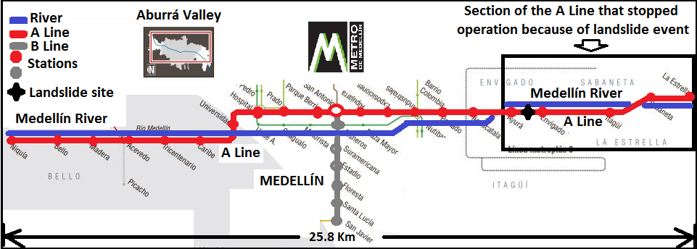

Figure 1: The A line of the Metro de Medellín and its southernmost section affected during a landslide event occurred in January of 2014.

- A Sensor Network Approach
Wireless sensor networks (WSN) have features that greatly favor the requirements of structural health monitoring systems. Continuous measurement derived from sensors deployed over tunnels, railways, bridges, and buildings, among other, can be achieved by means of wireless networks grouping sensor nodes (Fraser et al, 2010).

2.1 The MiWi Protocol and MiWi P2P
The MiWi protocol is proprietary (Microchip, 2010), among their main features we have their ease of implementation on 8,16 or 32 bit microcontrollers, their light footprint regarding to program memory usage and the topology and variants (MiWi P2P, MiWi pro). MiWi P2P is the most simplified version, it works in star and peer-to-peer topologies. MiWi P2P function in single hop networks, therefore the maximum distance for connecting nodes is determined by the range of transceivers. Similarly, to IEEE 802.15.4 Standard, we have in MiWi protocol Reduced Function Devices (RFD) and Full-Function Devices (FFD). The PAN Coordinator must be a FFD and, depending on the MiWi P2P topology, end devices can be either RFD or FFD. In star topology, the end devices only can establish communication with the PAN Coordinator and this can establish with all the network nodes. In Peer-to-Peer topology in MiWi P2P allows end devices to establish connection with other devices as shown in Figure 2
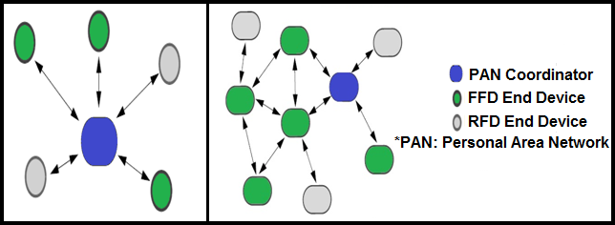

Figure 2: Network topologies in MiWi P2P protocol. Star topology (left) and P2P topology (right).
Basic configuration tasks when developing WSN applications under MiWi P2P proto-col include 2.4GHz channel allocation, device role (Coordinator or End Device), net-work address and PAN address. Microchip’s MiWi Application Programming Interface (MiApp) functions must be included into sensor node firmware in order to get better performance results from energy consumption point of view. Sleep mode must be enabled for both transceiver and microcontroller. Application developer can also use Microchip MiWi Media Access Controller (MiMAC) functions to access special features at a lower level.

- Related Work

3.1 Wireless Sensor Networks and Structural Health Monitoring
Since some years ago, wireless sensor networks have been adopted in the field of structural health monitoring (Caffrey et al, 2004). Thus, we can find in many countries around the world a great number of projects ranging from monitoring of heritage constructions to monitoring of transportation system infrastructure.
3.2 Sensors used for Monitoring Infrastructure in Transportation Systems
Variables commonly monitored in SHM applications for transportation systems include inclination, vibration, humidity, displacement, temperature, force, humidity and stress, among others (Hodge et al, 2015). The sensors used for monitoring these variables are accelerometers, linear potentiometric displacement transducers, fiber Bragg grating sensors, gyroscopes, inclinometers, strain gauges, ultrasonic sensors, phototube sensors, thermistors, and thermocouples. Among the techniques, technologies, and equipment used for SHM in transportation systems we find long range ultrasonic testing, soil water content monitoring, acoustic emission, image processing, cameras, geophones and, ground penetrating radars and time domain reflectometers.
3.2 Communications within the Scope of wireless sensors for SHM in Transportation Systems
Currently there are many protocols and communication standards which can be used for wireless sensor networks in SHM, therefore we can find in the literature reports of the use of IEEE 802.15.4-based protocols such as Zigbee, SmartRF and XMesh. Similarly, there are many alternatives adopted for extending the coverage range of these networks using gateway elements with communication capabilities within the range of local area networks (LAN), metropolitan area networks (MAN) and wide area networks (WAN) such as Global system for mobile (GSM) modems, WiFi (IEEE 802.11) modules and 900-MHz and 400-MHz band radios (Strazdins et al, 2013).
Development of a Prototype of Monitoring Unit
Along with the Metro de Medellín we have developed a proposal to integrate to their monitoring system a new set of data coming from a sensor network deployed over certain infrastructure points considered to be critical according to engineering analysis derived from site inspections and existent historical data registers. The methodology for the resulting research project involves the identification of monitoring requirements and site conditions, sensor selection, defining communication architecture, prototype and interface development, controlled condition tests, field validation tests and system integration.

4.1 Monitoring Requirements and Site Conditions
Metro staff suggested different points of the A line to install the first monitoring units in order to conduct tests. Figure 3 shows a location which is near to the place where the landslide occurred and that exhibits similar conditions to it. The walls next to the Medellín River will be monitored to prevent failures derived from landslide or similar causes. Any displacement of these walls must be detected and automatically reported to selected personnel via short message service and e-mail. Maintenance works are conducted daily according to scheduling and planning, therefore the information provided by these monitoring units will serve to rapidly act for solving any problem that could affect the normal operation of the Metro system.
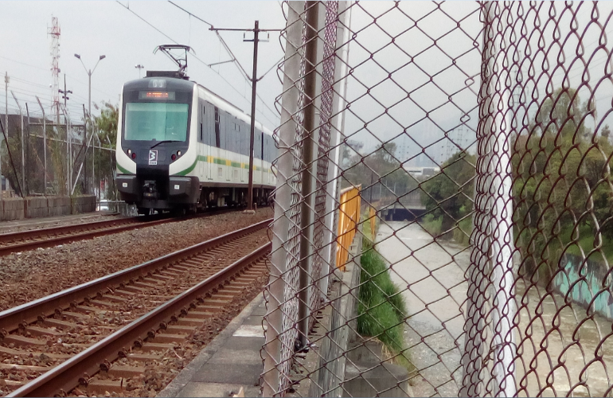

Figure 3: A line section (left) which runs parallel to the Medellín River (right) where are located the walls to be monitored by suggestion of Metro-de-Medellín staff

4.2 Sensor Selection
Inclinometers are sensors widely used in SHM applications, biaxial inclinometers (reference SCA121T-D07) were selected to be used in the tests to be conducted. After analyzing some criteria such as operating conditions, measurement range, sensitivity, cost, installation procedure and sensor resolution, we considered wall inclinometers properly suited to the monitoring needs of this project.

4.3 Communication Architecture
A three-layer architecture, based on the proposal of Dexternet (Kuryloski et al, 2009) for wireless sensor networks, has been adopted. Figure 4 shows some changes that are proposed in order to develop an application of continuous structural health monitoring.
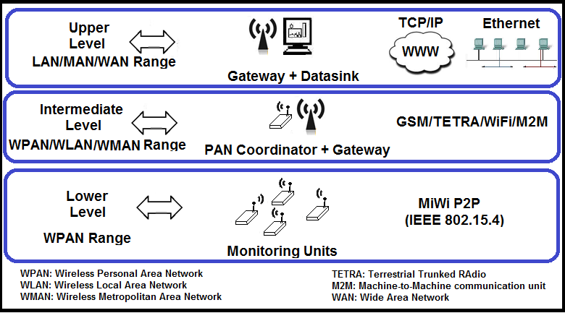

Figure 4: Three-level communication architecture proposed to cover communications for this structural health monitoring application.

This architecture has three levels defined according to the role that the devices in these levels plays related to the collected data. The lower level is based on a wireless sensor network which uses the MiWi P2P protocol to collect data from the field sensors deployed. The PAN coordinator belongs to the intermediate level, and it combines the management of sensor node communications with linking connection towards the datasink. At the intermediate level the PAN Coordinators could use gateways which transfer on-the-field collected data to the datasink by using other wireless protocols and communication standards and technologies such as WiFi (IEEE 802.11), M2M, GSM and TETRA (Terrestrial Trunked RAdio). At the upper level, traditional infrastructure networks can be reached by the connection performed by the computer-based datasink, the software running in this computer allows visualizing, storing, processing, analyzing, re-transmitting and publishing data.

4.4 Monitoring Units
The monitoring units for the proposed sensor network are based on Microchip’s PIC18F4620 microcontroller, as shown in Figure 5. The PIC18F4620 is an 8-bit microcontroller which can execute the code to perform MiWi communications and additionally perform data logging/acquisition tasks and perform serial communications with gateway modules when required. Star topology has been adopted, therefore the coordinator will initialize the network and the sensor nodes can only communicate with it. The coordinator collects the data sent from the sensor nodes, and it transmits this data to the computer-based datasink using a wireless gateway, Figure 5. Different transceiver options have been considered to function as gateways depending on the particular conditions of the places to be monitored.
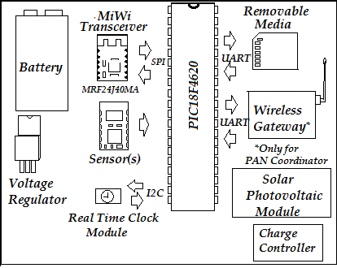

Figure 5: Elements constituting the personal area network coordinator.

For some monitoring points TETRA-complaint radios are to be used (Smolnikar et al, 2008). In this particular case, we will use MTP3200 portable radios which cost is about $1000 USD. The cost of these radios is high, but they have a very wide coverage and the operation of the whole Metro-de-Medellín is supported by TETRA radios which make easier integrating new structural health monitoring data to their existent monitoring system.
4.5 Code Development
MPLAB is an Integrated Development Environment from Microchip which provides a wide set of features that allow programmers to develop applications with microcontrollers, and other programmable devices from this manufacturer. In the MPLAB IDE projects are programed usually in C language, debugged, and compiled.
Several MPLAB projects were developed with monitoring units in single-operation mode and projects with monitoring units working in network-operation mode, involving at least a sensor node and the network coordinator. The code development for ensuring the proper functioning of the monitoring units was successfully achieved by customizing MiWi stack reference libraries and the files provided by Microchip. Complementary for-free available resources such as the C18 compiler from this manufacturer were also used for developing the code and compiling the firmware to be executed by the microcontroller governing the nodes.

- Prototype and Interface Development
5.1 Prototyping
A schematic connecting all the elements being part of the monitoring units was defined and from this connection diagram was created a printed circuit board (PCB). Energy harvesting by means of solar-photovoltaic modules are to be used to increase unit’s operating time without battery charging/ replacement. Mean solar radiation for Medellín city, according to national climatic and energy Agencies IDEAM and UPME ranges between 4,0 to 4,5 KWh/m2 daily (UPME-IDEAM, 2005). Weather, environmental and external agent (human beings or animals) influence was considered. Sun, rain, dust, moisture, vibration and similar factors could also affect node performance. Circuit component performance could become degraded because the influence of temperature changes, furthermore rain and similar weather conditions could affect communications. Sensor placement and enclosure selection were conceived considering extreme conditions and favoring maintainability issues and potential extern agent damage or operation interference.
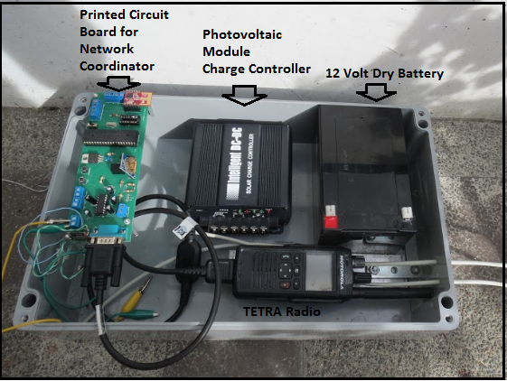

Figure 6: Prototype setup, enclosure and components.
5.1 Interface Development
In order to follow the behavior of the monitoring units and managing the data collected by the sensors a graphical user interface was developed with Labview, Figure 7. The data collected on the deployed monitoring units is provided serially by a gateway that is connected to a computer which acts as datasink and that can be located hundreds of meters or kilometers away from the monitored place.
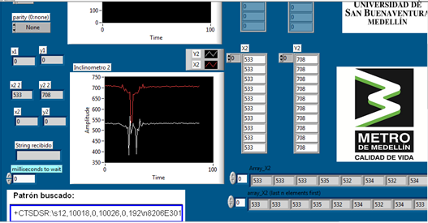

Figure 7: Graphical user interface developed in Labview showing the data provided by sensors.

- Performed Tests and Obtained Results
Range tests were conducted in order to establish the maximum distance reached by the MRF24J40MA transceiver, which was the choice made for communications at the lower layer of the proposed architecture. A maximum distance of about 100 meters was reached during a test in the field. Passing trains do not seem to have influence on packet reception during the performed tests.
Short data service (SDS) of TETRA platform has been used to transmit the collected data from the field to the computer based datasink which has another TETRA radio that serially transfer received data to the virtual instrument interface that performs the tasks needed by the monitoring system. The TETRA radio used as driven serially by means of special AT commands that allow automating data transferring and reception. The wide coverage of these radios has been verified for reception tests conducted in different places of the Valley of Aburrá with the transmitting and receiving radio separated for distances of several kilometers. The TETRA gateway has been tested for continuous operation conditions during about four months transmitting collected data to the computer-based datasink each 14 minute, this results in 96 messages daily and about 12000 messages transmitted during the test period.

- Conclusions

An approach is presented regarding the development of an application of structural health monitoring for the infrastructure of the Metro de Medellín. This approach is supported in the adoption of a three-level architecture, with a wireless sensor network at the lower level which is based on the IEEE 802.15.4-compliant MiWi P2P protocol. This protocol can be implemented on 8-bit, cheap and easily available microcontrol-lers without requiring paying royalty fees for network functioning.
After tests performed in field and outdoors conditions, the performance of end-devices and network coordinators as monitoring units has been first evaluated. In conducted tests the network coordinator, using a TETRA radio as gateway, have operate during months without battery charging. Further testing must be conducted with the monitoring units deployed over the field in order to validate their performance in this environment.
Data transmission and reception has been highly reliable, however some minor time periods where data was not available for reception despite of have being transmitted from the field gateway were found. The inactive communication periods were of a few hours during the four-month tests. Sporadically retards to deliver the data messages to the receiving TETRA radio also were found, these events were scarce during the conducted tests. As a percentage, we can state that field-datasink communication link availability surpassed 98% during the time the tests were performed. Less than 1% of the transmitted data messages transmitted to the datasink gateway were not delivered during this period.
References

El Tiempo - Redacción Medellín. Suspenden servicio de Metro de Medellín hacía el sur por deslizamiento. http://www.eltiempo.com/archivo/documento/CMS-13357159, 03/14/17.

Fraser M., Elgamal A., He X., and Conte J. (2010). "Sensor Network for Structural Health Monitoring of a Highway Bridge," Journal of Computing In Civil Engineering, Vol 11.
Microchip Technology inc (2010). Microchip MiWi™ Wireless Networking Protocol Stack (2010).

J. Caffrey, R. Govindan, E. Johnson, B. Krishnamachari, and S. Masri et al. (2004) "Networked sensing for structural health monitoring," Proceedings of the 4th International Workshop on Structural Control, pp. 1-10.
V. J. Hodge, S. O. Keefe, M. Weeks, and A. Moulds. (2015) "Wireless Sensor Networks for Condition Monitoring in the Railway Industry: A Survey," IEEE Transactions on Intelligent Transportation Systems, Vol. 16, No. 3, pp. 1088-1106.
Strazdins, G., Elsts, A., Nesenbergs, K., Selavo, L. (2013). Wireless Sensor Network Operating System Design Rules Based on Real-World Deployment Survey. Journal of Sensor and Actuator Networks, Vol. 2, No. 3, pp. 509-556.
P. Kuryloski, A. Giani, R. Giannantonio, K. Gilani, R. Gravina, V. Sepp, P. Yan, A. Y. Yang, J. Hyttinen, S. Sastry, S. Wicker, and R. Bajcsy. (2009). “DexterNet: An Open Plat-form for Heterogeneous Body Sensor Networks and Its Applications.” Proceedings of the Sixth International Workshop on Wearable and Implantable Body Sensor Networks. pp. 92-97.
M. Smolnikar, A. Hrovat, M. Mohori, I. Ozimek, T. Celcer, G. Kandus, and I. J. Stefan. (2008) "Telemetry and Telecontrol over Tetra Network," Informacije MIDEM, Vol. 38, pp. 61-68.
UPME-IDEAM. (2005). Atlas de radiación solar en Colombia, UPME, IDEAM., Bogotá, Colombia.

Authorization and Disclaimer
Authors authorize ESTEC to publish the paper in the conference proceedings. Neither ESTEC nor the editors are responsible either for the content or for the implications of what is expressed in the paper.

