Sixth Engineering, Science and Technology Conference “Tendencies and Challenges in Engineering, Science and Technology” (ESTEC 2017) October 11 - 13, 2017 Panama City, Panama.

Cooling Curve Analysis Method using a Simplified Energy Balance
C. González-Rivera
UNAM, Departamento de Ingeniería Metalúrgica, México City, México, carlosgr@unam.mx
A. Amaro-Villeda
UNAM, Departamento de Ingeniería Metalúrgica, México City, México, adrianvilleda@yahoo.com.mx
M. Ramírez-Argáez
UNAM, Departamento de Ingeniería Metalúrgica, México City, México, marco.ramirez@unam.mx
Abstract
In this work is described a new cooling curve analysis method focused on the experimental determination of the latent heat of phase changes and phase transformation kinetics.
The method analyses the cooling process of a metallic sample, initially liquid that is contained into a cylindrical metallic mold, both of known weight, thermally isolated at its top and bottom. The method is based on a simplified energy balance associated with the experimental measurement of the temperature change of the sample during its cooling process. The method was applied experimentally to zinc and tin of commercial purity, initially liquids and contained into stainless steel molds in order to determine its ability to determine the latent heat of solidification. In order to validate the method, the obtained values of latent heat were compared with the values reported in thermochemical databases. The obtained results suggest that this method can be used to characterize the solidification of metals.
.
Keywords: Solidification, Kinetics; Cooling curve analysis.
Resumen
En este trabajo se propone un método de análisis de curvas de enfriamiento enfocado en la determinación experimental del calor latente de cambios de fase y cinética de transformaciones de fase.
El método analiza el proceso de enfriamiento de una muestra metálica, inicialmente líquida que está contenida en un molde metálico cilíndrico, ambos de peso conocido, térmicamente aislados en su parte superior e inferior. El método se basa en un balance energético asociado con la medición experimental del cambio de temperatura de la muestra durante su proceso de enfriamiento. El método fue aplicado experimentalmente a muestras de plomo y de zinc de pureza comercial, inicialmente líquidos y contenidos en moldes de acero inoxidable con el fin de determinar su capacidad para determinar el calor latente de solidificación. Con el fin de validar el método, los valores obtenidos de calor latente fueron comparados con los valores reportados en tablas de datos termoquímicos. Los resultados obtenidos sugieren que este método puede utilizarse para caracterizar la solidificación de metales.
Palabras claves: Solidificación, Cinética, Análisis de curvas de enfriamiento.
- Introduction
Cooling curve analysis has played an important role in the control of the metallurgical quality of metallic products obtained through processes that in some of its stages involve the solidification of liquid metal and especially in the production of castings in gray and nodular irons, as well as in cast aluminum alloys (Stefanescu, 2015).
For that reason there has been interest in finding new ways of analyzing the cooling curves of metals and alloys during their solidification, giving rise to what are known as Computer Aided Cooling Curve Analysis (CA-CCA), historically represented by the Newton thermal analysis (NTA) (Barlow and Stefanescu, 1998, Cruz et al., 2006) and the Fourier thermal analysis (FTA) (Fras et al. 1993, Baez et al., 2004).
The NTA methodology has been described in detail elsewhere (Barlow and Stefanescu, 1998, Cruz et al., 2006). It analyzes a cooling curve that is obtained with a thermocouple located at the thermal centre of a cast. NTA calculations are performed on the first derivative of that curve. In the classical version of this method (Barlow and Stefanescu, 1998), the times of start and end of solidification are identified and the zero-baseline curve is obtained from an exponential interpolation between these points. Integration of the area between the first derivative of the cooling curve and the zero baseline curve gives relevant information of the solidification kinetics.
FTA method is based on the numerical processing of the readings of two thermocouples located at different radial positions into a cylindrical mold, which contains the melt under study, during its cooling and solidification. FTA uses the data acquired from the two thermocouples to obtain the thermal diffusivity of the sample and the zero baseline curve by an iterative procedure. The integration of the area between the first derivative of the cooling curve and the zero baseline curve gives relevant quantitative information on solidification kinetics.
In recent years, there have been a new generation of methods enhancing and ameliorating the potential applications of CA-CCA elsewhere (Gibbs and Mendez, 2008, Xu et al., 2012, Erbas, 2015, Kamyabi and Mendez, 2015). A very relevant change occurred with the proposal of Gibbs and Mendez (Gibbs and Mendez, 2008) who, for the first time created a method of quantitative characterization of solidification that did not depend on a zero baseline curve but, was based on an energy conservation equation, opening a new avenue for the development of new CCA methods.
Accordingly the aim of this work is to explore an alternative cooling curve analysis method, based in simplified energy conservation equations, taking into account the thermal role of the sample and also of the metallic mold containing the sample of interest, on the cooling process of the integral system metal sample/mold in order to determine experimentally the latent heat of solidification of two different metals of commercial purity
- description of the method
The method analyses the cooling process of a metallic sample of known weight, initially liquid that is contained into a cylindrical metallic mold of known weight, thermally isolated at its top and bottom.
The method assumes that both metal and metallic mold starts their cooling process at the same time, and shows the same cooling rate. Accordingly this cooling process, when there is no change of phase, can be described by eq. (1):
(1)

In Eq. (1) m is the weigth, Cp is the heat capacity and dT/dt is the cooling rate, using the sub index M for the metal and mo for the mold, h is the global heat transfer coefficient, A is the area of thermal exchange, T_{M} is the temperature of the metal and T₀ is the room temperature. Eq. (1) shows that the system formed by the metallic sample and the mold change their enthalpies as a result of a heat flow transferred to their surroundings through the exchange area A during its cooling at a given cooling rate. The global heat transfer coefficient h takes into account all the thermal resistances present in the heat transfer process from the sample to its surroundings including eventually air gap between sample and mold, refractory paint inner and external layers, thermal resistance of the metallic mold wall and combined radiation and convection heat transfer from the outer wall of the mold to the surroundings. This global heat transfer can be estimated numerically from eq. (1) and experimental information on the metallic sample and mold during it cooling process when the sample is fully liquid or solid (i.e. without change of phase) according with Eq. (2):

(2)

Thus, using experimentally available data, that includes the cooling curve of the metal sample, the weights of the metal and the mold, the room temperature T₀, and the area of heat transfer exchange for the sample and selected values for the heat capacities of the metal and the mold, allows the generation of values for the global heat transfer coefficient of the system under study as a function of temperature through the numerical processing of the experimental cooling curve. The numerical fitting of these data gives an equation that describes how this parameter changes as a function of temperature.
In order to know which parts of the cooling curves will be used to obtain h, the time of start and end of solidification, tss and tes respectively are determined on the first derivative of the cooling curve using the conventional criteria used by NTA method [3]. In this way the cooling curve of the sample is divided in three sequential sections: Cooling of the liquid, solidification and cooling of the solid
During solidification of the sample, that is between tss and tes the energy balance is:

(3)

In a time step Δt, energy balance is:

(4)

Using a simple Euler integration Scheme, Eq. (4) can be written as:

(5)

The instantaneous latent heat released by the sample is given by:

(6)

Finally the latent heat of solidification can be obtained from ec. (7)

(7)

- experimental
In order to establish the capacity of the proposed method to determine the enthalpy of phase change during the solidification of metals and alloys, two pure metals were chosen among the metals that have been extensively studied in the past and their thermophysical properties are reported in the sources of thermodynamic data. Zinc and Tin were chosen as the metals under study due to their low melting point. Triplicate determinations on each metal were performed in order to explore also the reproducibility of the method

Table 1. Thermophysical data taken as a reference (ΔH_{F}) and used during calculations (Cp_{L} and Cp_{S}) reported in sources of thermodynamic data, sub index L and S indicate solid and liquid metal respectively
Metal | Tf(ºC) | ΔH_{F} Enthalpy of solidification (J/Kg) | Cp, Heat Capacity (J/KgºC)
Zn_{S} | 419.5 | 111426 +/-1920 |  | 342.5+0.154x(T+273)
Zn_{L} |  |  |  | 480.2
Sn_{S} | 232.3 | 59605 +/- 1060 |  | 181.954+0.153 x(T+273)
Sn_{L} |  |  |  | 292.325-0.078 x(T+273)

Preweighted amounts of metal of commercial purity were put into a SiC crucible and placed in an electric furnace in order to obtain a liquid metal bath. The cylindrical metallic, stainless steel 316 molds (0.03m inner diameter, 0.05m in height, and 0.0015 m in thickness, covered with boron nitride) were heated in another furnace. Each preheated metallic mold was filled with liquid metal. Next, it was placed on a thermal analysis test stand, then it was thermally isolated at the top and bottom. In this stand, and in order to record the thermal history of the metal during cooling, one 0.0003 m diameter bore, type K thermocouple with alumina two bore insulator, 0.0015 m OD, was introduced at the mid-height of the mold cavity at the center of the probe . The thermocouple output was converted from analog to digital by means of a data acquisition card, NI FieldPointcFP 1804, and recorded into a PC hard disk drive, for a numerical post-processing task. The experimental cooling curves were numerically processed using the method proposed in this work to determine the latent heat of solidification.
Table 1 shows the thermophysical data used during calculations, reported in (William and Totemeier, 2013 and Kubaschewki et al. 1987) and Table 2 shows the experimental weights of the metallic samples and molds.

Table 2. Experimental weights of the metallic samples and molds
Zinc | Sample 1 | Sample 2 | Sample 3
Metalweigth (gr) | 214.8 | 223.92 | 212.48
Moldweigth (gr) | 240.97 | 239.11 | 242.56
Tin | M1 | M 2 | M 3
Metalweigth (gr) | 203.3 | 209.3 | 205
Moldweigth (gr) | 243.1 | 241.3 | 234.6
- results and discussion
Figure 1 shows the cooling curves of the metals under study typically obtained during experimentation for zinc and Tin. In all cases the curves shows three cooling stages. A first stage of cooling of the liquid sample, where temperature continuously falls until the start of the second stage when solidification of the sample starts and the metal temperature is maintained at a nearly constant temperature as a result of the release of latent heat, and this trend continue until the end of solidification, when the release of latent heat stops and the metal temperature falls again continuously, during the third stage of cooling of the sample in the solid state.
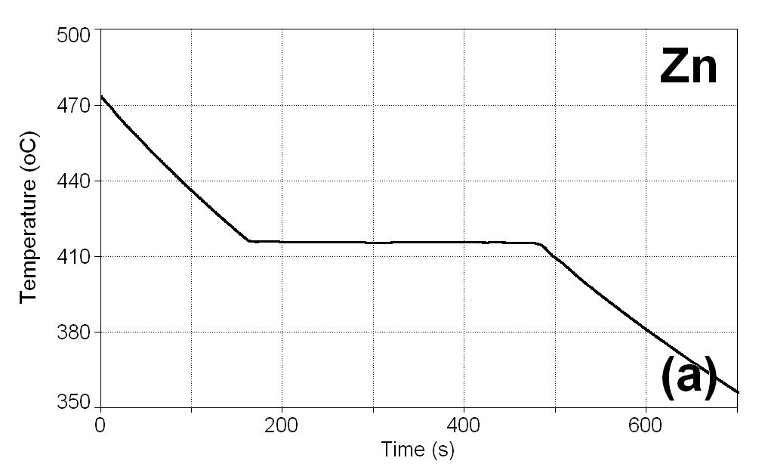 | 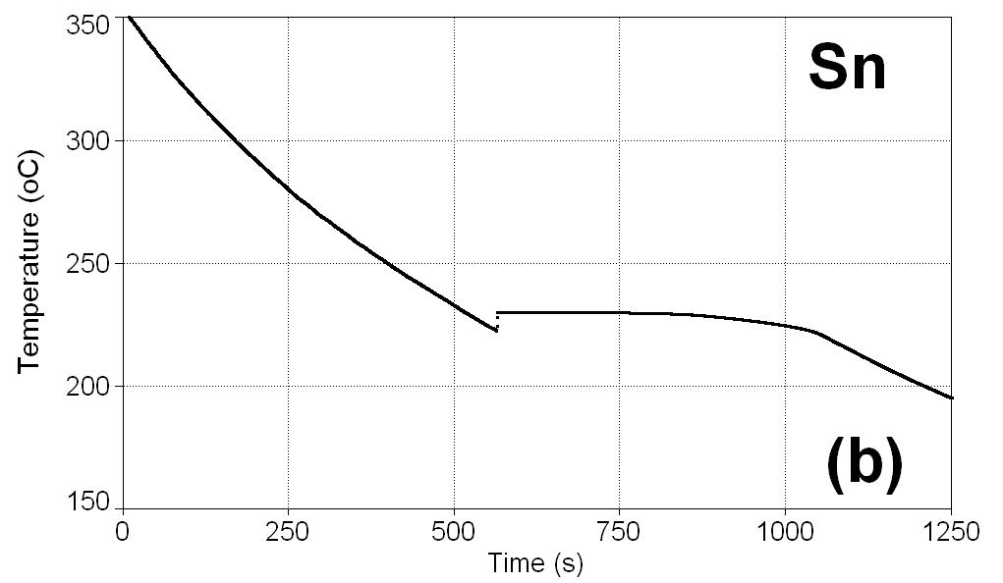
Figure. 1: Typical cooling curves of the samples during their cooling process: (a)Zinc and (b) Tin

The first derivative of the metal cooling curve was calculatedin order to identify the times of start, tss and end,tes of solidification, by applying the conventional criteria reported for the NTA [3].Figure 2 shows a graphical example of this determination in the case of one of the zinc samples. Subsequently, the heat transfer coefficient was calculated as a function of temperature using the thermal information of the metal cooling curves in the absence of phase change. Such calculations can be performed using a spreadsheet software like excel or can be done using one of the different programming languages available today, processing numerically the cooling curves of the sample during its cooling without change of phase, that is when the sample is fully liquid and fully solid, according with eq.(2) to obtain the heat transfer coefficient as a function of temperature.

Figure 3(a) shows the sections of the experimental cooling curves that were used to calculate the heat transfer coefficient based on Eq. (2) in the case of one of the zinc samples. Figure 3(b) shows the values generated for this coefficient as a function of temperature which were treated by numerical fitting to obtain an equation of h as a function temperature. Table 3 shows the result of the numerical fitting in terms of equations of h as a function of T, for the experimental runs.
Once the heat transfer coefficient as a function of temperature is known, the cooling curve of the metallic sample from the time of start to the time of end of solidification is numerically processed according with eq.(6) in order to determine, based on the temperature measurements of the sample during its solidification, the latent heat released in every time step and the total heat released during solidification of the sample of known mass, which allows to obtain the enthalpy of solidification. The heat capacity value used for the solidifying metal was the average value of the heat capacities of the liquid and the solid metal evaluated at the melting temperature

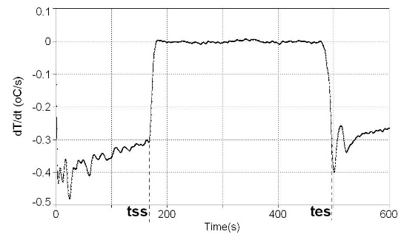
Figure 2: First derivative with respect to time of the cooling curve of zinc shown in Figure 1(a) and graphical determination of the times of starts tss and end tes of solidification.

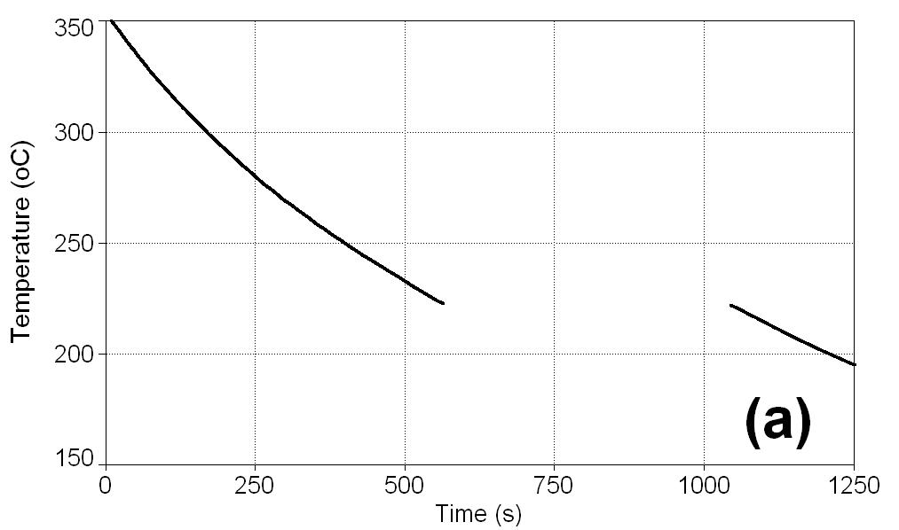 | 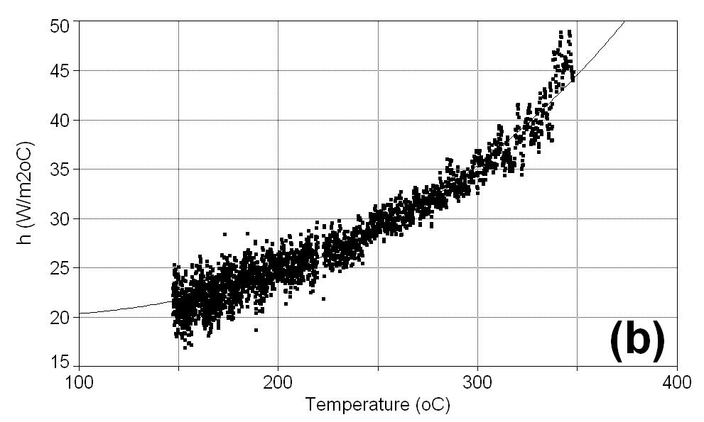
Figure 3: (a) Sections of the cooling curve show in Figure 1(b) used to calculate h using eq.(2); (b) Graphical values of the global heat transfer coefficient h , obtained as a function of temperature and numerical fitting line, corresponding to a cubic equation, see table 3.

Table3.-Expressions of the global heat transfer coefficient as a function of temperature obtained by numerical fitting for the six experimental runs
Metal |  | M1(W/m^{2o}C) | M2(W/m^{2o}C) | M 3 (W/m^{2o}C)
 | Zinc | h= 33.8+2.0e-7*T^3 | h=32.0+2.7e-7*T^3 | 25.8+2.1e-7*T^3
 | Tin | h= 19.5+6.0e-7*T^3 | h=18.6 +6.5e-7*T^3 | h=23.4+6.4e-7*T^3
M1:Sample 1;M2 : Sample 2; M3 : sample 3.
Figure 4 shows the instantaneous latent heat flow released as a function of time calculated for sample 3 of Sn. The integration of this flow during solidification provides the value of the energy released during the phase change, which divided by the weight of the sample provides the measured value of the latent heat of solidification per unit weight. The results obtained for the six experimental samples are shown in Table 4. It can be seen that the values of enthalpy of solidification obtained from this method are very close to the values reported in the sources of thermochemical data.

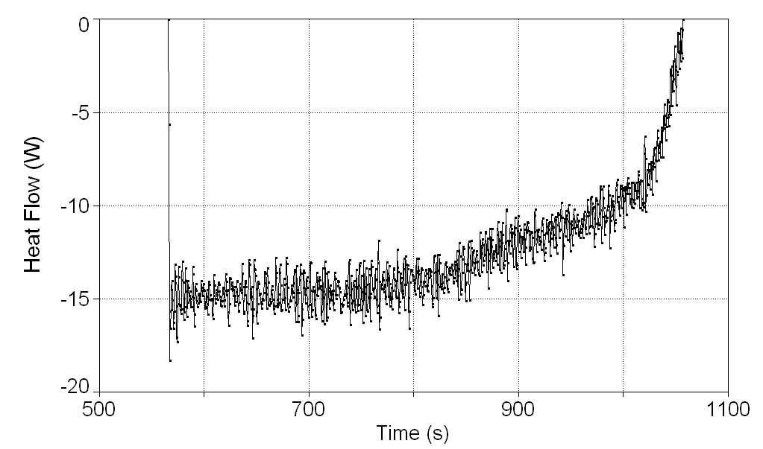
FIGURE 4.- Instantaneous latent heat flow released as a function of time during solidification for the three zinc samples

Table 4. Comparison between the calculated and reported values for the enthalpy of solidification for the three experimental samples of Zinc and Tin
Zinc: ΔH_{F} Ref[10)= 111426 +/-1920 J/Kg |  |  | Tin : ΔH_{F} Ref[10)= 59605 +/- 1060
 | ΔH_{F} (J/Kg) | % error |  | ΔH_{F} (J/Kg) | % error
M1 | 119413 | 7.2 | M1 | 58767 | 1.4
M2 | 122207 | 9.7 | M2 | 66931 | 12.3
M3 | 118854 | 3.2 | M3 | 63666 | 6.8
Average | 118854 | 6.7 | Average | 63121 | 5.9
Zinc: Calculated ΔH_{F}=118854 +/-4150 J/Kg |  |  | Tin : Calculated ΔH_{F}= 63121 +/- 4110 J/Kg
M1:Sample 1;M2 : Sample 2; M3 : sample 3

In the final row of Table 4, it can be seen the dispersion of the latent heat value calculated by this method for the enthalpy of solidification of zinc and tin. These values when compared to the values and their dispersions reported in the sources of thermodynamic data, values shown in the first row of Table 4 are very close.
Barlow and Stefanescu, (Barlow and Stefanescu, 1998), report errors in latent heat predictions using the NTA, FTA and other alternative methods for an Al-6.55%Si alloy, ranging from 50% to 8%, the latter obtained by FTA. More recently Erbas (Erbas, 2015) reports errors in the determination of latent heat of solidification of Sn, Zn and Al for conventional methods of the order, in average of 25% of error, although errors greater than 50% are eventually reached.
This result suggests that, despite its simplicity, the method proposed in this work provides a good approximation for the determination of latent heat of solidification. This aspect is currently being verified by experimentation with other metals and alloys of commercial purity as the subject of ongoing research.
- conclusions
A new cooling curve analysis method, based in simplified energy conservation equations and taking into account the presence of the metallic mold containing the sample of interest, on the cooling process of the integral system metal sample/mold was tested experimentally in order to determine its ability to measure the latent heat of solidification of zinc and tin of commercial purity.
The results generated by this method for the latent heats of solidification of zinc and tin are close to those reported in the sources of thermodynamic data and shows relative percentage errors lower than the errors commonly found using conventional cooling curve analysis methods. Accordingly the obtained results suggests that this method could be used to characterize the solidification of metals and alloys.
- ACKNOWLEDGMENTS
The authors acknowledge DGAPA UNAM for financial support (Project IN116817) and to C. Aguilar, A. Harrup, F. Tena and A. Ruiz for their valuable work by performing the experiments.

REFERENCES

Baez J, Gonzalez C., Chavez M.R., Castro M., Juarez J. (2004) Fourier thermal analysis of the solidification kinetics in A356/SiCp cast composites, Journal of materials processing technology . Vol. 153–154, pp 531–536.
Barlow, J. O., and D. M. Stefanescu. (1998): "Computer-aided cooling curve analysis revisited." Transactions of the American Foundrymen's Society , Vol. 106, pp 349-354.
Cruz, H., et al. (2006): "Quantification of the microconstituents formed during solidification by the Newton thermal analysis method." Journal of materials processing technology Vol. 178 pp. 128-134.
Erbaş, Kadir Can. (2016): "Analytically Solved Solid Fraction Model for the Newtonian Thermal Analysis of Casting." Metallurgical and MaterialsTransactions A Vol. 47 pp 3026-3030
Fras, E., et al. "A new concept in thermal analysis of castings." Transactions of the American Foundrymen's Society. Vol. 101 (1993): 505-511
Gale, William F., and Terry C. Totemeier, eds.( 2003.) Smithells Metals Reference Book. Butterworth-Heinemann,
Gibbs, John W., and Patricio F. Mendez. "Solid fraction measurement using equation-based cooling curve analysis." Scripta Materialia Vol. 58 pp 699-702.
Kamyabi-Gol, Ata, and Patricio F. Mendez. (2015): The Evolution of the Fraction of Individual Phases During a Simultaneous Multiphase Transformation from Time–Temperature Data. Metallurgical and Materials Transactions A Vol. 46 pp 622-638.
Kubaschewski, Oswald, A. L. Evans, and Charles Benjamin Alcock. (1987) Metallurgical thermochemistry. 5th edition, PergamonPress,
Stefanescu, D. M. (2015) "Thermal analysis theory and applications in metalcasting." International Journal of Metalcasting Vol. 9 , pp 7-22.
Xu, J. F., et al. (2012), Comparison of baseline method and DSC measurement for determining phase fractions. Materials Science and Technology Vol. 28 pp 1420-1425.

