*Sixth Engineering, Science and Technology Conference “Tendencies and Challenges in Engineering, Science and Technology” (ESTEC 2017) October 11 - 13, 2017 Panama City, Panama.*

##### Photoluminescence in Raman Scattering: Effects of HfO2 Template Layer on Ultrananocrystalline Diamond (UNCD) Films Grown on Stainless Steel Substrates

**Elida de Obaldia**

Universidad Tecnológica de Panamá, Panamá, [elida.deobaldia@utp.ac.pa](mailto:elida.deobaldia@utp.ac.pa)

University of Texas at Dallas, Richardson, TX 75080, USA

**Pablo Tirado**

Universidad de Sonora, Hermosillo, México, [pat160230@utdallas.edu](mailto:pat160230@utdallas.edu)

University of Texas at Dallas, Richardson, TX 75080, USA

**Jesús Alcantar**

Universidad de Sonora, Hermosillo, México, [jja130130@utdallas.edu](mailto:jja130130@utdallas.edu)

University of Texas at Dallas, Richardson, TX 75080, USA

**Jorge Montes**

Universidad de Sonora, Hermosillo, México, jorgea.montesg@correoa.uson.mx

**Orlando Auciello**

University of Texas at Dallas, Departments of Materials Science and Engineering and Bioengineering, Richardson, TX 75080, USA, oha120030@utdallas.edu

**Abstract**

The growth of polycrystalline diamond films can play an important role in industry if they can be grown on industrially used materials like aluminum (Al) or stainless steel (SS). A critical issue related to the growth of ultrananocrystalline diamond (UNCD) thin films on metals like SS, in a Hydrogen rich environment like the one present during growth of UNCD films, is the diffusion of Hydrogen (H) into the SS substrate, as it has been observed in prior research, which results in hydride formation in the SS that induce brittleness in the SS substrate. Several interface layers have been proposed described to avoid the H diffusion into the SS. However, HfO2 has not been explored. The work reported here was focused on investigating the growth of UNCD films on commercially available SS substrates by using an interface layer of HfO2, which was found to be a good diffusion barrier for H to inhibit penetration into the SS substrate. The samples where characterized with SEM and Raman spectroscopy. A photoluminescence (PL) effect, observed in the Raman scattering analysis, is present in all the samples. The PL effect may be due to the interaction of the UNCD / HfO2 interface. and the SS substrate rather than UNCD film alone. The novel result from the experiments described here, is the fact that it is possible to grow UNCD films on unseeded HfO2 layers on SS substrates.

**Keywords:** Poly-crystalline diamond, photoluminescence, UNCD, Stainless Steel, Hafnium Dioxide

**Resumen**

El crecimiento de las películas de diamante policristalino podrían desempeñar un papel importante en la industria si pudiera crecer en materiales de uso industrial como aluminio (Al) o acero inoxidable (SS). Los problemas específicos con el crecimiento de películas delgadas de diamante ultrananocristalino (UNCD) en un ambiente rico en hidrógeno, discutido previamente, se debe a la alta difusión de Hydrógeno (H) en el SS y la formación de hidruros que inducen fragilidad en el SS. Se han propuesto introducir diferentes capas sobre la superficie del SS, para evitar la difusión de H en SS. Sin embargo, HfO2 no ha sido explorado. Este trabajo se enfoca en investigar el crecimiento de láminas delgadas de UNCD sobre la superficie de sustratos comerciales de SS, creciendo una lámina ultradelgada de HfO2 que prueba ser una buena barrera pare evitar la difusión de H que inhibe la penetración en el substrato. Las muestras se caracterizaron por espectroscopia SEM y Raman. Un efecto de fotoluminiscencia (PL) fue observado en todas las muestras. La hipótesis que se propone es que el efecto PL se debe principalmente a la interacción entre la lámina de HfO2 y el sustrato SS en lugar de la lámina de UNCD. Un resultado sorprendente de los experimentos discutidos aquí, es el hecho de que es posible crecer láminas de UNCD sobre sustratos de HfO2/SS sin previa inserción de semillas de diamante nanocrystallino.

**Palabras claves:** Diamante nano-cristalino (UNCD), foto fluorescencia, acero inoxidable, lámina, dióxido de hafnio.

1. **Introduction**

Many of the electrical and mechanical properties of Diamond have been observed in synthetically grown diamond thin films of different grain sizes [1]. It has also been mentioned that the growth of these thin diamond films, could play an important role in industry if they can be grown on industrially used materials like aluminum (Al) or stainless steel (SS), in addition to other industrial materials. [2, 3]. Specific issues with the growth of ultrananocrystalline diamond (UNCD) thin films in a Hydrogen rich environment has been previously reported due to the high H diffusion into the SS and the formation of hydrides that make the SS brittle, in addition of formation carbide interfaces [4]. Interface layers of different materials have been proposed to be grown on the surface of SS to minimize or eliminate the H diffusion into the SS as listed in Ref [5], however HfO2 has not been explored. Our previous work has shown that HfO2 forms an excellent interface for the growth of UNCD on a HfO2/Si [6]. The work reported here was focused on investigating the growth of UNCD films on commercially available SS substrates by using an interface layer of HfO2 grown on the surface of the SS substrate, and preparing the surface of the HfO2 with two methods: 1) use of conventional wet seeding [1] with nanodiamond particles, via insertion of the substrate in a container with solution of nanodiamond particles in methanol, exposed to sound waves in a sonicator, to embed diamond nanoparticles on the surface of the SS substrate, as seeds to nucleate ad growth the UNCD films [1]; no seeding of the surface of the HfO2 layer. The seeded and no seeded HfO2 layers were subsequently exposed to a hot filament chemical vapor deposition process to grow the UNCD films. The films were analyzed using Raman spectroscopy and SEM. The observation of the photoluminescence, from Raman scattering analysis, exhibited by the UNCD films grown on the HfO2 layer is also discussed in this paper.

1. **Methodology**

The UNCD films analyzed in this study were grown in a hot filament chemical vapor deposition (HFCVD) system previously described in the literature [7, 8]. The films were grown using a HFCVD system from Blue Wave Semiconductors, which has a holder with capacity for growing films on substrates with up to 100-mm diameter. The substrate holder has the capability of rotation, to induce good film thickness uniformity, as well as a heater with feedback mechanism, and the capability for moving the holder up and down in the z-motion to adjust the distance between the filaments and the substrate, which is critical to produce high quality UNCD films. The capability for adjusting the distance between the filaments and the substrate holder is critical to control the substrate temperature due the contribution of heating from radiation from the filaments. The temperature measured by a thermocouple inserted on the surface of the fixed part of the metallic holder (used to measure temperature during film growth with rotating substrate part) was calibrated, in a dedicated experiment, against a thermocouple pasted on the surface of a Si wafer. For this experiment, the temperature read on the substrate holder thermocouple was kept at 360 °C, which corresponds to a temperature of 460 °C on the surface of the substrate. The basic principle of the HFCVD deposition is to use the hot filaments to dissociate the CH4 molecules, flown into the chamber, as they collide with the filaments’ hot surface [5, 6]. The CH4 molecules are cracked into CHx (x= 1, 2, 3) radicals and C ions and neutrals, which react on the surface of the substrate to grow the UNCD film of the desired material. In the case discussed here, for the UNCD films, the gas mixture, used to grow the films, include H2 (hydrogen), CH4 (methane) and Ar (Argon) with flow rates of of 5:1:45 sccm respectively. The insertion of H and Ar gases is to produce the conditions necessary to grow the films. More details can be found in Refs. [7] and [8]. For the experiments discussed here, the growth phase, with filaments heated to 2300 °C and the substrate heated to 460 °C , lasted 4 hours. The substrates used in this experiment were commercially available stainless steel (SS) medallions of 10 mm diameter. The experiment was designed to study the growth of UNCD films on SS substrates with a thin layer (~40-60 nm thick) of HfO2 grown on the surface. The HFO2 layer was grown using atomic layer deposition (ALD) (Cambridge NanoTech Savannah 100 Atomic Layer Deposition), involving flowing the Tetrakis dimethylamido hafnium (Hf(NMe2)4) growth precursor and H2O as the oxidant gas. Two types of substrates were prepared HfO2/SS exposed to wet “seeding” with diamond nanoparticles and HfO2/SS “without seeding”. A SS substrate without a HfO2 layer and seeded was also included in the study. The chemical bonds of C atoms in the UNCD films was analyzed using visible Raman spectroscopy, implemented in a Thermo Nicolet Raman spectrometer with 532 nm wavelength laser beam. The morphology of the surface of the UNCD films was characterized using a scanning electron microscopy (SEM, ZEISS SUPRA-40). Table 1 shows the parameters for each of the SS substrates used in this experiment. All the UNCD films were grown simultaneously under the same growth conditions.

**Table 1 - Preparation of Stainless Steel Substrate used in this work.**



1. **Analysis and Results**

Figure 1 shows three consecutive SEM pictures of sample SS20, which shows the grown film of UNCD at 3 different magnifications. Sample SS20 was not seeded prior to UNCD film deposition. Figure 1A shows that the surface of the SS medallion was packed with imperfections, mostly scratches. This was typical for all samples except SS25 [See Fig 2]. Figure 1B and Figure 1C show that there are patches of uniform growth. The tendency on scthe SS scratches is the growth of microstructures of polycrystalline diamond even if the sample were not previously seeded. Scratching the surface of Silicon wafers with diamond particles has been used as a technique for creating nucleation sites for diamond [9].

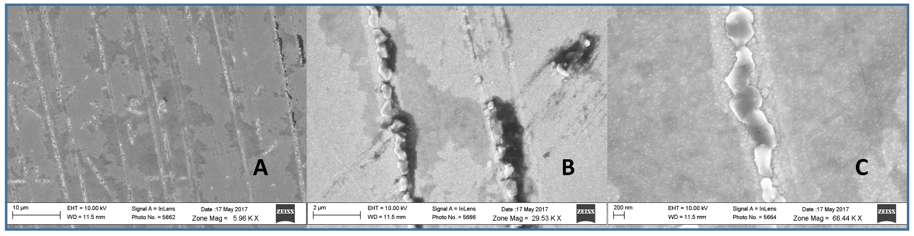

**Figure 1.** SEM micrographs of UNCD films grown on 60 nm HfO2 on SS no seeded (Sample SS20).

The surface is fully covered, and the rough imperfections of the surface of the substrate may create nucleation sites that can result in the growth of larger grains.

Figure 2 shows the SEM for sample SS25, which “did not have” a template layer of HfO2. The Raman spectrum for this film (not shown) shows mostly graphitic growth. The exact mechanism for the apparent etching was not investigated, however it is suggested that C ions diffuses through the layers faster than it can forms C-C bonds, leaving the H+ to diffuse and interact with the Fe, Cr and Ni in the bulk, forming hydrates compound that result in material degradation as observed in the image.

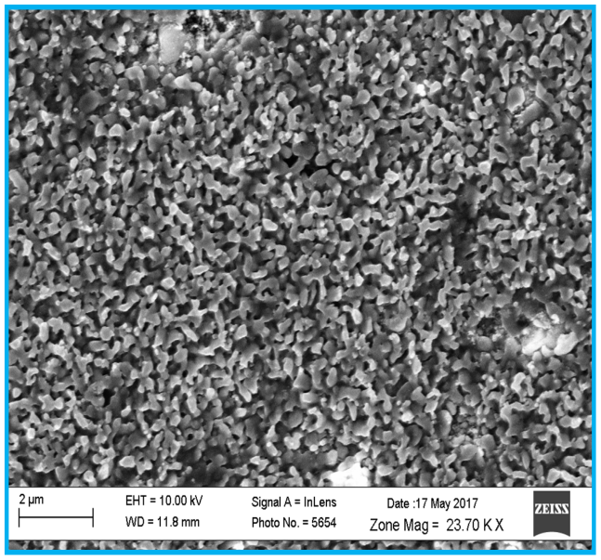

**Figure 2** - SS25 with no HfO2 protection layer on SS

The Raman spectrum of Carbon bonds compounds is well understood, see for example Steven et al,[10]. Raman analysis is fast and nondestructive. Figure 3A shows the Raman spectrum of the 4 samples that show Carbon based thin films. The main apparent feature in this data is the profile showing photoluminescence [PL] from Raman scattering for the different samples. PL in polycrystalline diamond thin films is associated with the presence of hydrogen [11] The PL, in UNCD,is due to the recombination of electron-hole pairs within the sp2 bonds localized in the grain boundaries that surround the grains with the characteristic sp3 bonds of diamond. [12]. Adamoupulus et *al*. also point out that the increase in PL with increase in H content on the films may be due to longer co-localization of the electron-hole pair in its own cluster, as well as the increase in recombination sites.

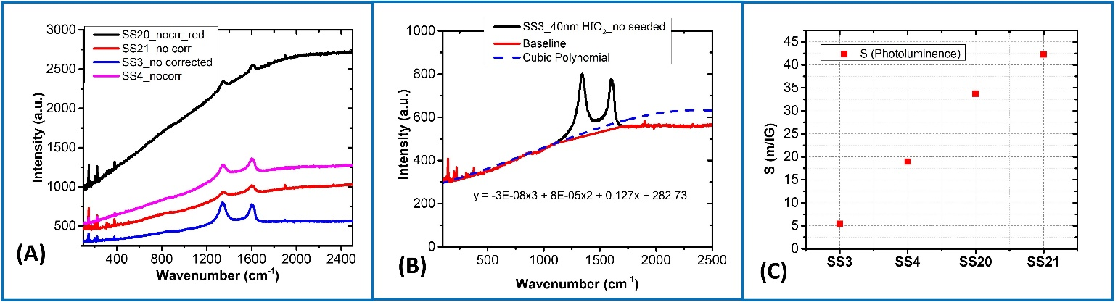

**Figure 3** – Raman analysis of UNCD films on HfO2 on SS, using with 532 nm laser wavelength. A) Raw data from the SS3, SS4, SS20 and SS21 UNCD films grown on HfO2on SS; B) PL background fitted to a 3er order polynomial; C) PL for the four samples in this study.

The Raman spectra, for the samples in this study, were taken without photoluminescence (PL) correction. The raw data is shown in Fig 3A. The baseline of the PL is best fitted to a third order polynomial as shown in Fig 3B. A figure of merit for the photoluminescence of carbon peaks was first proposed by Marchon et *al*. [13]. The figure of merit, S, is the ratio of the slope of the Raman spectrum PL background to the intensity of the G peak at 1560 cm-1. The resulting units are in microns [m]. Figure 3C shows the PL for the four samples in this study. Since all the films were grown with the same conditions, the PL effect due to temperature [14] can be discarded. Our data shows that a thicker layer of HfO2 results in higher PL. Furthermore, a seeded sample also results in higher PL.

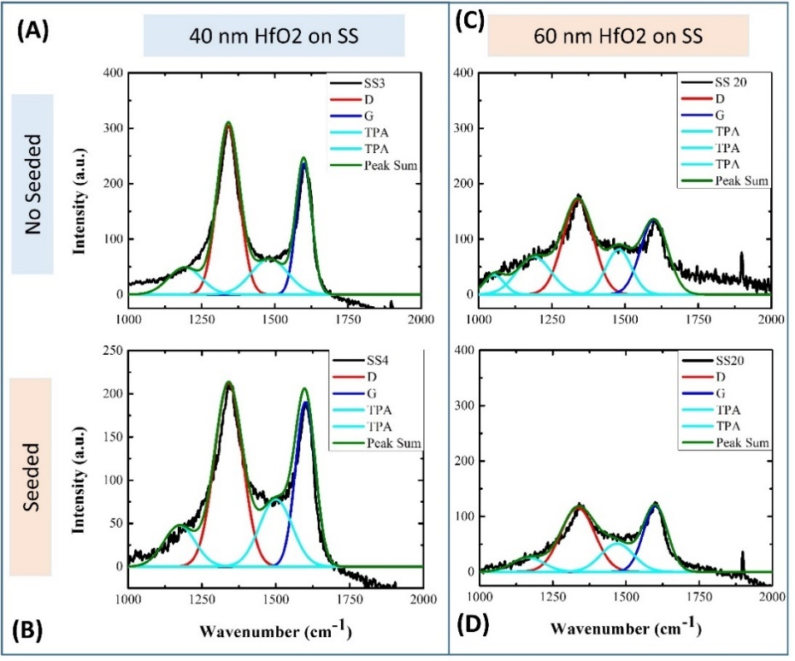

**Figure 3 –** Raman spectrum of samples A) SSA, B) SS4, C) SS20 and D) SS21

As mention before, the PL effect of the Raman spectrum can be removed with a fit to a polynomial. The resulting peaks were fit to a sum of pure Gaussians in the 100-2000 cm-1 range, using the software Fityk for this purpose. The visible wavelength Raman spectrum of UNCD is due only to the grain boundary signal since the grain sizes (2-5nm) produce a very small scattering cross section that is easily overshadowed by the resonant sp2 Raman signal in the visible range [15]. For all spectra shown in Figure 3 above, four bands can be observed. Those bands are the G band located at 1580 cm-1, which is due to the stretching of sp2 bonds, whether in rings or chains, the D band located at 1355 cm-1, which correspond to the breathing mode of sp2 chains and is an indication of disorder in sp2 bonded regions , and finally the bands located at 1150 cm-1 and 1450 cm-1, which are due to trans polyacetylene (TPA) type bonds in the grain boundary and therefore are an indication of the presence of hydrogen in the samples [16]. The combination of this signals is considered characteristic of UNCD films, since this type of structures tend to form in the grain boundary during UNCD growth. The intensity of Raman spectra show that signal is more intense in the UNCD films grown on 40 nm thick HfO2 layers than in those grown on 60 nm thick HfO2 layers, indicating that a thicker layer of UNCD was formed on the former.

The wave length used in Raman measurements is associated with the scattering cross-section of carbon molecules types. Several works were associated the PL to hydrogen carbon materials specially sp chemical bonds (chains), several signals of sp carbon chains have signals between 1900-2300 cm-1 associated to short carbon chains, and the cross-section signals can be showed using different wavelength or different Raman techniques like SERS. Using a wavelength of 532 nm in Raman analysis is providing a PL signal between 1900-2300 cm-1producing overlapping with signals of D-band (1335 cm-1) and G-Band (1600 cm-1).

The resulting PL in the sample in this study can be a response of the interface of the UNCD films nucleation sites on HfO2/SS. UNCD films grown on Al substrate, using the same growth conditions as for the UNCD films grown on SS, do not show the PL effect. The PL increase with thick HfO2 layer on SS. Higher intensity of PL in Raman scattering is related with the first nucleation steps of UNCD films. Rastorguev et al [17] argue that the change in PL on HfO2 could be due to the change in crystalline structure, or the OH and H2O trapped in the film or a combination of both. Further studies of the interface of the UNCD/HfO2/SS heterostructure are need, particularly using HRTEM, to determine the exact mechanism of the interaction.

A surprising result from this experiment, is that it is possible to grow UNCD on unseeded HfO2/SS substrates, and further work is underway to understand this effect, since it may have substantial technological impact.

1. **Conclusions**

This work discussed here showed studies of the photoluminescence effect from Raman scattering during analysis of UNCD films grown on SS substrates with a top template layer of HfO2. The PL effect from Raman analysis can provide information of structures with specific C-C bonds, between grains boundaries, and the first layer between UNCD films and HfO2 template layer on SS. The thickness of the HfO2 layer was varied. Furthermore, the surface of the HfO2 layer was either “wet seeded” with nano diamond particles or not. The results suggest that the dominant source of PL is in the HfO2 layer or the interface of the HfO2 and the SS. The contribution to the PL of the UNCD films appears not to be the dominant factor, but more studies are need to confirm this hypothesis. A surprising result from this study, is the fact that UNCD films can be grown directly on unseeded HfO2 films grown on SS substrates. Further studies are also needed to understand this effect.

**References**

1. Auciello, O. and A.V. Sumant, *Status review of the science and technology of ultrananocrystalline diamond (UNCD™) films and application to multifunctional devices.* Diamond and Related Materials, 2010. **19**(7–9): p. 699-718.

2. Kohmura, N., et al., *Diamond growth on the high purity iron substrate using hot-filament CVD method.* Diamond and Related Materials, 2005. **14**(3): p. 283-287.

3. Hirakuri, K.K., et al., *Diamond growth in solid substrate from gaseous source.* Journal of Applied Physics, 2004. **97**(2): p. 023516.

4. Sun, X., et al., *Deposition of diamond coatings on Fe-based substrates with Al and Al/AlN interlayers.* Surface and Coatings Technology, 2015. **284**: p. 139-144.

5. Chen, S., M. Gao, and R.P. Wei, *Hydride formation and decomposition in electrolytically charged metastable austenitic stainless steels.* Metallurgical and Materials Transactions A, 1996. **27**(1): p. 29-40.

6. Alcantar-Peña, J.J., et al., *Science and technology of diamond films grown on HfO2 interface layer for transformational technologies.* Diamond and Related Materials, 2016. **69**: p. 221-228.

7. Alcantar-Peña, J.J., et al., *Low temperature hot filament chemical vapor deposition of Ultrananocrystalline Diamond films with tunable sheet resistance for electronic power devices.* Diamond and Related Materials, 2016. **69**: p. 207-213.

8. Fuentes-Fernandez, E.M.A., et al., *Synthesis and characterization of microcrystalline diamond to ultrananocrystalline diamond films via Hot Filament Chemical Vapor Deposition for scaling to large area applications.* Thin Solid Films, 2016. **603**: p. 62-68.

9. Yang, Q., C. Xiao, and A. Hirose, *Plasma-enhanced deposition of nano-structured carbon films.* Plasma Science and Technology, 2005. **7**(1): p. 2660-2664.

10. Steven, P. and J.N. Robert, *Raman Spectroscopy of Diamond and Doped Diamond.* Philosophical Transactions: Mathematical, Physical and Engineering Sciences, 2004. **362**(1824): p. 2537-2565.

11. Casiraghi, C., A.C. Ferrari, and J. Robertson, *Raman spectroscopy of hydrogenated amorphous carbons.* Physical Review B, 2005. **72**(8): p. 085401.

12. Adamopoulos, G., et al., *Hydrogen content estimation of hydrogenated amorphous carbon by visible Raman spectroscopy.* Journal of Applied Physics, 2004. **96**(11): p. 6348-6352.

13. Marchon, B., et al., *Photoluminescence and Raman spectroscopy in hydrogenated carbon films.* IEEE Transactions on Magnetics, 1997. **33**(5): p. 3148-3150.

14. Dychalska, A., et al., *A Raman spectroscopy study of the effect of thermal treatment on structural and photoluminescence properties of CVD diamond films.* Materials & Design, 2016. **112**: p. 320-327.

15. Birrell, J., et al., *Interpretation of the Raman spectra of ultrananocrystalline diamond.* Diamond and Related Materials, 2005. **14**(1): p. 86-92.

16. Hu, X.J., X.H. Chen, and J.S. Ye, *The roles of hydrogen in the diamond/amorphous carbon phase transitions of oxygen ion implanted ultrananocrystalline diamond films at different annealing temperatures.* AIP Advances, 2012. **2**(4): p. 042109.

17. Rastorguev, A.A., et al., *Photoluminescence study of the electronic structure of HfO2 films.* Journal of Structural Chemistry, 2008. **49**(1): p. 21.

***Authorization and Disclaimer***

*Authors authorize ESTEC to publish the paper in the conference proceedings. Neither ESTEC nor the editors are responsible either for the content or for the implications of what is expressed in the paper.*