Sixth Engineering, Science and Technology Conference “Tendencies and Challenges in Engineering, Science and Technology” (ESTEC 2017) October 11 - 13, 2017 Panama City, Panama.

Metal Biocorrosion of a Water Well: A Case Study

Vicente Calbo
Universidad Tecnológica Nacional, Facultad Regional La Rioja, La Rioja, Argentina, vicentecalbo@yahoo.com.ar

Octavio Javier Furlong
Instituto de Física Aplicada, Universidad Nacional de San Luis CONICET, Argentina, ojfurlong@gmail.com

Silvia Viviana Julián
Universidad Tecnológica Nacional, Facultad Regional La Rioja, La Rioja, Argentina, siljulian@yahoo.com.ar
Abstract
Recently, in the city of La Rioja, the Microbiologically-Induced Corrosion (MIC) phenomenon has been confirmed. The last studied case corresponds to the water well of the La Rioja Regional Faculty of the National Technological University (UTN), where the water well facilities showed signs of this phenomenon.
These microorganisms catalyze the iron (and magnesium) oxidation reactions, solubilizing or solubilizing and precipitating the metal. Confirming the existence of the MIC phenomenon is essential to mitigate or solve the problem.
The laboratory work consisted in processing pipe and pump samples extracted after the well ceased to be used, at three initial temperatures and with different culture media, trying to cultivate, reproduce, and isolate and identify the different species.
Thus, through culture methodology, the existence of a mixed flora featuring iron bacteria and sulfate-reducing bacteria was confirmed.
Complementary Scanning Electron Microscopy (SEM) and Energy-dispersive X-ray Spectroscopy (EDS) spectroscopy scans allowed to visualize the bacteria, the damage to the analyzed material, and the morphology of the bioprecipitation.
This little-known phenomenon causes significant economic losses and should therefore be taken into account in the execution as well as the maintenance of wells.

Keywords: Metal Corrosion, Microbiologically Induced Corrosion, Water Well, Bacteria.
Resumen
En la ciudad de La Rioja, se ha confirmado recientemente el fenómeno de corrosión inducida por microorganismos (CIM). El último caso estudiado corresponde a la perforación de agua de la Facultad Regional La Rioja de la Universidad Tecnológica Nacional (UTN), donde las instalaciones de la perforación mostraron indicios de este fenómeno. Estos microorganismos catalizan las reacciones de oxidación del hierro (y manganeso), solubilizando o solubilizando y precipitando el metal. Confirmar la existencia del fenómeno de CIM es fundamental para mitigar o prevenir el problema.
El trabajo de laboratorio consistió en procesar muestras de las cañerías y bomba, extraídas al dejar de funcionar el pozo, a tres temperaturas iniciales y con distintos medios de cultivos, tratando de cultivar, reproducir y aislar e identificar las especies.
Como resultado, mediante metodología de cultivos, se confirmó la existencia de una flora mixta con presencia de bacterias del hierro y bacterias reductoras de sulfatos.
Análisis complementarios de microscopía electrónica de barrido (MEB) y espectrometría EDS (Energy-Dispersive X-Ray Spectroscopy), permitieron visualizar las bacterias, el daño en el material analizado y la morfología de la bioprecipitación.
El fenómeno, poco conocido, ocasiona pérdidas económicas importantes, por lo que debe ser tenido en cuenta tanto en ejecución como en mantenimiento de pozos.

Palabras claves: Corrosión Metálica, Corrosión Inducida por Microorganismos, Perforacion de Agua, Bacterias,
- Introduction
Technological materials, as well as natural substances, undergo a degradation process in which according to the environment conditions, microorganisms participate in greater or lesser extent. Fungi, algae, lichens and bacteria are being increasingly studied as alteration agents of materials used by the modern industry (De Turris et al., 2013). Industrial and urban structures, machines and installations, are daily exposed to the natural environment, or to special conditions for their proper operation, which are cases that involve diverse ranges and combinations of pH and temperatures, among other parameters, (Calbo el al., 2016).
In regard to the metals, the bacteria accelerate processes that occur naturally, serving as catalytic agents that accelerate kinetics of redox reactions (Ghiorse, 1984). Back in 1898, bacteria that attack and precipitate iron were characterized as chemoautotrophs (Winogradsky, 1922), determining that they obtained energy by the oxidation of Fe²⁺ to Fe³⁺. Afterwards, two functional groups were defined: metallo-oxidizing bacteria, which attack and precipitate the metal, and metallo-precipitating non-oxidizing bacteria (Cullimore and McCann, 1977). After the discovery of ferrobacteria, sulfate-reducing bacteria (SRB) were detected, which generate the non-assimilatory reduction of sulfate and use this compound as final electron acceptor. The energy for their metabolisms is generated in these redox reactions, and the final result is the formation of sulphides, which in turn results in acid aggression. There are two domains associated with this process, Bacteria and Archaea; both microorganisms are encompassed within the SRB (Muyzer and Stams 2008).
During the mid-20th century, these bacteria were associated with the premature aging of underground water pumping installations. In Argentina, the problem was detected at the end of the last century in the provinces of Río Negro, Santa Cruz, Mendoza, Entre Ríos, La Pampa and Buenos Aires, and more recently, the province of Catamarca was added to this list (Gariboglio and Smith, 1993), and now this problem is also confirmed in La Rioja.
The aerobic iron bacteria, the anaerobic and some facultative, consume the material through different but complementary mechanisms, leading to its thinning or eventual perforation (Figure 1). Another negative effect is the biofouling, which consists on the sedimentation and cementation of the bacteria metabolic products (Characklis, 2009). Over time, each bacteria produces a specific sediment that increases its thickness layer after layer. When the affected surface corresponds to the inner side of a pipe or holes (filters), the fouling or biofouling leads to an obstruction that eventually turns the installations inoperative (Figure 2).
The theoretical chemical reactions that explain this phenomenon are (Gariboglio and Smith, 1993):
Reactions in the presence of ferrobacteria in aerobic:

Me → Me⁺⁺ + 2e- (Dissolution of the metal – Anodic reaction)
O₂ + H₂O + 4e- → 4OH⁻ (Electron capture – Cathodic reaction)
3Me²⁺ + 6OH⁻ → 3Me(OH)₂ (Precipitation of insoluble products – Metabolites)

Reactions in the presence of SRB in anaerobic:

4Fe → 4Fe⁺² + 8e⁻ (Anodic reaction)
8H₂O → 8H+ + 8OH⁻ (Water dissociation)
8H⁺ + 8e⁻ → 4H₂ (Cathodic reaction)
4H₂ + SO₄⁻² → S⁻² + 4H₂O (Bacterial cathodic depolarization)
Fe⁺² + S⁻² → FeS (Corrosion product– Metabolites)
3Fe⁺² + 6OH⁻ → 3Fe(OH)₂ (Corrosion product– Metabolites)

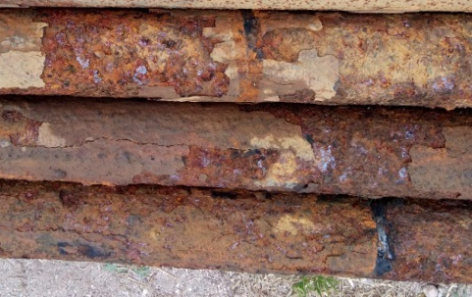
Figure 1: Exfoliative corrosion.

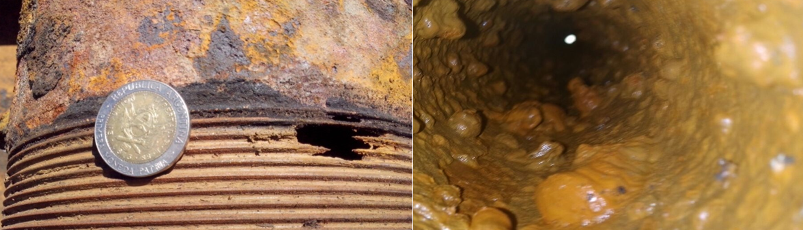
Figure 2: Nodular obstruction.
There are signs of the MIC phenomenon during the operation of wells, mainly the decrease of the water flow rates without a decrease of the phreatic level, and changes in the water organoleptic quality. Also, during maintenance or repair, observations reveal the presence of nodules, crusts and perforations due to pitting or scaling.
In the case of the La Rioja Regional Faculty, no significant changes were detected in the water organoleptic quality since it is destined to the campus irrigation system. However, the depth pump broke and when extracting the impulsion train towards the surface, pitting and obstruction were observed. Both the pump as well as the pipes had to be replaced, causing expenses and interfering with the normal functioning of the institution.
Based on the above, it was suggested that this perforation was being affected by the MIC phenomenon. The findings showed that the well was colonized by MIC microorganisms, and the confirmation of this hypothesis allowed to specify the amount of material to be used for the replacement to provide a reasonable duration in the fixed installation.

2- Materials and methods

Biochemical analyses were performed to confirm the MIC phenomenon. Complementary Scanning Electron Microscopy (SEM) and Energy-dispersive X-ray Spectroscopy (EDS) scans were performed.
The biochemical analyses were performed on fouling samples obtained from the well, ensuring their sterility; petri dishes, glass tubes and flasks for the culture media were sterilized in autoclave at 121ºC (15 lb/cm ) for 20 minutes, and the commercial plastic materials came already sterilized.
The commercial culture media were from Laboratorios Britania (Trypticase Soy Broth, Sabobaud Agar, Levine Eosin Methylene Blue (EMB) Agar, MacConkey Agar, Triple Sugar Iron (TSI) Agar, Salmonella Shigella (SS) Agar, Cetrimide Agar and others).
The special liquid and solid medium for the development of ferrobacteria was prepared according to the formula of the 9K culture medium (Silverman and Lundgren, 1959) and corroborated with the commercial medium BRH-20 from AquaLab, used for the detection of heterotrophic aerobic bacteria related to the metabolism of iron. For the development of SRB, medium with sodium lactate containing yeast extract and mineral salts was use, and contrasted with BRS-20 medium from Aqualab, used for the detection of SRB.
An anaerobic jar was used for the cultures in anaerobic conditions, using GasPak envelopes to generate the proper environment. The incubation of the strains in the Petri dishes, flasks and tubes were performed in parallel in three stoves at different temperatures: the first at 37 ºC during the entire experiment, the second started at 30 ºC and increasing the temperature by 2 degrees every time a replating was performed up to 36 ºC, and the third one started at 40 ºC, increasing the temperature by 5 degrees every time a replating was performed (weekly). These were based on tests previously performed in other well were survival differences of the germs were observed according to the temperature, so that the results at different temperatures and conditions were compared (aerobic and anaerobic).
The extracted material was suspended in sterile distilled water, taking a fraction for the pH measurement and another to seed in the different enriched liquid and solid media (with thioglycolate, yeast extract, agarose, salts, trypticase soy, peptone, sugars and others). At the same time, pH and Gram staining measurements of the initial suspensions were performed daily.
Afterwards, the different selective solid media were reseeded for isolation purposes, and replated to obtain more material and maintain the strains viable. In addition, the strains were isolated and enriched in special liquid media for each case, and the subsequent tests required for their classification were performed.
The resulting cultures were evaluated by the characteristics of the colonies (color, texture, elevation and edge) and then microscopically characterized by their shape with Gram staining.
A blank was also incubated in all the cultures, or a portion of the same plate was reserved to such end, that is, not-inoculated to have a negative control.
3. Results and discussion
In general, in all the media enriched with organic and inorganic supplements, there was development of a bacterial consortium with yeast. Gram(+) cocci are discarded due to being catalase-negative. Gram(-) bacilli were isolated from special media that only contain mineral salts as energy source. Thus proving development in the laboratory with and without Fe²⁺, and with and without sulfur, S⁶⁻. That is, it was determined the presence of bacilli that oxidized the iron and of bacteria that reduced and oxidized sulfur in the differential media. Since the chemoautotrophs bacteria, which require simple inorganic substances as energy source and CO₂ as carbon source, are in very low proportions in this cultures, the samples were previously enriched with several replatings.
In the special medium for SRB, Gram(-) bacteria developed under aerobic conditions up to 45 º C. These are whitish or cream-colored mucous colonies with irregular edges.
The development of the SRB in the special liquid medium, and without carbohydrates under anaerobic conditions, decreased the measured pH after one week by one unit.
There is development of aerobic Gram(-) bacilli that could not be identified, but it is know that they do not ferment glucose, lactose nor sucrose (in Levine EMB Agar there is little development of colonies without apparent color, and there was no change in the TSI Agar). The ortho-Nitrophenyl-β-galactoside (ONPG) test turn out negative and they are not enterobacteria (diverse media were tested to such end). It was ruled out that these were pathogenic microorganism (the tests for coliforms, Faecal Streptococci, Shigella, Salmonella, Pseudomonas aeruginosa, Clostridium, Mycobacterium tuberculosis and protozoan cysts, were negative). The development of these heterotrophic bacteria took place in media at pH 3 and 6, enriched with yeast extract, being positive at both pHs and under a stable condition for 15 days, with which it is corroborated that they are acidophilic bacteria. Pseudomonas with Cetrimide (-) and MacConkey (-) are ruled out.
The replatings were performed weekly increasing the temperature by 5 ºC, achieving development up to 50 ºC only in the media with Gram (+) bacilli, which sporulated (Figure 3 (left)). Different Gram (+) bacilli where observed, some forming endospores in chains, others isolated as well as terminal spores.
The evolution of the cultures was followed by performing Gram staining, and in the last three temperature increments the formation of spores was very rapid (aerobic conditions).
Based on the obtained results, it can be said that:
-There is presence of Sulfur Reducing Bacteria and Sulfur Oxidizing Bacteria (they decreased the pH of the medium and are not sugar-fermenting bacteria). They use CO₂ as carbon source and inorganic substrates as energy source, under anaerobic conditions.
-There is presence of ferro-oxidizing bacteria. In the special solid medium, an orange color is observed as Fe²⁺ is precipitated as F³⁺. The special liquid medium turns cloudy and becomes darker with some precipitates.
-There is presence of different bacteria capable of forming endospores as resistance structures, figure 3 (left).
-There is presence of yeasts and hyphae (Figure 3 (right)).

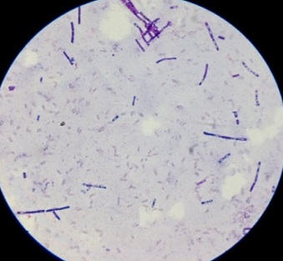
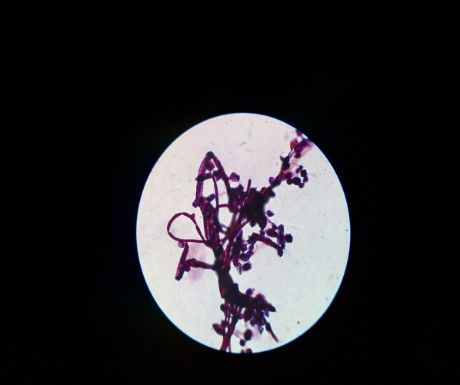
Figure 3: Bacilli and endospores (left), yeasts and hyphae (right).

Furthermore, SEM and EDS analyses were performed on the foulings detachments. The SEM was a LEO 1450-VP microscope from the Laboratory of Electron Microscopy and Microanalysis (LABMEM) of the National University of San Luis (UNSL), Argentina.
The foulings are precipitated metabolites (biomineralization) and have the same chemical composition of the iron minerals but with a peculiar shape. Figure 4 shows a micrograph that is consistent with biomineralizaion; also, a bacillus can be observed. The EDS spectrum (Figure 5) is also consistent with the corresponding mineral composition.

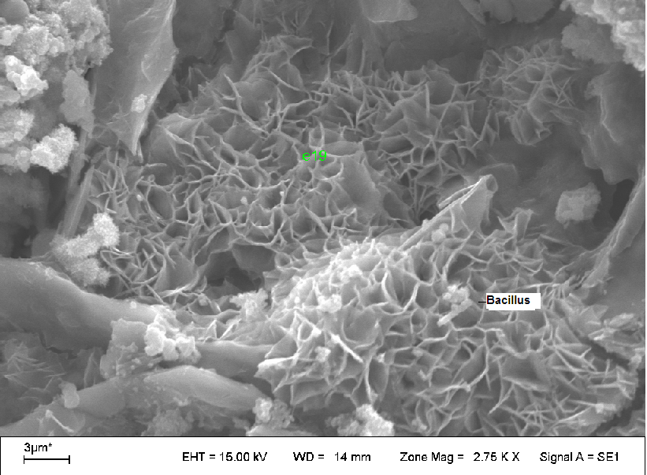
Figure 4: Incrustation micrograph.

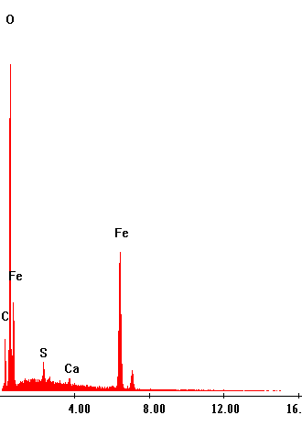
Figure 5: EDS spectrum of the analyzed fouldings.
4. Conclusions
The study performed by the Federal Council of Investments (CFI) and the end of the past century in Argentina, demonstrated that the MIC phenomenon was present in all the evaluated cities. The MIC signs lead to their discovery in the aquifer of the dejection cone of the City of La Rioja. Furthermore, as a result of this work, it is confirmed that the well of the Regional Faculty La Rioja is affected by the MIC phenomenon. This phenomenon can be present in a much greater extent, but since it is little known, no adequate controls are performed. These microorganisms, which are not pathogenic, are not detected in routine water quality analysis.
The operation life of the installations is significantly reduced due to that the corrosion chemical reactions are catalyzed by the detected microorganisms. This results not only in an economic loss; the City of La Rioja is supplied of drinking water almost exclusively from underground sources, and when this wells are out of service there are sectors that become affected for weeks. In our case, the La Rioja Regional Faculty is supplied by the water network and only the landscape was affected.
There are recommendations for preventing, treating the colonization and mitigating the MIC effect. In the present case, the impulsion pipe made of ordinary steel (75 mm in diameter) was replaced a galvanized steel one, which is more expensive but also more resistant towards corrosion.
Extending the reach of this work, we can conclude that being the MIC phenomenon a biological contamination, it is susceptible to propagation, and prophylactic measures have to be implemented with the perforation equipment and pipes that are installed.
On the other hand, the colonization takes place in stages, the iron bacteria colonize first under aerobic conditions, and their foulings act as a hermetic layer that generate anaerobic conditions, so that the SRB become in play, being much more aggressive since they completely pierce the pipe walls. Therefore, it is recommended to perform periodic removals by brushing of the foulings of the iron bacteria since it would extend the operational life of the installations.
References

Calbo, V, Furlong, O. and Torres Delugi, M. (2016). “Iron Mineral Bioprecipitation in Water Wells in La Rioja” Libro de las actas de las XIII Jornadas Argentinas de Tratamiento de minerals, Mendoza, Argentina. 001-006.
Characklis, W.G. (2009) “Fouling biofilm development: a process analysis2 Biotechnol. Bioeng. Vol. 23, No. 9, pp 1923-1960.
Cullimore, D.R. and McCann, A. (1977) “The identification, cultivation and control of iron bacteria in ground water” In: Aquatic Microbiology, Editors: Shinner, F.A. and Shewa, J.M. Academic Press. Inc., New York, pp. 219-261.
De Turris, A., Ocando, L., Romero, F. and Fernández, M. (2013). “¿Pueden los Microorganismos Impactar los Materiales de Construcción?” DIALNET GT Ciencias Aplicadas, Vol. 10, pp 23-33.
Gariboglio, M.A. and Smith, S.A. (1993) “Corrosión e incrustación de microbiológica en sistemas de captación y conducción agua. Aspectos teóricos y aplicados” Consejo Federal de Inversiones CFI, Buenos Aires.
Müyzer G. and Stams A.J.M. (2008) “The ecology and biotechnology of sulphate-reducing bacteria” Nat. Rev. Microbiol. Vol. 6, pp 441-454.
Ghiorse, W.C. (1984) “Biology of iron- and manganese-depositing bacteria” Annu. Rev. Microbiol. Vol. 38, pp 515-550.
Silverman, M.P. and Lundgren, D.G. “Studies on the Chemoautotrophic Iron Bacterium Ferrobacillus Ferrooxidans II” J. Bacteriol. Vol 78, No. 3, pp 326–331.
Winogradsky, S. (1922) “Eisenbakterien als Anorgoxydanten. Zentralblatt für Bakteriologie. Parasitenkunde, und Infektionskrankheiten” Abt. 2 57:1-21.

Authorization and Disclaimer
Authors authorize ESTEC to publish the paper in the conference proceedings. Neither ESTEC nor the editors are responsible either for the content or for the implications of what is expressed in the paper.

