Sixth Engineering, Science and Technology Conference “Tendencies and Challenges in Engineering, Science and Technology” (ESTEC 2017) October 11 - 13, 2017 Panama City, Panama.

Model for knowledge management with the ontological approach in social networks

Nancy Edith Ochoa Guevara
Bogotá, Colombia. Corporación Universitaria Minuto de Dios – Uniminuto. nochoagueva@uniminuto.edu.co
Javier Augusto Ríos Suarez
Bogotá, Colombia. Corporación Universitaria Minuto de Dios – Uniminuto. jriossuarez@uniminuto.edu.co
Helio Henry Ramírez Arévalo
Corporación Universitaria Minuto de Dios – Uniminuto. hramirez@uniminuto.edu.co

Abstract: The article shows the results of the structure of collective knowledge management (CKM), defined from the concept of research management of research groups in the university with the use of a semantic algorithm. The process begins with the creation of a site in the social network facebook with the subject of the investigative management in the university. Through a structure of dimension given by profile, role, category and subcategory making direct connection with a relational database called MySQL. Through the application of metadata and algorithm is expected to obtain the lessons learned from these groups during the development of their projects. The result is the proposal of a functional scheme that allows the design and creation of a collective knowledge management model as support for university research.

Keywords: Knowledge management, Collective knowledge, Knowledge model, Scientific Production

- Introduction
In recent years, the trend of knowledge management (KM) is towards the collective (CKM) As a fundamental process in organizational management (OKM).
This work focuses on the analysis and evaluation of the research management that the research groups generate to support the architecture of collective knowledge in the university. The work seeks the implementation of a CKM model with a prototype of a computer system which demonstrates the possibility of doing OKM of CKM; The latter is developed from the basis of production reported by research groups at the university and its lessons learned.
Its relevance is to make the most of the experiences gained from research groups through a scheme of lessons learned in an open and unstructured environment such as social networks. Where it was possible to establish an architecture for the Management Model Knowledge in scientific research as a contribution of the groups to the context of Science and Technology in the locality, city and country region.
The work was carried out in three phases. In the first phase, the conceptual aspects that defined and included a model for the CKM and the steps to be considered for its construction were developed (Pereira, 2011). Followed by the definition of KM and CKM by some expert authors in the area. Subsequently in terms of CKM, it is deepened on its benefits for flexible scenarios worked in groups with a specific objective to support collective knowledge generated by individuals (Cárdenas & Spínola, 2013).
The second phase presents the environment of the research groups in the university, highlighting their work and the role they play in strengthening the Qualified Registration, Self-Assessment and High-Quality Accreditation process in their academic programs as supply and demand in the university. work environment.
The third part focuses on the description of the implementation and verification of the prototype of the computer system. This will be implemented online on a website through a relational database that will support the actual registration of an indefinite and random number of research output and its lessons learned. Taking as reference the ontological algorithm and the source of the social network Facebook, in order to propose a model for the management of knowledge of these groups.
In the end the use of the socialization strengths generated in social networks is shown combining the structured and unstructured knowledge of CKM in support of the OKM.
The article is developed based on the state of the art of the KM, the lessons learned and structure of the research groups, then the applied methodology is broken down, with the results obtained and the authors' discussion about it. In the end, we will close with the conclusions and references queries by other authors who have done similar studies.

- State of the art
It is represented through studies conducted in the individual and collective GC with research groups at the University.

  - Scientific Production in universities
How is research knowledge generated and transmitted in the university? Has been studied from different perspectives, focusing only on one of the phases of the KM cycle. There are authors who analyze parts of the knowledge cycle: how are the forms of knowledge creation in research (Gaviria, et al., 2007, García, (2011), how to share and transfer knowledge from Human capital theory and KM (Iqbal & Toulson & Tweed, 2011).
In this work, the most widely used model is the knowledge spiral or SECI model (Nonaka, & Takeuchi, 1995; García-Alsina & Gómez-Vargas, 2015), since it allows to study the forms of knowledge creation from Tacit and explicit knowledge in addition to their different forms of conversion. Where the explicit that refers to the quantifiable (measurable), what is transmitted and stored, and the tacit, which is subjective, lie in the deepest individual experience. Like the values and emotions of individuals; To this reconstruction is called "knowledge conversion spiral" and is not a linear and sequential process, but exponential and dynamic.
Other studies focus on identifying the benefits of CKM in the field of research (Kidwel et al., 2000; Vásquez, 2010). Finally, there are other types of studies whose objective is to measure the productive capacity and the intellectual capital of the research groups (Bueno & Morcillo & Rodríguez & Luque, 2003; Vásquez, 2010). Focusing on the context of research carried out by research groups at the university.

2.2 Learning Lessons
They are understood from the explicit knowledge that is generated through the positive or negative results acquired during the development and execution of a process and its ability to innovate through experience (Brent, 2008).
However, these lessons learned through the "research production" generated by researchers require more than "the management of knowledge management and contextual learning that is progressively implemented in institutional structures to carry out the processes of Innovation "(Peluffo, 2010, p.44). Where the management of the institution must focus on the human intellect of the university to turn it into knowledge.
2.3 Characterization of research groups
There are several approaches to characterize research groups that facilitate progress in the study of KM practices at the university. The authors Rey, Martín and Sebastián, (2008) suggest three ways to analyze the research groups: a) according to the results, b) the inputs; Or c) according to psychosocial characteristics.
Some authors point to the structure of the group, understood as the forms of internal organization and distribution of functions (Londoño, 2005; Gaviria, 2007; Hamui, 2010). For their part, Bueno et al. (2008) consider the components of intellectual capital as a means to characterize research groups.
The criteria for characterizing research groups, according to intellectual capital, are grouped into the three categories offered by the Intellectus Model: human capital, structural capital and relational capital (Bueno et al., 2008; Rivera 2011). Alsina & Cobarsi-Morales, 2010). In the case of social capital, technological capital, and finance capital, Alsina & Cobarsi-Morales (2010.

3. Metodology
It was done through the application of some modules of the GEINVE-CKM prototype with the unformatted texts collected in the social network and worked with the ontological algorithm, in order to give it a specific format to be interpreted through a database MySQL relational data.

3.1 Architecture
For this study, we analyzed some cycles of knowledge taking into account that in the various models there are points in common such as individual values, teamwork, communication channels, organizational culture and the creation, assimilation and distribution of knowledge. Proving that the process is based more on cultural and organizational aspects than on a technocratic perception (García, 2011).
These cycles were implemented in a prototype of a computer system (PSC) to be applied to some research groups in the areas of science and technology (S & T) of a scientific research center in the city of Bogota, Colombia.
Fig. 1 shows the relationship between the elements that form the proposal of the CKM model taking some key elements of the spiral SECI model and its transformation with the use of the application of data processing technology, socialization and internationalization between Others (Haslinda & Sarinah, 2009; Kebede, 2010).
The proposal presented integrates some components in each of its quadrants:

- Quadrant 1: It starts from the system of investigative management that the university has to direct the research groups where it is possible to share the KM.
- Quadrant 2: It presents the capacity of the knowledge that each one of the groups of investigation has to generate production through the relation of concepts.
- Quadrant 3: It starts from the group measurement model of the scientific center to generate production of the format TOP where it is possible to build the architecture of the crossed knowledge.
- Quadrant 4: It starts from the results of the research production as contribution to the scientific community in the country, justifying the concepts learned.

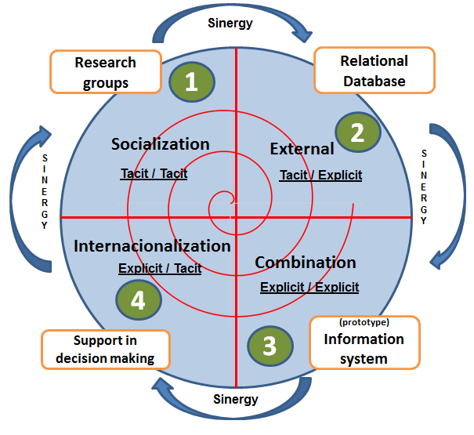
Fig. 1 Global architecture of the CKM model
The proposal of this model CKM in the university focuses on the development of intellectual capital which allows explaining the effectiveness of organizational learning, the efficiency of KM and the expected results as contribution to the scientific community of the country.
At the same time, it uses the logical sequence of data, information and knowledge, which flow in the upper quadrants where the knowledge is presented tacitly / tacitly and tacit / explicit respectively. These in turn allow that through a model centered in group measurement of the scientific center, is generated through the research production of the CKM as contribution of the scientific community of the country.
This production allows to establish a specific scheme in the lessons learned for this CKM model as fundamental elements of the same, where the research groups are aligning not only their CKM but their experience to achieve a transfer of adequate knowledge to other groups or institutions of higher education.
3.2 The prototype: GEINVE-CKM
The prototype was generated from the scheme of the research management model in the university under the conception of the lessons learned within a CKM environment (Ochoa & Cruz & Gil, 2015) developed under a free code language Java Servet Page (JSP) Which allows through a relational MySQL database the registration of structured information, from an ontological algorithm used for the treatment of massive unstructured information obtained in the social network facebook.
Fig. 2 shows the explicit elements that make up this prototype:

- Knowledge User: Researcher group
- Application: Model of measurement of groups of the scientific center
- Platform: Relational Data Base
- System: Information processing and its respective analysis (semantic algorithm social network).
.
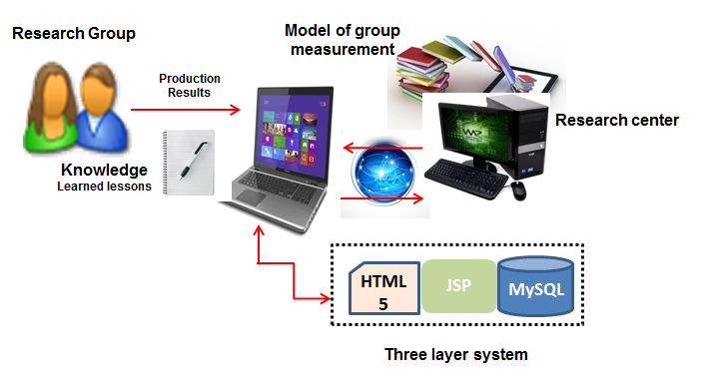
Fig. 2 Scheme Prototype GEINVE-KM

The prototype works with two approaches. First, with the Research Management System at the university, which contains the individual and research research production as shown in Fig. Second, with an explicit knowledge approach called "Lessons Learned" divided into two: those directly registered by the researchers of the group in a structured way and those presented in a massive way in the facebook social network, seeking collective learning among them, to Through the use of metadata for specific queries and searches.
For the development and operation of the lessons learned it was necessary to interact with some libraries and special structures of the computer system in three layers:

- Enterprise Java (King et al, 2014): It allows to establish the connections of the .jar /.jsp / .html making connection between the layers of the system.
- ServletLoginController (QVT, 2007): Used to make the authentication of the users to the system of investigation management through the user and identification number of the account.
- jQuery API (jQuery Foundation 2013): A JavaScript for connecting the HTML pages that make up the prototype business layer.
- JavaServer Pages (JSP): Base language for coding the business layer of the prototype (instructions). Class.jar
- JavaBean (JavaBean, 2014). JSP Business Layer Code Editor.

3.3 Functional architecture design and algorithm analysis
The analysis was based on explicit knowledge and was able to share successful experiences, motivations, feelings, objects and other elements along with their connections or relationships.
The following is the development of the CKM architecture that allows the analysis of the lessons learned registered in the social network facebook through the scheme of profile, role, categories and subcategory where each participant made his selection and managed to interact with the prototype GEINVE-CKM for the synergy of knowledge.
Fig. 3 shows the flow of data, information, knowledge obtained through the interaction of users of the social network and the CKM architecture implemented in the prototype. All this related to the subject of research production in the university, according to the model of knowledge management used for this purpose.
The model is based on the categories of socialization, exteriorization, combination and interiorization and their respective subcategories in the spiral of Nonaka and Takeuchi.
At the same time, it allows the user in the social network to relate the data of other users in the form of an appointment in order to achieve the continuous flow of information and to strengthen the knowledge base of the lessons learned, with the specific subject of the investigative production in college. This architecture proposes a simple consultations component to facilitate decision support through the tools involved.

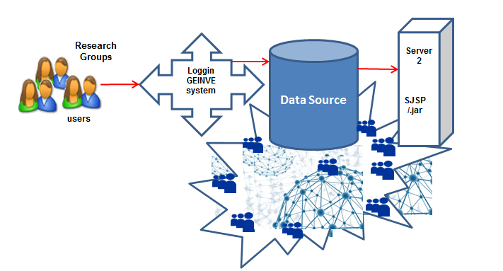
Fig. 3 Analysis of the algorithm

As a result, the development of a comprehensive scheme aimed at CKM is expected to establish the current state of research production in the university based on the characterization of its users (researchers), their learned lesions registered in the prototype and the selected filters in the facebook social network.
When the user (researcher) is authenticated through the GEINVE-CKM system, a request is immediately made to select the profile, role and category to which it is necessary to record the lesson learned under the dimension scheme.
Then it allows you to interact with the lessons learned in the network where the prototype selects the common ones and allows you to choose some that in prospective would like to obtain. Organizing information at the semantic level (Senso, 2011), generating the CKM for the analysis of the learning obtained by each one of the researchers of the group, during the development of a research project in the university.

3.4.1 Profile, role and dimension of the architecture
The profile, role and dimension elements were implemented according to the knowledge cycle of Nonaka and Takeuchi (1995): profile: researcher, teacher, professional, other; Role: Leader of the group, national co-investigator or international co-investigator, other; Dimension: Approach based on category and subcategories where it is possible to structure the lessons learned from the group through the components of the spiral scheme socialization, exteriorization, combination and interiorization.
Table 1 shows the coding assigned to the dimensions to better understand the lessons learned in the research production of the participants in the social network, facilitating the analysis and interpretation in the semantic algorithm.
Table 1. Dimensions of the scheme in social network

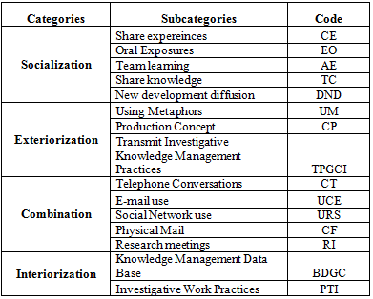

3.4 Algorithm of semantic analysis. Ontological Method
In Fig. 3 information is represented in a natural language where the human being can read and understand it. But it can not be directly interpreted by machines, so what to do? According to the authors Khare and Tantek (2006) it is recommended to stop and organize the information under an automated reasoning scheme, so that these machines are able to interpret the information through the semantic web. The purpose is to analyze research production of groups in the university.
The algorithm used to know the learning lessons in the social network facebook, works under the scheme of data mining and automatic learning with a quantity of unstructured type text string.
The ontological method was chosen, for which specific rules were manually constructed to identify and organize the mass text collected from the social network.
The GEINVE-CKM prototype was first activated to make a general revision of the obtained mass text, in order to correct spelling mistakes and to eliminate some loose letters. This procedure was done by migrating the text (external) in a flat file without structure or format, achieving almost 85% correcting inconsistencies of tildes, transcription and other negative elements in the text. This procedure was practically manual.
Then the process of migrating the text (internal) with the text already debugged in the prototype was performed again. Then the model of the algorithm of the ontological method of the prototype was activated which contains a text model through the scheme of a tree of dependence of the words that compose said text. This tree allowed to group the subject with the corresponding adjectives, verbs, among others; In sentences (Kontopoulos & Berberidis & Dergiades & Bassiliades, 2013).
In Fig. 4 the XML set used in the tree process for the ontological scheme is observed. This allowed to activate detectable patterns with keywords (metadata) that are in different positions of the pattern. This process was done through an XML document (Wei & Atle, 2010) where each node represents a tree that has the same form as the pattern of the searched text, being able to assign the value corresponding to the rule and the text with respect to the identified subject.

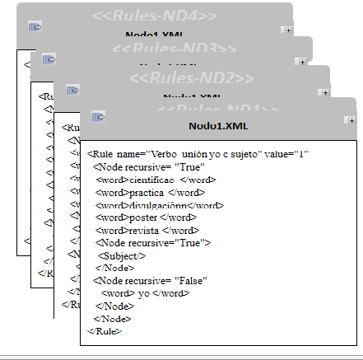
Fig. 4 XML documents - Ontological method

The XML facilitated the review, analysis and evaluation of each one of the sentences of the text, extracting through the metadata the lessons learned (Kontopoulos & Dergiades & Bassiliades, 2013) in the process and thus the synergy was known to support the Management of the CKM collective knowledge generated by research groups in the university (Sens, 2011).

4. Results
The GEINVE-CKM web 2.0 prototype allowed a correlation between the lessons learned directly by the researchers of a research group and the ones selected in prospective by those presented in the social network facebook.
This contributed to establish a document for the proposal of a model in the collective knowledge management CKM of these research groups inside the university. Seeking to generate plans of improvement that guarantee the success of the change and its competitive level in prospective of the S & T of the country through the dynamics of the lessons learned in a group and social way.
In addition, a process of synergy was generated with the other research groups inside and outside the university with the theme of "research production". Where the contribution to the academic and scientific community is strengthened and the skills and skills of its researchers are highlighted.
Semantically, the model determines the direct relationship between "research" and "type of research", generating a schema of "experience", "skills" and "skills" in the automatic learning process through the nonprobabilistic profile, role or dynamic dimension in the process. This in order to improve the organizational learning and the CKM behavior in the approach of the contribution of the research groups towards a community of knowledge.
This first approach of the relation of lessons learned and its identifier allowed to generate a scheme of possibilities in the semantic relation that can be projected for the decision making in the allocation of resources, times and spaces in the management of projects of the groups. Taking the scheme in an increasingly broad group, to become a model of support for the "transfer of knowledge" with an avant-garde vision worldwide.
Table 2 presents the profile and number of participants in the study through the social network scheme facebook.

Tabla 2. Profile Attributes and Role of Participants
Profile | Participants
Researcher | 214
Teacher | 1011
Professional | 450
Other | 1233
Total, Participants | 2.908

To be the first study through the social network facebook the number of participants is good but the registration of researchers is very low, although the number of teachers and professionals is also excellent to start the analysis of the scheme as such.
Fig. 5 shows the activated class.jar in the GEINVE-CKM prototype used to structure the unstructured massive table that was collected from the participation of the social network facebook.

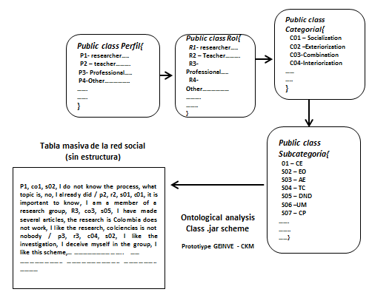
Fig. 5 Ontological analysis massive table social network

Fig. 6 shows the trend of the lessons learned once the massive table collected in the social network of Figs. 4 and 5 is structured. There is observed around the number of participants in the subcategories and the main lessons learned from the same.

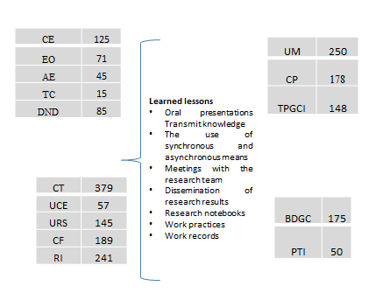
Fig. 5. Lessons learned social network

In the figure, also a knowledge domain is widely observed when applying the category of combination, followed by the category of exteriorization being at very close levels between the categories of socialization and interiorization respectively. While there is a group that without being in the profile made its contributions in an empirical way to the category.

- Conclusions
Through the theoretical framework, three models were identified as the methodological basis for the architecture of the knowledge management model such as the collective knowledge management approach and the Nonaka and Takeuchi knowledge conversion model combined with the organizational model of López-Cruz & Obregón, 2015). Followed by the advances of the prototype GEINVE-CKM as fundamental tool of the model with the records of the lessons learned from the social network facebook.
From the GC cycle, participants with a profile and role of researchers and teachers have strengthened their lessons and experiences through the combination, exteriorization, socialization and internalization respectively in the university, with the support of the workshops of Research, synchronous and asynchronous communication, work minutes, research notebooks and dissemination of results (Ochoa & Cruz, 2017).
Although there was a high percentage of participants in the profile of others, it was observed that they did not ignore some of the tasks of the spiral SECI model in their informal research works, being a potential to be reviewed, analyzed and evaluated in future studies in Similar topics.
With the interaction between the XML-tree document and the three-layer scheme of the GEINVE-CKM prototype, it was possible to establish an ideal structure to pass the obtained text in the social network to one previously structured in a MySQL relational database as the starting point for the proposal of the model of management of knowledge in the university in future studies.

- References

Alsina, M. & Cobarsi-Morales, J. (2010). El papel del capital social en la inteligencia competitiva. Revista General de Información y Documentación, 20, 313-323. [The role of social capital in competitive intelligence. General Journal of Information and Documentation, 20, 313-323]
Bueno, E., Morcillo, P., Rodríguez, J., Luque, M.A. (2003). Knowledge management and knowledge creation in Academia: a study based on surveys in a Japanese research university. Journal of Knowledge Management, 13(2), 76-92.
Bueno, E., Salmador, M. P., & Merino, C. (2008). Génesis, concepto y desarrollo del capital intelectual en la economía del conocimiento: Una reflexión sobre el Modelo Intellectus y sus aplicaciones. [Genesis, concept and development of intellectual capital in the knowledge economy: A reflection on the Intellectus Model and its applications]
Brent Robertson BA (2008) A software-based lessons learned management system: enhancing knowledge management in organizations. In: Proceedings of the de IIE annual conference.
Cárdenas J, Spinola M (2013) Role of knowledge management systems within the expertise transfer. In: 2013 Proceedings of the PICMET’13 de Technology Management in the IT-driven services (PICMET).
García-Alsina, M., Gómez-Vargas, M. (2015). Factores influyentes de la gestión del conocimiento en el contexto de la investigación universitaria Información, cultura y sociedad: revista del Instituto de Investigaciones Bibliotecológicas, (33), pp. 29-46 Universidad de Buenos Aires Buenos Aires, Argentina [Factors influencing knowledge management in the context of university research Information, culture and society: journal of the Institute of Library Research, (33), pp. 29-46 University of Buenos Aires Buenos Aires, Argentina]
García, M. (2011). Análisis de la creación de conocimiento de las TIC en el contexto de la Universidad. Economía industrial, (379), 159-166. [ Analysis of the creation of knowledge of ICT in the context of the University. Industrial economics, (379), 159-166]
Gaviria, M. M., Mejía, A. M., & Henao, D. L. (2007). Gestión del conocimiento en los grupos de investigación de excelencia de la Universidad de Antioquia. Revista Interamericana de Bibliotecología, 30(2), 137-163. [ Knowledge management in the research groups of excellence of the University of Antioquia. Inter-American Journal of Library Science, 30 (2), 137-163]
Tian, J., Nakamori, Y. & Wierzbicki, A. P. (2009).
García-Alisina, M., & Gómez-Vargas, M. (2015). Prácticas de gestión del conocimiento en los grupos de investigación: estudio de un caso. Revista Interamericana de Bibliotecología, 38(1), 13-25. [ Practices of knowledge management in research groups: case study. Inter-American Journal of Library Science, 38 (1), 13-25]
Hamui, M. (2010). Estructura de organización en la trayectoria de dos grupos de investigación científica de ciencias básicas de la salud en la generación de conocimiento. Revista Mexicana de Investigación Educativa, 15(46), 713-738. [ Organizational structure in the trajectory of two groups of scientific investigation of basic sciences of health in the generation of knowledge. Revista Mexicana de Investigación Educativa, 15 (46), 713-738]
Haslinda, A., Sarinah, A. (2009) A Review of Knowledge Management Models. The Journal of International Social Research. 2(9), pp.187-198.
Iqbal, S., Toulson, P., & Tweed, D. (2011). HRM Practices and Individual Knowledge-Sharing: An Empirical Study of Higher Education Institutions in Pakistan. Trabajo presentado en 8th International Conference on Intellectual Capital, Knowledge Management & Organizational Learning –ICICKM.
Java Bean. (2014). En Wikipedia, la enciclopedia libre. Recuperado el 1 de agosto de 2014 a las 6:15 p.m. de http://es.wikipedia.org/ wiki/JavaBean. [In Wikipedia, the free encyclopedia. Retrieved on August 1, 2014 at 6:15 p.m. From http://en.wikipedia.org/wiki/JavaBean]
JQuery Foundation T (2013) JQuery API.
Khare, R., Tantek, C. (2006). "Microformats: a pragmatic path to the semantic web". Proceedings of the 15th international conference on World Wide Web, pp. 865–866
Kebede, G. (2010) Knowledge management: An information science perspective. International Journal of Information Management. 30, pp.416-424.
King, G., Muir, P., Richards, (2014). Contextual Components. A Framework for Enterprise Java. http://docs.jboss.org/seam/2.3.0.Final/reference/en-US/html/
Londoño, F. (2005). Un análisis sobre la dinámica de los grupos de investigación en Colombia. Investigación y Desarrollo, 13 (1), 184-203. [ An analysis on the dynamics of research groups in Colombia. Research and Development, 13 (1), 184-203]
López-Cruz O, Obregón N. (2015) A network based methodology to reveal patterns in knowledge transfer. Int J Interact Multimed Artif Intell 3(5):67–76.
Mejía, A. (2007). Estructura organizativa de los grupos de investigación de la Universidad de Antioquia como fuente de creación de conocimiento. Revista Interamericana de Bibliotecología, 30(2), 89-102. [ Organizational structure of the research groups of the University of Antioquia as a source of knowledge creation. Inter-American Journal of Library Science, 30 (2), 89-102]
Nonaka, I. & Takeuchi, H. (1995). La organización creadora de conocimiento: cómo las compañías crean la dinámica de la innovación. México: Oxford University Press. [ The knowledge-creating organization: how companies create the dynamics of innovation. Mexico: Oxford University Press]
Nonaka I, Peltokorpi V (2006) Objectivity and subjectivity in knowledge management: a review of 20 top articles. Know Process Manag 13(2):73–82.
Ochoa NE. (2012). Estado del arte: El modelo de evaluación de investigación en las universidades Latinoamérica. Bogotá, Colombia. http://revistasdm.ecci.edu.co/index/IngECCI. 2012.[ State of the art: The research evaluation model in Latin American universities. Bogota Colombia. Http://revistasdm.ecci.edu.co/index/IngECCI. 2012]
Ochoa Guevara NE., Cruz Bernal IM., y Gil Aros C (2015). Estrategias en la Construcción del Prototipo Inicial para un Modelo Integral en la Gestión Investigativa de la Universidad ECCI orientado hacia el esquema de Negocio. Proyecto GEINVE v1.0. Revista de Publicaciones UNAD 9(3). Pag. 45 – 55. Bogotá, Colombia.
http://hemeroteca.unad.edu.co/revista1/index.php/pi/article/view/1438 [Strategies in the Construction of the Initial Prototype for an Integral Model in the Investigative Management of the ECCI University oriented towards the Business scheme. GEINVE Project v1.0. Journal of Publications UNAD 9 (3). Page 45 - 55. Bogotá, Colombia.
Http://hemeroteca.unad.edu.co/revista1/index.php/pi/article/view/1438]
Ochoa-Guevara, NE., Cruz-Bernal, IM., Ríos JA. (2017). Design and Construction of an Integral Model for Investigative Management in the University GEINVE Project v2.0. Serie: Management Science – Theory and Applications. Binding: Softcover. https://www.novapublishers.com/catalog/product_info.php?products_id=62582
Peluffo, M. (2010). Gestión del conocimiento tácito: buenas prácticas y lecciones aprendidas en la internacionalización universitaria. Revista de Innovación Educativa, 10 (51), 43–55. [Management of tacit knowledge: good practices and lessons learned in university internationalization. Journal of Educational Innovation, 10 (51), 43-55]
QVT. Query, View, Transformation. (2007). Specification. Final Adopted Specification ptc/07-07-07. OMG.
Rey, J., Martín, M. J. & Sebastián, J. (2008). Estructura y dinámica de los grupos de investigación. ARBOR Ciencia, Pensamiento y Cultura, (732), 743-757. [Structure and dynamics of research groups. ARBOR Science, Thought and Culture, (732), 743-757]
Rivera, S. (2011). Medición de las capacidades de investigación desde el enfoque de Capital Intelectual. XXIV Congreso Internacional de Estrategia SLADE. [ Measurement of research capacities from the Intellectual Capital approach. XXIV International Congress of SLADE Strategy]
Sens, J.A. (2011) “Gestión del conocimiento y tecnologías semánticas en inteligencia y defensa”, Inteligencia y Seguridad: Revista de Análisis y Prospectiva, 10 (20, pp: 29-53. [ "Knowledge management and semantic technologies in intelligence and defense", Intelligence and Security: Journal of Analysis and Prospective, 10 (20, pp: 29-53]
Vásquez, F. (2010). Modelo de gestión del conocimiento para medir la capacidad productiva en grupos de investigación. Ciencia, Docencia y Tecnología, 21(41), 101-125. [ Knowledge management model to measure productive capacity in research groups. Science, Teaching and Technology, 21 (41), 101-125]
Wei Wei and Jon Atle Gulla. (2010). Sentiment learning on product reviews via sentiment ontology tree. In Proceedings of the 48th Annual Meeting of the Association for Computational Linguistics, ACL '10, pages 404413, Stroudsburg, PA, USA. Association for Computational Linguistics.

Authorization and Disclaimer
Authors authorize ESTEC to publish the paper in the conference proceedings. Neither ESTEC nor the editors are responsible either for the content or for the implications of what is expressed in the paper.

