Sixth Engineering, Science and Technology Conference “Tendencies and Challenges in Engineering, Science and Technology” (ESTEC 2017) October 11 - 13, 2017 Panama City, Panama.

Boussinesq solitons as propagators of neural signals

Edgar Villagran Vargas
Facultad de Tecnologías de Información, Universidad de La Salle Bajio, Guanajuato, México.

Juan Ramón Collantes C.
Facultad de Ciencias y Tecnología, Universidad Tecnológica de Panamá. Panamá.

Máximo A. Agüero Granados
Facultad de Ciencias, Universidad Autónoma del Estado de México, Toluca, México.

ABSTRACT

We consider certain approximation for determining the equation of motion for nerve signals by using the model of the lipid melting of membranes. The nerve pulses are found to display nonlinearity and dispersion during the melting transition. In this simplified model the nonlinear equation early proposed by Heimburg and coworkers transformed to the well known integrable Boussinesq non linear equation. Under specific values of the parametric space this system shows the existence of singular and regular soliton like structures. After their collisions the mutual creation and annihilation (each other) of nerve signals along the nerve, during their propagation, has been observed.
Keywords: Boussinesq equation, singular solitons, single neurons, neural code.

RESUMEN
Nosotros hemos analizado una aproximación analítica para determinar la ecuación del movimiento de pulsos nerviosos usando el modelo del disolución del lípido en membranas. Los pulsos nerviosos muestran no linealidad y dispersión durante su transición fundente. En este modelo simplificado la ecuación inicial no lineal propuesta por Heimburg y colaboradores se transformó en la conocida ecuación no lineal integrable de Boussinesq. Bajo valores específicos de los parámetros del espacio este Sistema muestra la existencia de estructuras solitónicas singulares y regulares. Después de sus colisiones durante su propagación, fueron observados la creación y el aniquilamiento mutuo (de uno con el otro) de los pulsos a lo largo del nervio.
Palabras claves. Ecuación de Boussinesq, solitones singulares, neuronas únicas, código neuronal.

I. INTRODUCTION
One of key fundamental problems in biophysics is to understand how nature makes to carry information from one point to the other. It’s more, the information without significant distortion will travel along distances between two considerable long separated centers. Regarding the neural transmission, Hodgkin and Huxley (HH) in 1952 proposed a model for nerve pulses based on ion gradients through the nerve membrane conducted by special ion channels [1]. Subsequently, Fitz Hugh proposed a simplified neuronal version of Hodgkin and Huxley model. Nagumo suggested as analogous neuronal, a nonlinear electrical circuit, controlled by an equation system also similar to those of Van Der Pol currents and also from the point of view of dynamic systems [2].
However, in varios lines of investigation concerning nerve pulse propagation it is shown
that the action potential can pass though each other. The experiments do not show this ever, but in contrary, the collision and annihilation of nerve pulses are observed in real experiments. Including there is a standard ”collision test” for identification of neurons in brain neurophysiology [3] in synthesis when nerve impulses collide they could annihilate leaving as residue other types of nonlinear patterns. In this line of research we propose a simple modification of Heimburg model in which the solitary wave structures behave in a manner of macroscopical particles and they could annihilate, or conserve their initial configuration after collisions. This reduced model is a variant of the Boussinesq nonlinear equation that support regular and singular solitary traveling wave solutions and could represent at least an attempt to solve this crucial problem.
We use the model of Heimburg and coworkers [4] and by applying the trivial boundary condition we found some non-classic soliton like solutions i.e singular solutions additionally to the well regular traveling solitons. Thus, in the next section we briefly expose the main features of the nonlinear evolution equation for nerve pulses. In the III section we show that regular and singular soliton solutions with the boundary trivial condition could appear and discuss some properties of their interactions for one, two and three soliton solutions. Finally, conclusions are drawn in section IV.

II. NONLINEAR EQUATION OF MOTION FOR NERVE PULSES

The theory is based on hydrodynamic properties of a density pulse in the presence of dispersion. The equation of motion proposed by Heimburg and coauthors started with the classic sound propagation equation in the absence of dispersion along the quasi-unidimensional axon:
$$\frac{∂^{2}U}{∂t^{2}}=\frac{∂}{∂x}\left(c^{2}\frac{∂U}{∂x}\right)-h\frac{∂^{4}U}{∂x^{4}} (1)$$
being $U=ρ^{A}-ρ_{0}^{A}$ the change of density in the membrane, $ρ_{0}^{A}$ is the density of the membrane
at physiological condition slightly above of melting transition and $c^{2}=c_{0}^{2}-pU+qU^{2}$, with $c_{0}$ the sound velocity. The value is the dispersion parameter which sets the scale of the system in order to produce pulses of a few centimeters width.
Thus, we will assume small changes of the lateral density $U$ of the membrane. In such a case, we will have a low amplitude soliton but with enough energy to overcome the required threshold and evoke the action potential in the membrane. Thus, in the approximation of small changes in the lateral density U equation (1) become

$$\frac{∂^{2}U}{∂t^{2}}-c_{0}^{2}\frac{∂^{2}U}{∂x^{2}}+\frac{p}{2} \frac{∂^{2}{\left(U\right)}^{2}}{∂x^{2}}+h\frac{∂^{4}U}{∂x^{4}}=0, (2)$$

The expression (2) is the well known Boussinesq equation.

III. REGULAR AND SINGULAR NERVE SOLITON PULSES
For the sake of simplicity, let us introduce the following changes of variable

$$U=c_{0}^{3}u, z=\frac{c_{0}}{\sqrt{h}} x, τ=\frac{c_{0}^{2}}{\sqrt{h}} t (3)$$
The equation (2) then becomes

$$u_{ττ}-u_{zz}+λ{\left(u^{2}\right)}_{zz}+u_{zzzz}=0 (4)$$

with $λ=p\sqrt{h}/2$ without lost of generality we can put $λ=6$ and the notation $u_{z}={∂u}/{∂z}$ was used.
One of the general method for finding soliton solutions of eq. (4) were developed by

Hirota [5], for which the unknown function is represented as

$$u\left(z, τ\right)=\frac{∂^{2}}{∂z^{2}}lnf\left(z, τ\right) (5)$$

A. One regular and singular soliton signal
Let us now obtain the one soliton and holon solutions for the nerve signal. For this case, the unknown function $f\left(z, τ\right)$ is taken as
$$f\left(z, τ\right)=1+αe^{θ\left(z, τ\right)}, with θ\left(z, τ\right)=rz+ωτ and α=cte. (6)$$
If $α>0$ then the regular nerve pulse is represented by the well known bell soliton

$$u=\frac{p^{2}}{4}{Sech}^{2}\left(\frac{p}{2}\left(z+εvτ\right)+lnα\right) . (7)$$

While, if $α<0$, the singular or holon type of solution is observed

$$u=-\frac{p^{2}}{4}{Csch}^{2}\left(\frac{p}{2}\left(z+εvτ\right)+ln\left|α\right|\right) (8)$$

with $ε=±1, v^{2}=1-p^{2}$, the values of $α, z$ and $τ$ can be reparametrized in such a way that we could produce the desirable coefficient values in the Boussinesq equation (2).
The Figure (1) shows the soliton profiles obtained from expression (7) for the one soliton solution ( 1SS ) for an artificial biomembrane of DPPC. In addition, in this figure we observe that, as the soliton amplitude decreases, its width increases.

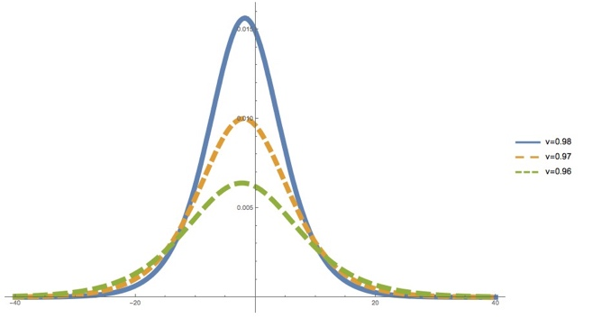

FIG. 1: Profiles of one soliton solution with $α=1.2$ for different velocity values. The highest pulse is slower then other soliton pulses.

B. Two and three soliton solutions and their interactions
When analyze two soliton solutions. The unknown function $f\left(z, τ\right)$ in the equation (6) has the form
$f\left(z, τ\right)=1+φ_{1}+φ_{2}+Aφ_{1}φ_{2} (9)$
Where

$$φ_{i}=e^{z_{i}}, { z}_{i}=r_{i}z+ε_{i}ω_{i}τ+{\overline{z}}_{i} , i=1, 2$$

Here the parameters $r_{i}, ω_{i}, {\overline{z}}_{i}$ are constants and $ε_{i}=±1$. Transforming the variables $z_{i}$ as $z_{i}=r_{i}\left(z+α_{i}+ε_{i}v_{i}τ\right)$, being $v_{i}={ω_{i}}/{r_{i}}$ the velocities of the wave packets, $α_{i}={\overline{z}}_{i}/r_{i}$, y $r_{i}≠0$. By substituting these expressions in the eq. (9) for $N=2$ and taking in mind analytical solutions, it is posible to determine the value of the parameter $A$
$$A=\frac{{\left(ε_{1}v_{1}-ε_{2}v_{2}\right)}^{2}-3{\left(r_{1}-r_{2}\right)}^{2}}{{\left(ε_{1}v_{1}-ε_{2}v_{2}\right)}^{2}+3{\left(r_{1}-r_{2}\right)}^{2}} . (10)$$

The relationship between the velocities $v_{i}$ and parameters $r_{i}$ are:

$$v_{i}^{2}=1-r_{i}^{2}$$
Like for the previous one soliton solution, since amplitudes are dependent on velocities, the solutions of less amplitude are moving faster than the larger amplitude ones. This property is very different from what happens with the common solitons of KdV and others non linear systems, where the behavior is exactly inverse. The 2-soliton solution has the following analytic form [6]
$$u=\frac{\left(4r_{1}^{2}{Sech}^{2}\left(z_{1}/2\right)+4r_{2}^{2}{Sech}^{2}\left(z_{2}/2\right)+\left(A-1\right){Sech}^{2}\left(z_{1}/2\right){Sech}^{2}\left(z_{2}/2\right)\left[G\left(Z, τ\right)\right]\right)}{{\left[4+\left(A-1\right)\left\{1+Tanh\left({z_{1}}/2\right)\right\}\left\{1+Tanh\left({z_{2}}/2\right)\right\}\right]}^{2}} (11)$$

with $G\left(z, τ\right)=\left[2r_{1}r_{2}+r_{2}^{2}\left(1+e^{z_{1}}\right)+r_{1}^{2}\left(1+e^{z_{2}}\right)\right]$

For the case $N>2$ the procedure is very similar for example for the $N=3$ the generatrix function $f\left(x, τ\right)$ takes the form
$$f\left(x, τ\right)=1+δ_{1}e^{η_{1}}+δ_{2}e^{η_{2}}+δ_{3}e^{η_{3}}+a_{12}e^{η_{1}+η_{2}}+a_{13}e^{η_{1}+η_{3}}+a_{23}e^{η_{2}+η_{3}}+a_{12}{a_{13}a_{23}e}^{η_{1}+η_{2}+η_{3}}$$
with $δ_{i}=±1$, for $i=1, 2, 3$ and $a_{ij}$ are defined by Eq.(10).

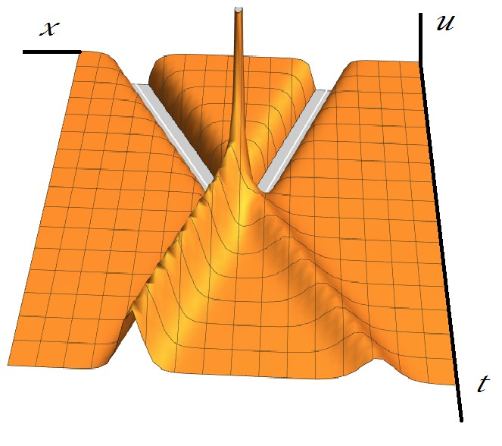
FIG. 2: Interaction of two regular solitons that after collision produce two hole soliton like structure when A < 0. Both solitons are moving in opposite directions to each other.

The sign of the main parameter $A$ in the equation (10) determines the appearance of the following asymptotic types of solutions after mutual pair collisions.
1. When $A>0$ the two types of solutions splits asymptotically when $τ→±∞$ to the one

of the available solutions:
$u≈\frac{r_{i}^{2}}{4}{Sech}^{2}\left({r_{i}\left(x±v_{i}t\right)}/2\right) and u_{II}≈\frac{r_{j}^{2}}{4}{Sech}^{2}\left(lnA+{r_{j}\left(x±v_{j}t\right)}/2\right)$
The parameter velocity region of existence of these regular solutions for definiteness is
$$v_{1}^{2}+v_{2}^{2}-0.5ε_{1}ε_{2}v_{1}v_{2}-1.5\sqrt{\left(1-v_{1}^{2}\right)\left(1-v_{2}^{2}\right)} >1.5$$
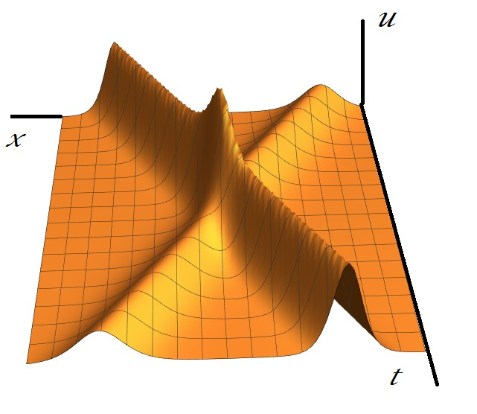

FIG. 3: Two soliton solution for which their amplitudes are not the same. Both pulses travel in opposite direction when the parameter $A>0$
2. If the coefficient $A<0$ additionally to the solutions presented above, could emerge during the splitting after collisions the holon type of soliton similar to solution (8).
3. When $A=0$. In this case we obtain positive singular solutions without any physical sense.
In figure (2) we observe the mutual transformation of holons to regular solitons and viceversa. The figure (3) shows the normal interaction between solitons. The Figure (4) shows us the interaction of three solitons.

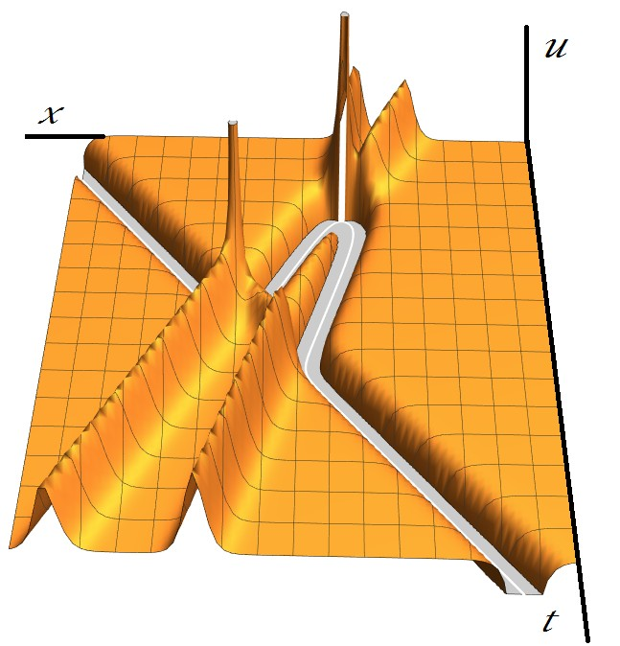
FIG. 4: Three soliton like structures interacting and producing mutual annihilation and creation of singular or regular solitons.

IV. RESULTS AND DISCUSSIONS

By introducing the slight modification to the nonlinear term, we found an important characteristics of the obtained solutions: as the soliton amplitude decreases, its width in- creases. For the case of nerve pulses, this is interpreted as follows: as the soliton amplitude decreases, it possess a smaller energy associated and therefore a smaller amount of phos- pholipids change the state but even in this case, for solitons with velocities around $100m/s$, the corresponding change in the membrane lateral density is about $15.2\%$, which means that nearly the $62\%$ of the membrane passes through the phase transition, which is sufficient to overcome the threshold value for triggering an action potential in the nerve. During the interactions of the explicit regular and singular soliton solutions we can observe the following types of behaviors: normal interaction that means the two solutions after interactions pass each other with small change in their phase; annihilation of solutions. We can say that the creation and annihilation of soliton pulses is possible to take place and in some sense map the experimental facts.

V. AKNOWLEDGMENTS
This work was partly supported by The Secretary of Advanced Studies of the Universidad Autonoma del Estado de Mexico under grant 4294/2017/CI and under agreement PRODEP Mexico /103.5/123510.
VI. Authorization and Disclaimer
Authors authorize ESTEC to publish the papers in the conference proceedings. Neither ESTEC nor the editors are responsible either for the content or for the implications of what is expressed in the paper
REFERENCES
[1] Hodgkin A. L. and Huxley A. F. A quantitative description of membrane current and its appli- cation to conduction and excitation in nerve. J. Physiol. (London) 117(2) 500-544 (1952).
[2] FitzHugh P. G., Mathematical models of excitation and propagation in nerve, Biophys J., 1445466 (1961), Nagumo, J., Arimoto, S., and Yoshizawa, An active pulse transmission line simulating nerve axon, S. Proc. IEEE, 50 20612070,(1964).Ongay F., Aguero M. Bifurcaciones del sistema de FitzHugh Nagumo, Ciencia Ergo Sum, 17-3 295-306, (2011).
[3] http://yatesmccalllabgroup.com/antidromic.html . S. Shrivastava and M. Schneider. Evidence for two-dimensional solitary sound waves in a lipid controlled interface and its implications for biological signaling, Jour. of Royal Society Innterface, DOI: 10.1098/rsif.2014.0098
[4] Heimburg T and Jackson A. Thermodynamics of the Nervous Impulse. Structure and Dynam- ics of Membranous Interfaces. Kaushik Nag (Ed), Wiley-VCH (2007). Heimburg T and Jackson A D. On soliton propagation in biomembranes and nerves. Proc. Natl. Acad. Sci. USA 102 (28) 9790 – 9795 (2005).
[5] R. Hirota in Solitons, R.K. Bullough and P.J. Caudrey Eds. (Springer-Verlag Berlin 1980) p.120.
[6] M. Aguero and R. Alvarado. Bright and singular solitons in the Boussinesq like equation. Phsica scripta, Vol. 62, 232-237, 2000
[7] Villagran-Vargas E, Ludu A, Hustert R, Gumrich P, Jackson A D and Heimburg T. Periodic solution and refractory periods in the soliton theory for nerves and the locus femoral nerve. Biophys Chem. 153 159 – 167

