Sixth Engineering, Science and Technology Conference “Tendencies and Challenges in Engineering, Science and Technology” (ESTEC 2017) October 11 - 13, 2017 Panama City, Panama.

A heavy metal network: connecting remediation strategies

Paola Posligua Chica
Universidad de Las Américas (UDLA), Ingeniería Ambiental, Quito, Ecuador, paola.posligua@udla.edu.ec
Universidad Nacional Mayor de San Marcos, Lima, Perú

Carlos Banchón Bajaña
Universidad Agraria del Ecuador (UAE), Ingeniería Ambiental, Guayaquil, Ecuador, cbanchon@uagraria.edu.ec

Elvito Villegas
Universidad Nacional Mayor de San Marcos, Lima, Perú, elvitovs@yahoo.com
Abstract
Heavy metals in the environment are negatively affecting ecosystems and human life. The anthropogenic source of heavy metals has increased because of sludge from wastewater plants, tanneries, fertilizers, pesticides, and mining industry. As well as environmental conditions change, there is an effect of sedimentation of heavy metals in natural sediments which affect groundwater sources. Thus, the relevance of the present bibliometric work is to address the different interactions between heavy metals and natural sediments. Therefore, this work claims a perspective to predict heavy metal precipitation behaviors in the presence of cations and anions, changes of pH considering its mineral and organic forms, and, solid and liquid phase displacement, migrations towards the contaminated soil and cationic stabilization of heavy metals. In this sense, Cd, As, Mo, Cr, Al, Mn, Al, Cd, Hg, Zn, Pb, Cu, Co, and Ni are mostly correlated with basic pH and Ca/Mg/Fe/Mn minerals. This network has also found that there is a link connection between the contamination source i.e. fertilizers, pesticides and biosolids, and physical-chemical parameters like ionic strength, oxidation-reduction potential, and salinity. Thus, the scope of the present work includes a different perspective in looking remediation strategies by the generation of a connectionist system.
Keywords: Speciation, bioaccumulation, adsorption, recalcitrance, network
- Introduction
Approximately 663 million people worldwide still lack improved drinking water sources (WHO, 2015) and what remains as natural water sources are being contaminated by almost 2 million tons of sewage every day (UN, 2014). Water is contaminated by nutrients from agricultural runoff, industrial effluents and atmospheric inputs from fossil fuel burning and bushfires. In particular, developing countries discharge more than 70% of their industrial waste into the environment (Corcoran, 2010). The heavy metals are one of the concerns for environmental pollution due to their ability to bio-accumulate and develop a cyanogenic effect on the ecosystem (Masscheleyn, Delaune, & Patrick Jr., 1991). The presence of heavy metals (Hg, Ni, Pb, As, Cu, Cd and Zn) in natural bodies is mainly attributed to the pollution generated by tanneries, textile industries, mining, oil, steel and metal coatings. Specifically, As, Cr, Pb and Hg are located within metals of high significance for public health due to their bioaccumulation in the food chain (Tchounwou, Yedjou, Patlolla, & Sutton, 2012). For example, the World Health Organization (WHO) identified that a significant population in India are under the risk of As contamination. There, the As threshold value (10 mg L⁻¹) has already exceeded up by double (Barla, Shrivastava, Majumdar, Upadhyay, & Bose, 2017; Smedley & Kinniburgh, 2002). To treat industrial or domestic effluents, in many developing countries there is a common practice thru oxidation ponds. The problem is that there is no way to take advantage of residual sludge. Thus, the primary concern is that sludge becomes a sink for persistent contaminants such as heavy metals. Besides, the accumulation of heavy metals in sediments was also identified in many natural bodies due to anthropogenic and natural sources (Davutluoglu, Seckn, Kalat, Yilmaz, & Ersu, 2010; Kalbitz & Wennrich, 1998). In this way, the distribution of heavy metals in the environment is an aim of research to find remediation strategies to extract, adsorb or biotransform them. Thus, if the distribution of heavy metals and their mobility is identified, it can be determined the ways to reduce toxicity and bioavailability. Therefore, herein is presented a novel network approach to understand the physical-chemical dynamics to remediate heavy metal contamination.
- Sources of heavy metals
The natural sources of heavy metal contamination are volcanic eruptions, metal corrosion, atmospheric deposition, geochemical reactions, soil erosion and sediment resuspension (Tchounwou et al., 2012). While pollution from anthropogenic activities comes from pesticides, biosolids, fertilizers, tanneries, textile industries, mining, petrochemistry, steel and metal coatings. Industrial activities are now projected to exceed 3:1 natural sources of heavy metals (Alloway, 2013; Wuana & Okieimen, 2011). In nature, bacterial oxidation of sulfur minerals is a factor in the formation of acid drainage's, where iron reacts by bacterial oxidation of pyrite (FeS₂)(Dutta et al., 2017; Gleisner & Herbert, 2002). Namely, when the pyrite is exposed to air, as in mining excavations, a slow chemical reaction occurs with molecular oxygen (Southam & Beveridge, 1994):
(Eq. 1) FeS₂ + 3.5O₂ + H₂O → Fe⁺² + 2SO₄^{–2} + 2H⁺¹
This initiating reaction leads to the development of the acidic conditions under which Fe⁺² is relatively stable in the presence of oxygen. However, Thiobacillus ferro-oxidants catalyze the oxidation from Fe⁺² to Fe⁺³ (Flis, Glenn, & Dilworth, 1993; Gadd, 1992). The ferric ions are soluble and can react spontaneously with more pyrite to oxidize it, producing more Fe⁺², (SO₄)⁻² and H⁺¹ (increasing the acidity). However, ferric ions are present only when the pH values are less than 2,5. For values above this pH, the Fe⁺³ ion reacts with water to form ferric hydroxide (Fe(OH)₃), which is insoluble (Kps = 6,3 x 10^{–38}). Similarly, copper present in chalcocite (Cu₂S) is oxidized by Thiobacillus ferro-oxidants (Harvey & Crundwell, 1997), by three different reactions:
(Eq. 2) Cu₂S → CuS + Cu⁺²
(Eq. 3) CuS + O₂ → Cu⁺² + (SO₄)⁻²
(Eq. 4) CuS + 8Fe⁺³ + H₂O → Cu⁺² + 8Fe⁺² + (SO₄)⁻² + 8H⁺¹
On the other hand, transition metals are elements that are present in low concentrations in rocks, soils, water and the atmosphere; a small fraction are nutrients (Fe, Cu, Zn, Co, Mn, Cr, Mo, V, Ni) (Hughes & Poole, 1991; Gadd, 1992), but many of them, in high concentrations, are toxic to living organisms. Besides, in nature there is another group of elements of greater ecotoxicity: Hg, Pb, Cd, Al, Tl, Ar. Most of them tend to bioaccumulate in living beings (Bai, Zhang, & Gong, 2006).
The tannery process, which converts animal skin into leather products, includes the discharge of effluents with a toxic level of heavy metals (Cr, Cu, Pb, Zn and Ni) up to 35000 mg/kg. Also, tanneries discharge formic acid, ammonium salts, kerosene, sodium hydroxide, chlorates, sulfuric acid, phenols and even high levels of salinity (Haroun, Idris, & Omar, 2009; Lefebvre & Moletta, 2006). Thus, the contamination from tanneries is a risk situation for almost 2 million people in Asia and Latin America (Harris & McCartor, 2011). Tannery removes the scalp from the animal's skin using alkaline products such as sodium sulfide, which also functions as a chemical sequester for oxygen dissolved in water (Mwinyihija, 2010). The tannery industry consumes more than 100 liters of water and approximately 2 kg of chemicals per square meter of final product and also requires more than 1 ton of fuel per 1000 m² of product (Alibardi & Cossu, 2016). Approximately 500 kg of sludge (40% dry matter content) is generated per tonne of raw skin treated from the treatment process with high levels of fat, skin, surfactants and alkaline lime (El-Bestawy, Al-Fassi, Amer, & Aburokba, 2013; Montañés, Sánchez-Tovar, & Roux, 2014). In general, it is estimated that up to 30% of the chrome used in the tannery is wasted in wastewater (Kavouras et al., 2015; Kiliç et al., 2011). Without proper treatment, direct application of tannery sludge to agriculture is a risk to biodiversity and to the human food chain due to the toxic levels of heavy metals accumulated in the sludge (Silva et al., 2010). Sludge has been mixed with livestock manure for decomposition by vermicomposting, this because direct application of the sludge is toxic to Eisenia fetida worms (Vig, Singh, Wani, & Dhaliwal, 2011). However, the current trend is the extraction of heavy metals by bioleaching using chemilitropic bacteria such as iron and sulfur oxidants (Acidithiobacillus thiooxidans) for the production of fertilizing biosolids (Fang & Zhou, 2007; Y.-S. Wang, Pan, Lang, Xu, & Zheng, 2007).
The United States discharges about 6.2 million tonnes of domestic wastewater annually, while the European Union approx. 10 million tonnes annually (Babel & Del Mundo Dacera, 2006). The significant generation of industrial and domestic effluents is a potential use for agriculture as biosolids. For example, United States applies approximately half of the production of biosolids to its soils, while the European Union about 30% (Silveira, Alleoni, & Guilherme, 2003). However, the reuse of biosolids decreases due to heavy metals from waste plastics, dyes, cleaning products, medicines, and pesticides. Therefore, the use of biosolids in agriculture is a concern, even more, because the use of residual effluents has allowed the irrigation of up to 20 million hectares worldwide (Wuana & Okieimen, 2011). Despite the control of toxicity in wastewater irrigation or use of biosolids, the accumulation of heavy metals in agricultural soil represents a fundamental role in environmental protection.
Liquid discharges from the mining industry contain Cu, Zn, Cd, As, Mn, Al, Pb, Ni, Ag, Cr, Fe and Hg in concentrations between 10⁻⁶ and 10² g/L (Huisman, Schouten, & Schultz, 2006). Drainage activities in this industry have been reported to have a direct impact on 7000 km of rivers and approximately 23000 Ha of lakes and reservoirs in the United States (Cohen, 2006). In South America, silver extraction accounts for approx. 400 metric tons of mercury between the 16th and 20th century (Q. Wang, Kim, Dionysiou, Sorial, & Timberlake, 2004). In Bolivia, more than 330 tons of Hg were discharged from 1952, assuming an average of five mercury units (Maurice-Bourgoin, Quiroga, Chincheros, & Courau, 2000). In the Amazon area, gold mining activities discharged about 3,000 tons of mercury since 1979 (Hilson, 2006). Based on these facts, the authors focussed research interests not only in the liquid phase of natural resources but more emphasis on the contamination with heavy metals in the solid phases like sediments and sludge. A further outlook will be to propose a biological and chemical strategy to capture heavy metal fractions.
- Physical-chemical interactions
The mobility, solubility, bioavailability, and toxicity of heavy metals in the environment will depend on pH changes, ionic strength, mineral precipitation, adsorption-desorption, complexation, plant root adsorption and biological immobilization by microorganisms (Wuana & Okieimen, 2011). Therefore, the ability of sediments to retain or release cations allows the prediction of the environmental effects of wastewater or another kind of wastes. Thus, heavy metals such as free or in colloidal particles will reach thermodynamic equilibrium within the solid phase as a function of the kinetics of physical-chemical changes in dissolution.
The solubility and chemical potential of heavy metals in water will depend on pH and the oxide-reduction potential (ORP) as well as the interaction with organic and inorganic compounds. Changes in liquid phase will eventually cause precipitation of heavy metals and thus their accumulation in the bottom of rivers, estuaries, lagoons and other natural bodies. This precipitation effect has a major impact on the health of the environment due to the continued migration of cations from wastewater to suspended solids or sediments. The transfer of cations is the cause of bioaccumulation, biomagnification, and toxicity in aquatic life. For these reasons, it is of great interest to address the implications of uncontrolled waste handling with dangerous concentrations of heavy metals.
Figure 1 is a network to show the interactions among heavy metals as a function of pH and the types of anions or cations that are present in solid and liquid phases. Most heavy metals tend to precipitate at basic pH, but the precipitation of Ni, Zn, Cu, Pb, and Cd will be carried out in natural sediments at acidic pH in the presence of organic matter. However, Al, Cr, and As will not precipitate under these acidic conditions. In the presence of phosphates, carbonates, clays, silt and hydroxides, Hg, Al, Cu, Mo, Zn, Cd, Pb, Cr, As, Mn will precipitate at basic pH, while Ni, Zn, Cd and As will be adsorbed by Fe/Mn minerals. Cr precipitates in the presence of Ba^{+2,} Pb⁺², and Ag⁺. At acid pH, arsenates and other anionic forms of arsenic will precipitate in the presence of cations. Besides, under acid conditions, As(V) is co-precipitated or adsorbed on iron oxyhydroxides; however, the mobility of As increases when pH is basic (Tchounwou et al., 2012). In general, sediments will tend to adsorb heavy metals according to the presence of clays, carbonates, and oxides of Fe and Mn, organic matter, when pH is basic, and ORP decreases. Also, the content of organic matter, concentrations of Mg and Ca minerals and pH will determine the mobility of heavy metals. Thus, this adsorptive capacity will have a deep effect on the bioavailability of heavy metals in sediments when wastewater is subject to abnormal physical-chemical changes like oxygen concentration depletion.
In the Akyatan Lagoon (Turkey) and in Mulde river (Germany), a pattern of cationic distribution was found under anoxic conditions (Davutluoglu et al., 2010; Kalbitz & Wennrich, 1998). It was shown that metals could be mobilized by decomposition processes and that could affect the displacement of cations in the inert fraction, while the input of metals from anthropogenic activity were in the interchangeable fractions and soluble in acids that are equilibrated in aqueous phase, thus accelerating its bioavailability (Davutluoglu et al., 2010). An important feature of heavy metals is the toxicity and bioavailability for living things; for example, As and Cr are more toxic when they reach their highest oxidation state, while Mn and Fe when they are in their reduced state (Lay & Levina, 2011).

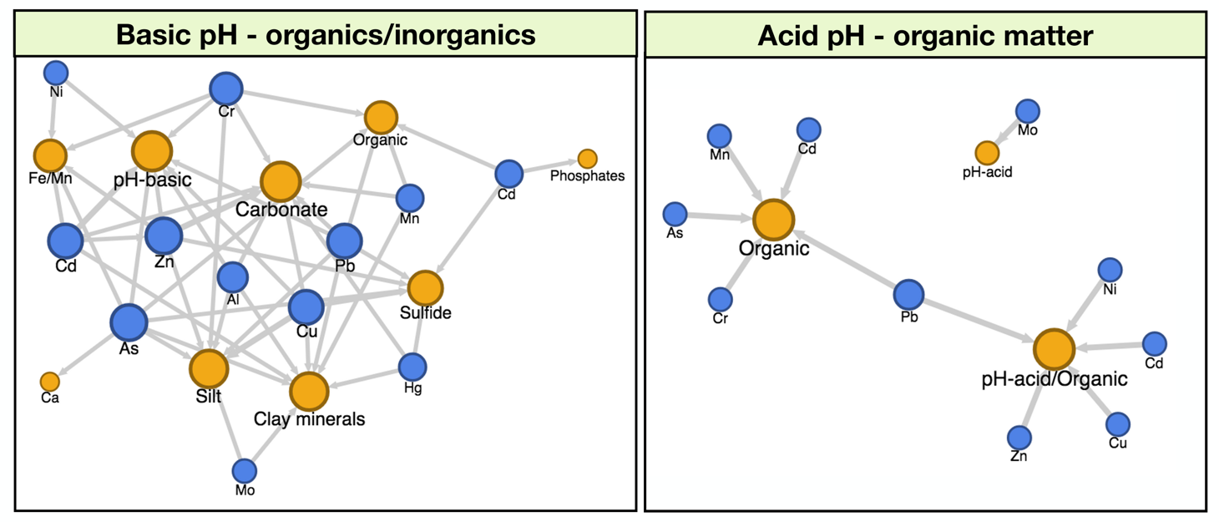

Figure 1: Heavy metals precipitation conditions with acidic and basic pH, and organics/inorganics.
Due to the advance of the agricultural frontier, an indiscriminate use of pesticides and fertilizers accumulate heavy metals in soils. In Asia, rice analysis demonstrate evidence of As, Cd and Pb (M. Wang, Hu, Zhang, & Lai, 2017; Zhang, Jiang, & Ou, 2011). Figure 2 shows a network among the environment, organic matter and heavy metals. According to Fig. 2, As, Al, Pb, Cd, Zn, Cu, Cr tend to precipitate in natural sediments when pH gets basic and also due to interactions among fertilisers, biosolids, pesticides, clay, and silt minerals. Mo, Mn, Co, Ni, and Cu are more alike to precipitate when pesticides, biosolids, and crops like rice are at an acidic pH. Atmospheric deposition of Pb, Hg, Cd and Cu have been found in mega-cities.

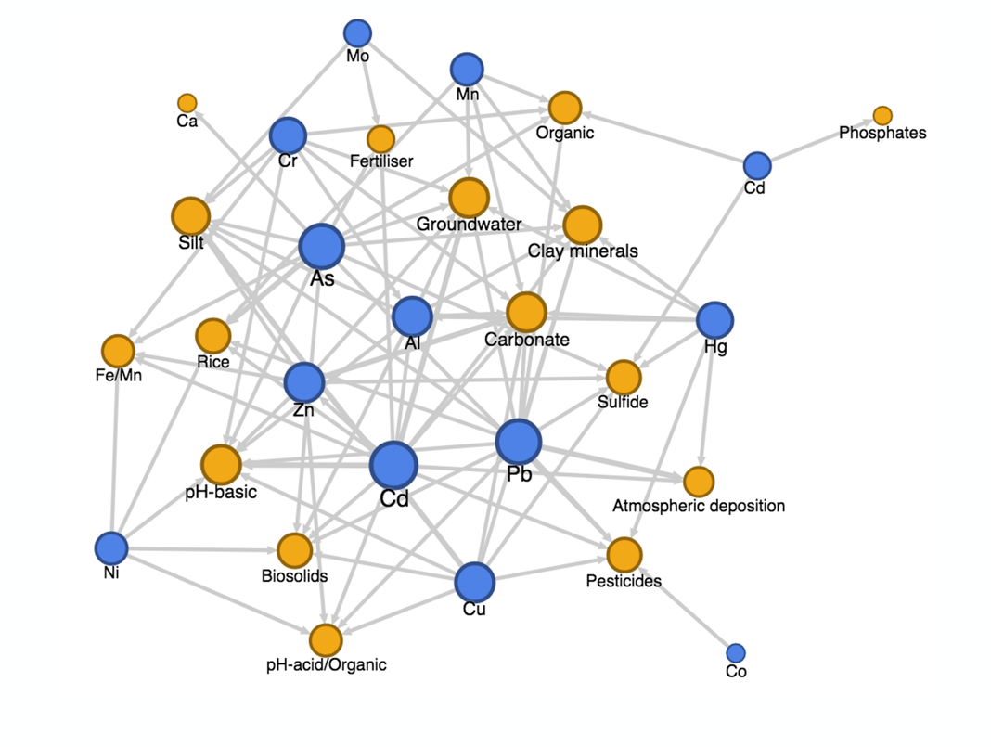

Figure 2: Heavy metals deposition in the environment due to pH and organics/inorganics.

- Outlook on remediation
Before the implementation of remediation technologies, is necessary to identify heavy metals accumulation mechanisms according to the exchange capacity under acidic or basic as well as ORP conditions. Mn and Fe oxides, in combination with sulfides and organic matter, are of great influence in the remediation process. For example, the bioaccumulation on microbial cells has a recalcitrant effect on the degradation of hydrocarbons. Thus, remediation strategies should be designed by analysing all these accumulation mechanisms. As an outlook for remediation, it should consider that heavy metal stabilization is a priority before applying a biological or chemical remediation.
According to Fig. 3, the most used technologies to remediate heavy metals are related with chemical stabilization like precipitation and ionic exchange (i.e. zeolites). Besides, the most commonly used solvent is ethylenediaminetetraacetic acid (EDTA), which acts as a chelating agent with high pollutant removal efficiencies. Phytoremediation technologies are among the most utilized for the remediation of contaminations with heavy metals (Wuana & Okieimen, 2011). One method to control the solubility of heavy metals at acid pH can be the formation of non-toxic complexes with the addition of chelators and organic acids, so therefore a phytoremediation could be enhanced. In precipitation technologies, for example, the common treatment for mining industries effluents is carried out with lime (calcium oxide), calcium carbonate or caustic soda for the precipitation of metal hydroxides (Fig. 3). However, sludge precipitation generates an environmental problem due to the handling of heavy metal hydroxides. It is for this reason that in the United States, the remediation of effluents of the mining industry was implemented through phytoremediation systems. In the 90's, approximately 400 lagoons were built, where totora species were planted for their resistance to heavy metal concentrations and residual water acidity (Cohen, 2006). To this method is added the biological removal of heavy metals by sulfate-reducing bacteria. These heterotrophic or autotrophic anaerobic microorganisms facilitate the conversion of sulfate ions to sulfides. Heavy metals tend to react with sulfur ions, for later precipitation as shown in Fig. 1. On this perspective, the removal of heavy metals by natural adsorbents such as zeolites is highly relevant before applying the main remediation technology like i.e. landfarming. In this context, many ideas come to mind in the design of remediation strategies based on the knowledge of the interactions between heavy metals and the environment.

Figure 3: Ranking of technologies found in scientific literature to remove or stabilize heavy metals.
- Authorization and Disclaimer
Authors authorize ESTEC to publish the papers in the conference proceedings. Neither ESTEC nor the editors are responsible either for the content or for the implications of what is expressed in the paper.
- Acknowledgment
Authors thank Javier Álava, Giovanna Morán, Carmita Lagua, Marco Bastidas and Darío Estupiñán for their collaboration.
References
Alibardi, L., & Cossu, R. (2016). Pre-treatment of tannery sludge for sustainable landfilling. Waste Management, 52, 202–211. https://doi.org/10.1016/j.wasman.2016.04.008
Alloway, B. J. (Ed.). (2013). Heavy Metals in Soils (Vol. 22). Dordrecht: Springer Netherlands.
Babel, S., & del Mundo Dacera, D. (2006). Heavy metal removal from contaminated sludge for land application: A review. Waste Management, 26(9), 988–1004.
Bai, H.-J., Zhang, Z.-M., & Gong, J. (2006). Biological Synthesis of Semiconductor Zinc Sulfide Nanoparticles by Immobilized Rhodobacter spheroids. Biotechnology Letters, 28(14), 1135–1139.
Barla, A., Shrivastava, A., Majumdar, A., Upadhyay, M. K., & Bose, S. (2017). Heavy metal dispersion in water saturated and water unsaturated soil of Bengal delta region, India. Chemosphere, 168, 807–816.
Cohen, R. R. H. (2006). Use of microbes for cost reduction of metal removal from metals and mining industry waste streams. Journal of Cleaner Production, 14(12–13), 1146–1157.
Corcoran, E. (Ed.). (2010). Sick water?: the central role of wastewater management in sustainable development: a rapid response assessment. Arendal, Norway: UNEP/GRID-Arendal. Retrieved from http://www.unep.org/pdf/SickWater_screen.pdf
Davutluoglu, O. I., Seckn, G., Kalat, D. G., Yilmaz, T., & Ersu, C. B. (2010). Speciation and implications of heavy metal content in surface sediments of Akyatan Lagoon Turkey. Desalination, 260(1–3), 199–210.
Dutta, M., Saikia, J., Taffarel, S. R., Waanders, F. B., de Medeiros, D., Cutruneo, C. M. N. L., Saikia, B. K. (2017). Environmental assessment and nano-mineralogical characterization of coal, overburden, and sediment from Indian coal mining acid drainage. Geoscience Frontiers. https://doi.org/10.1016/j.gsf.2016.11.014
El-Bestawy, E., Al-Fassi, F., Amer, R., & Aburokba, R. (2013). Biological Treatment of Leather-Tanning Industrial Wastewater Using Free Living Bacteria. Advances in Life Science and Technology, 12, 46–65.
Fang, D., & Zhou, L.-X. (2007). Enhanced Cr bioleaching efficiency from tannery sludge with co-inoculation of Acidithiobacillus thiooxidans TS6 and Brettanomyces B65 in an air-lift reactor. Chemosphere, 69(2), 303–310.
Flis, S. E., Glenn, A. R., & Dilworth, M. J. (1993). The interaction is between aluminum and root nodule bacteria. Soil Biology and Biochemistry, 25(4), 403–417.
Gadd, G. M. (1992). Metals and microorganisms: a problem of definition. FEMS Microbiology Letters, 100(1-3), 197–203.
Gleisner, M., & Herbert, R. B. (2002). Sulfide mineral oxidation in freshly processed tailings: batch experiments. Journal of Geochemical Exploration, 76(3), 139–153.
Haroun, M., Idris, A., & Omar, S. (2009). Analysis of heavy metals during composting of the tannery sludge using physicochemical and spectroscopic techniques. Journal of Hazardous Materials, 165(1–3), 111–119. https://doi.org/10.1016/j.jhazmat.2008.09.092
Harris, J., & McCartor, A. (2011). The World’s Worst Toxic Pollution Problems. Blacksmith Institute’s. Retrieved from http://worstpolluted.org/docs/TopTen2011.pdf
Harvey, P. I., & Crundwell, F. K. (1997). The growth of Thiobacillus ferroxidase: a Novel Experimental Design for Batch Growth and Bacterial Leaching Studies. Applied and environmental microbiology, 63(7), 2586–2592.
Hilson, G. (2006). Abatement of mercury pollution in the small-scale gold mining industry: Restructuring the policy and research agendas. Science of The Total Environment, 362(1–3), 1–14.
Hughes, M. N., & Poole, R. K. (1991). Metal speciation and microbial growth—the hard (and soft) facts. Microbiology, 137(4), 725–734.
Huisman, J. L., Schouten, G., & Schultz, C. (2006). Biologically produced sulphide for purification of process streams, effluent treatment and recovery of metals in the metal and mining industry. Hydrometallurgy, 83(1–4), 106–113. https://doi.org/10.1016/j.hydromet.2006.03.017
Kalbitz, K., & Wennrich, R. (1998). Mobilization of heavy metals and arsenic in polluted wetland soils and its dependence on dissolved organic matter. Science of The Total Environment, 209(1), 27–39.
Kavouras, P., Pantazopoulou, E., Varitis, S., Vourlias, G., Chrissafis, K., Dimitrakopulos, G. P., … Xenidis, A. (2015). Incineration of tannery sludge under oxic and anoxic conditions: Study of chromium speciation. Journal of Hazardous Materials, 283, 672–679. https://doi.org/10.1016/j.jhazmat.2014.09.066
Kiliç, E., Puig, R., Baquero, G., Font, J., Çolak, S., & Gürler, D. (2011). Environmental optimization of chromium recovery from tannery sludge using a life cycle assessment approach. Journal of Hazardous Materials. https://doi.org/10.1016/j.jhazmat.2011.05.040
Lay, P. A., & Levina, A. (2011). Chromium: Biological Relevance. In Encyclopedia of Inorganic and Bioinorganic Chemistry. John Wiley & Sons, Ltd.
Lefebvre, O., & Moletta, R. (2006). Treatment of organic pollution in industrial saline wastewater: A literature review. Water Research, 40(20), 3671–3682. https://doi.org/10.1016/j.watres.2006.08.027
Masscheleyn, P. H., Delaune, R. D., & Patrick Jr, W. H. (1991). Effect of redox potential and pH on arsenic speciation and solubility in a contaminated soil. Environmental Science & Technology, 25(8), 1414–1419.
Maurice-Bourgoin, L., Quiroga, I., Chincheros, J., & Courau, P. (2000). Mercury distribution in waters and fishes of the upper Madeira rivers and mercury exposure in riparian Amazonian populations. Science of the Total Environment, 260(1), 73–86.
Montañés, M. T., Sánchez-Tovar, R., & Roux, M. S. (2014). The effectiveness of the stabilization/solidification process on the leachability and toxicity of the tannery sludge chromium. Journal of Environmental Management, 143, 71–79. https://doi.org/10.1016/j.jenvman.2014.04.026
Mwinyihija, M. (2010). Main Pollutants and Environmental Impacts of the Tanning Industry. In Ecotoxicological Diagnosis in the Tanning Industry (pp. 17–35). New York, NY: Springer New York. Retrieved from http://link.springer.com/10.1007/978-1-4419-6266-9_2
Silva, J. D. C., Leal, T. T. B., Araújo, A. S. F., Araujo, R. M., Gomes, R. L. F., Melo, W. J., & Singh, R. P. (2010). Effect of different tannery sludge compost amendment rates on growth, biomass accumulation and yield responses of Capsicum plants. Waste Management, 30(10), 1976–1980.
Silveira, M. L. A., Alleoni, L. R. F., & Guilherme, L. R. G. (2003). Biosolids and heavy metals in soils. Scientia Agricola, 60(4), 793–806.
Smedley, P., & Kinniburgh, D. . (2002). A review of the source, behaviour and distribution of arsenic in natural waters. Applied Geochemistry, 17(5), 517–568. https://doi.org/10.1016/S0883-2927(02)00018-5
Southam, G., & Beveridge, T. J. (1994). The in vitro formation of placer gold by bacteria. Geochimica et Cosmochimica Acta, 58(20), 4527–4530.
Tchounwou, P. B., Yedjou, C. G., Patlolla, A. K., & Sutton, D. J. (2012). Heavy Metal Toxicity and the Environment. In A. Luch (Ed.), Molecular, Clinical and Environmental Toxicology (Vol. 101, pp. 133–164). Basel: Springer Basel.
UN. (2014). Water quality. United Nations Department of Economic and Social Affairs. Retrieved from http://www.un.org/waterforlifedecade/quality.shtml
Vig, A. P., Singh, J., Wani, S. H., & Dhaliwal, S. S. (2011). Vermicompo QWQ4sting of tannery sludge mixed with cattle dung into valuable manure using earthworm Eisenia fetida (Savigny). Bioresource Technology, 102(17), 7941–7945.
Wang, M., Hu, K., Zhang, D., & Lai, J. (2017). Speciation and Spatial Distribution of Heavy Metals (cu and Zn) in Wetland Soils of Poyang Lake (China) in Wet Seasons. Wetlands. https://doi.org/10.1007/s13157-017-0917-1
Wang, Q., Kim, D., Dionysiou, D. D., Sorial, G. A., & Timberlake, D. (2004). Sources and remediation for mercury contamination in aquatic systems?a literature review. Environmental Pollution, 131(2), 323–336.
Wang, Y.-S., Pan, Z.-Y., Lang, J.-M., Xu, J.-M., & Zheng, Y.-G. (2007). Bioleaching of chromium from tannery sludge by indigenous Acidithiobacillus thiooxidans. Journal of Hazardous Materials, 147(1–2), 319–324.
WHO. (2015). Progress on sanitation and drinking water. World Health Organization, UNICEF Joint Water Supply and Sanitation Monitoring Programme.
Wuana, R. A., & Okieimen, F. E. (2011). Heavy Metals in Contaminated Soils: A Review of Sources, Chemistry, Risks and Best Available Strategies for Remediation. ISRN Ecology, 2011, 1–20.
Zhang, W., Jiang, F., & Ou, J. (2011). Global pesticide consumption and pollution: with China as a focus. Proceedings of the International Academy of Ecology and Environmental Sciences, 1(2), 125.

