Sixth Engineering, Science and Technology Conference “Tendencies and Challenges in Engineering, Science and Technology” (ESTEC 2017) October 11 - 13, 2017 Panama City, Panama.

Experimental study of a natural ventilation strategy in a full-scale enclosure under meteorological conditions: a buoyancy-driven approach

Miguel Chen Austin
University of Bordeaux, I2M, UMR 5295, 33400 Talence, France, miguel.chen@u-bordeaux.fr
Technological University of Panama, Panama City, Panama, miguel.chen@utp.ac.pa

Denis Bruneau
Arts et Métiers ParisTech, I2M, UMR 5295, 33400 Talence , Bordeaux, France, denis.bruneau@ensam.eu

Alain Sempey
University of Bordeaux, I2M, CNRS, UMR 5295, 33400 Talence, France, alain.sempey@u-bordeaux.fr

Laurent Mora
University of Bordeaux, I2M, CNRS, UMR 5295, 33400 Talence, France, laurent.mora@u-bordeaux.fr

Alain Sommier
University of Bordeaux, I2M, CNRS, UMR 5295, 33400 Talence, France, alain.sommier@u-bordeaux.fr
Abstract
The performance of a natural ventilation strategy, in a full-scale enclosure under meteorological conditions is studied through an experimental study, a buoyancy-driven approach, by means of the estimation of the air exchange rate per hour and ventilation power. A theoretical and an empirical model are proposed based on the airflow theory in buildings and blower-door tests. A preliminary validation, by comparing our results with standards in air leakage rate determination, is made. The experimental study conducted here has shown that the natural ventilation strategy implemented reach promising air exchange rate levels, as they are rather high compared to other experimental studies found in the literature. The proposed models have shown good potential and further analysis should take place. Also, other methods for validating these models should be implemented (for instants: CFD simulation or tracer gas methods), as the one in the standards is rather rough estimations.
Keywords: Buoyancy-driven, natural ventilation, ventilation power, blower-door test, airflow in buildings.
Resumen
El desempeño de una estrategia de ventilación natural en un recinto a escala real bajo condiciones meteorológicas es estudiada a través de un estudio experimental, desde el punto de vista de la ventilación impulsada por diferencia de temperatura, mediante la estimación de la taza de renovación del aire y la potencia de ventilación. Se propone un modelo teórico y un modelo empírico basado en la teoría del flujo de aire en edificios y blower-door test. Una validación preliminar es realizada, en la cual se comparan nuestros resultados con los estándares pertinentes. El estudio experimental realizado aquí demostró que la estrategia de ventilación natural implementada alcanza niveles prometedores de la taza de renovación del aire, ya que son bastante altos en comparación con otros estudios experimentales encontrados en la literatura. Los modelos propuestos han demostrado un buen potencial y análisis complementarios deben realizare. Además, se deben implementar otros métodos para validar estos modelos (por ejemplo: simulación CFD o métodos de tracer gas), ya que el de los estándares son estimaciones aproximadas.
Palabras claves: Ventilación impulsada por diferencia de densidad, ventilación natural, potencia de ventilación, blower-door-test, flujo de aire en edificios.
- Introduction
Many centuries have passed since natural ventilation is being used to fit our needs regarding the freshening and renewing of the air, and more than 50 years since it is formally studied. Yet, the mechanics of such process hasn’t been fully understood. Many Softwares in fluid dynamics have been developed ever since, to aid such understanding. Natural ventilation is driven by wind forces and buoyancy forces; here, only the natural ventilation due to thermal buoyancy forces is considered. This natural ventilation principle is driven by density differences between the indoor and outdoor air. This study aims to identify the performance of a night natural ventilation strategy, by means of the estimation of two parameters: the air exchange rate per hour and the ventilation power; the development of a theoretical and an empirical model, is presented. Experiments were carried out on a test platform (considered here as a single-zone building) called “Sumbiosi” in the campus of the University of Bordeaux. This platform is a BEPos prototype and was born out of the competition Solar Decathlon in 2014 (a simple scheme is presented in figure 1).
Both models are based on the airflow theory in buildings. The empirical model is particularly based on blower-door tests. In civil engineering, such tests help the designer and builder, to know the air leakage rate and the minimum air exchange rate, assuring that the natural airflow rates of the building’s construction are consistent with the standards and regulations. According to these standards, the air leakage rate is determined by performing blower-door tests at very high-pressure differences using fans, and all doors and ventilation openings are kept closed. Here, we proposed to use this technic to determine the air exchange rate when the ventilation openings are opened. Hoping that this study will help the determination of an instant air exchange rate due to thermal buoyancy forces in monozone enclosures, using simple “in situ” measurements.
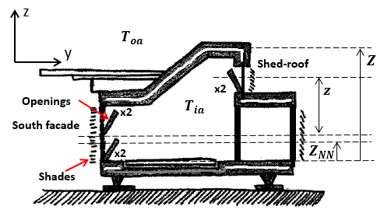
Figure 1: Schematic representation of the simple model

- Methodology
This section is committed to the development of a simple theoretical and empirical model.
  - Hypothesis and assumptions
To overcome some limitations in this study, all hypotheses and assumptions used here, are listed with their respect mathematical notation and justification in Table 1. Each hypothesis or assumption will be taken into account only when cited or mentioned.
  - Theoretical analysis: an enclosure with air infiltrations uniformly distributed, small openings and turbulent airflow regime
A simple and theory-based model is implemented here to estimate the air exchange rate per hour and ventilation power. A schematic is presented in figure 1. For the analysis, the openings are considered small (see hypothesis No.1 in Table 1) and air infiltrations/exfiltrations on the enclosure’s envelope are considered uniformly distributed. Under assumption No.2, the theoric air exchange rate (${\text{ach}}^{\text{th}}$), when the enclosure’s openings are closed (eq. 1) and opened (eq. 2), is determined by the following equations, respectively:

Table 1: Hypotheses and assumptions
No. | Hypotheses/assumptions | Notation | Justification
1 | Small openings | $$z_{\text{opening}}\text{<<}Z$$ | A typical assumption where the openings’ height is considered small as no bidirectional flow due to thermal buoyancy take place at the opening’s height
2 | Flow regime is fully turbulent at the openings | $$\overset{˙}{V}∝\sqrt{ΔP}$$ | For a real building $\overset{˙}{V}∝{\left(ΔP\right)}^{n}$, where n = 0,5 stands for a turbulent regime and n = 1 for laminar regime
3 | Boussinesq approximation | $$Δρ=\text{ρβ}ΔT$$ | To simplify calculations
4 | Ideal gas approximation | $$β=1/T$$  $$P=ρ\text{RT}$$ | To simplify calculations
${\text{ach}}_{\text{closed}}^{\text{th}}=\frac{\text{3600}C_{d}A|_{\text{eq}−\text{closed}}}{V_{\text{ia}}}\sqrt{\frac{2ΔP}{ρ}}$ (1)
${\text{ach}}_{\text{opened}}^{\text{th}}=\frac{\text{3600}C_{d}A|_{\text{eq}−\text{opened}}}{V_{\text{ia}}}\sqrt{\frac{2ΔP}{ρ}}+{\text{ach}}_{\text{closed}}^{\text{th}}$ (2)
where $V_{\text{ia}}$ is the indoor air volume, $ρ$ the air density and $ΔP$ represents the pressure difference between the indoor and outdoor air. The term $C_{d}A|_{\text{eq}−\text{opened}}$ represents the opposing equivalent resistance, in the airflow direction, by the enclosure openings and here we propose to use the following arrangement, based on (Allard 1998) and the hypothesis No.1:
$C_{d}A|_{\text{eq}−\text{opened}}={\left[\frac{1}{{\left(2C_{d}A|_{\text{South}}+2C_{d}A|_{\text{Shed}}\right)}^{2}}+\frac{1}{{\left(2C_{d}A|_{\text{South}}\right)}^{2}}\right]}^{−12}$ (3)
where $C_{d}$ is the discharge coefficient of the opening, which accounts the contraction and friction loss (Heiselberg et al., 2000) and $A$ is the effective area of the opening, which accounts only the free cross passing area. When the openings are closed, equation 3 reduces to: $C_{d}A|_{\text{eq}−\text{closed}}=C_{d}A|_{\text{leakage}}$ where in this case the $C_{d}$ account for the characteristics of the cracks, windows or doors joints (Zürcher and Frank, 2014). This value will be determined experimentally. Under hypothesis No.1, which indicates that the openings height is negligible with respect to the absolute height of the enclosure, the overall pressure difference ($ΔP$) is given by $ΔP=Δρ\text{gz}$, where $z$ is the distance between the center of the south facade and upper opening (see figure 1) when opened, and is $Z/2$ when closed. Together, eqs. 1 to 3 with assumptions No.3 and No.4, the air exchange rate could be expressed as a function of the temperature difference between the indoor and outdoor air (denoted with the subscripts “ia” and “oa”, respectively), as follows:
${\text{ach}}_{\text{leakage}}^{\text{th}}=\frac{\text{3600}C_{d}A|_{\text{eq}−\text{leakage}}}{V_{\text{ia}}}\sqrt{\frac{2\left|T_{\text{ia}}−T_{\text{oa}}\right|\text{gz}}{T_{\text{ia}}}}$ (4)
${\text{ach}}_{\text{opened}}^{\text{th}}=\frac{\text{3600}\left(C_{d}A|_{\text{eq}−\text{opened}}+C_{d}A|_{\text{leakage}}\right)}{V_{\text{ia}}}\sqrt{\frac{2\left|T_{\text{ia}}−T_{\text{oa}}\right|\text{gz}}{T_{\text{ia}}}}$ (5)
Here, the values of the discharge coefficients employed for this type of openings and for the leakages orifices, are not presented here. The natural ventilation power ($Φ_{\text{NV}}$) will be calculated by the basic equation: $Φ_{\text{NV}}={ρc}_{p}V_{\text{ia}}\frac{\text{ach}}{\text{3600}}\left(T_{\text{oa}}−T_{\text{ia}}\right)$, which gives the instant natural ventilation power in W. The following section is dedicated to model the air exchange rate based on experimentation.
  - Empirical analysis: an enclosure with air infiltrations no-uniformly distributed and unknown airflow regime
Now, in the case that the air infiltrations/exfiltrations are considered not to be uniformly distributed on the enclosure’s envelope, and the airflow regime is unknown, the air exchange rate per hour is determined when openings are closed by the following equation:
${\text{ach}}_{\text{leakage}}^{\text{emp}}=\frac{C_{\text{env}−\text{leakage}}}{V_{\text{ia}}}{\left(ΔP\right)}^{n_{\text{leakage}}}$ (6)
where $C_{\text{env}}$ is the airflow rate coefficient in $m^{3}h^{−1}{\text{Pa}}^{−n}$ which depends on the leakage surface and the shape of the orifices of the envelope; $n$ is the airflow exponent which indicates the flow regime, varying from 0,5 for fully turbulent to 1 for fully laminar and normally 2/3 for the transition region (Zürcher and Frank, 2014; Allard and Ghiaus, 2005). $ΔP$ is the building’s pressure difference between the inside and the outside. The air leakage area ($A_{l}$) as a function of the pressure difference by the following equation:
$C_{d}A|_{\text{leakage}}=\frac{1}{\text{3600}}C_{\text{env}−\text{leakage}}{\left(\frac{ρ}{2}\right)}^{12}{\left(ΔP\right)}^{n_{\text{leakage}}−12}$ (7)
As for equation 3, we propose a similar expression for the term $C_{d}A|_{\text{eq}−\text{opened}}$ , but now using the definition in equation 7 which will be determined by the blower-door tests:
$$C_{d}A|_{\text{eq}−\text{opened}}^{−2}=\frac{1}{{\left(\frac{1}{2}\frac{C_{\text{env}−\text{South}}}{\text{3600}}{\left(\frac{ρ}{2}\right)}^{12}{\left(ΔP\right)}^{n_{\text{South}}−12}+\frac{C_{\text{env}−\text{Shed}}}{\text{3600}}{\left(\frac{ρ}{2}\right)}^{12}{\left(ΔP\right)}^{n_{\text{Shed}}−12}\right)}^{2}}$$
$+\frac{1}{{\left(\frac{1}{2}\frac{C_{\text{env}−\text{South}}}{\text{3600}}{\left(\frac{ρ}{2}\right)}^{12}{\left(ΔP\right)}^{n_{\text{South}}−12}\right)}^{2}}$ (8)
As said in §1, equation 6 is determined by performing blower-door tests where the enclosure’s openings are kept closed. Here, we have tried to perform these tests keeping the openings not closed for different opening configurations: (i) only the openings at the South facade are opened, (ii) only the openings at the Shed-roof are opened, and (iii) both openings are opened. The air exchange rate per hour would be then, determined by equation 5. Several blower-door tests have been carried out with the aim of determining the relation presented in equations 6 to 8 for the cases (i) to (iii). For eq.6, only one fan was required and two fans for cases (i) to (iii). As in §2.2, the pressure difference is expressed in terms of temperatures:
$ΔP=\frac{{\text{gP}}_{\text{ref}}}{R}\left(\frac{T_{\text{ia}}−T_{\text{oa}}}{T_{\text{oa}}T_{\text{ia}}}\right)z$ (9)
where $R$ is the air constant when considering it as an ideal gas and $P_{\text{ref}}$ is a reference pressure, usually the atmospheric pressure. Here $P_{\text{ref}}$ is taken to be 101325 $\text{Pa}$; $R$ to be 287${\text{Jkg}}^{−1}K^{−1}$ and $g$ to be 9,81${\text{ms}}^{−2}$.
  - Validation
A preliminary step in validating the former models presented here could be by comparison with the standards in air leakage rate determination, such as NF EN 12831 (2004). this standard uses the following model to determine the air leakage flow rate per hour, based on blower-door tests for estimating the heat losses of a heated space due to air leakage (Penu, 2015).: ${\text{ach}}_{\text{leakage}}=2{\text{ach}}_{@\text{50}\text{Pa}}e_{i}ε_{i}$, where ${\text{ach}}_{@\text{50}\text{Pa}}$ is the air exchange rate per hour at a pressure difference of 50 Pa between indoors and outdoors, $e_{i}$ is the exposure coefficient of the heated space, $ε_{i}$ is a height correction factor.
In this study, the platform can be considered as a standard monozone building with double glazed windows with normal joints. Thus, according to the standard, the value of ${\text{ach}}_{@\text{50}\text{Pa}}$ is normally between 4 to 10 $h^{−1}$. Considering the site where the platform is installed as moderately s sheltered by surrounding buildings, the values of $e_{i}$ and $ε_{i}$, are 0,02 and 1, respectively. The blower-door tests results for ${\text{ach}}_{@\text{50}\text{Pa}}$ are not presented here.
  - Description of the experiments carried out
During summertime, a measurement campaign was carried out from July 27th to September 12th, 2016. The natural ventilation strategy implemented was the one showed in figure 1, where the openings at the South facade and Shed-roof were programmed to open when the indoor air temperature is greater than the outdoor air, and they were programmed to close otherwise and when raining. We encountered that most of the time, the openings were closed during daytime and open during nighttime. All along the measurement campaign; air and surface temperatures, airspeed and heat flux measurements were carried out. Here, only the temperature measurements will be required, which were performed by type T thermocouples previously calibrated, having an absolute uncertainty of ±0,3°C. In order to test the models presented in previous sections, only data from the days that have presented winds with anticyclonic characteristics will be used: low speed (< 5 ${\text{kmh}}^{−1}$) and variable direction. This is the case for the nighttime of August 15th and 16th. Both days had similar meteorological conditions, in the daytime as in nighttime, according to (Météo France Sud-Ouest, 2016): Clear and sunny with same temperature levels in daytime, and partly cloudy during nighttime with same temperature levels; the same windspeed, but not the same direction during the daytime.
- Results and discussion:
In order to compare the results from the theoretical and empirical models, the results obtained are presented in the following figures and table. The indoor and outdoor temperatures for both days are presented in figure 2. Results for the instant air exchange rate per hour, from both models, are presented in figure 3. On this figure, it can be observed that when the openings are opened (zone b), the values from the theoretical model are greater than empirical ones, as expected; when the openings are closed (zone a), the results from both models cannot be distinguished from one another. This is because the same experimental data were used to determine these values for both models and might be justified by the fact that the only way to determine the air leakage rate “in situ” is through experimentation. The main difference between equations 3 and 8 is that the former uses constants values in the opening’s equivalent airflow resistance ($C_{d}A|_{\text{eq}−\text{opened}}$) and the latter uses an expression that allows this opening’s equivalent airflow resistance to vary with the pressure difference between the enclosure’s inside and outside. In this matter, if the average value of the resulting air exchange rate for both models (see Table 2: averaged air exchange rate values are presented with its standard deviation) is taken, small differences were encountered: 7,2% (5,78% taking the maximum values). This consideration of an airflow resistance that depends on the pressure difference has been analyzed and proved by various studies, as in (Heiselberg et al., 2000). Very similar results were encountered comparing both days. In part, this might be explained by the fact that, there were very similar meteorological conditions. Nevertheless, it can be observed in figure 3, the air exchange rate levels had reached around 5$h^{−1}$only by thermal buoyancy forces when the natural ventilation strategy is applied. The performance of this strategy can be highlighted by plotting the air exchange rate per hour with respect to the parameter that characterized the buoyancy force ($ΔT$), as shown in figure 4. For instance, it can be observed that a temperature difference near 13°C (when the outdoor temperature is higher than indoors, zone a) is needed to reach values near 1,5$h^{−1}$, while when the strategy is applied (zone b), only a temperature difference near 0,5°C was needed to reach 1,5$h^{−1}$. The negatives values indicate when the outdoor air temperature is higher than the indoor. Moreover, a more reliable comparison could be done on the same time-period but, based on measurements: How different would the $\text{ach}$ values be? First, when the openings are closed and then when they are opened during the same time-period; here it is done at different time-periods. This before could become a difficult task, as two days in a row with the same meteorological conditions would be needed and predicted conditions could vary rapidly, despite the very accurate models which can predict the daily weather.
Continuing the evaluation of the performance, figure 5 shows the ventilation power in kW with respect to the temperature difference. Results from the theoretical model could be distinguished from those from the empirical model, having a maximum absolute difference of 0,08 kW (5,26% maximum). Negative values in the ventilation power indicate a heat loss: heat flows from the inside to the outside. The empirical model estimated an energy loss by ventilation of approximately 26,7 MJ for August 15th and 32,5 MJ for August 16th, when the ventilation strategy is applied (zone b). On the other hand, when the openings were kept closed (zone a), they estimated an energy gain of approximately 24,7 MJ for August 15th and 14,3 MJ for August 16th. Thus, overall, 2 MJ were lost on August 15th and 18,2 MJ were lost on August 16th, only by ventilation. These results may seem very high, but they should be compared with the building total thermal capacity and other heat sources but, which are not part of this study.
- Conclusions and perspectives
An experimental study was conducted to identify the performance of a buoyancy-driven natural ventilation strategy, by means of the air exchange rate per hour and ventilation power levels. This study has shown that the implemented strategy reached promising air exchange rate levels, as they are rather high compared to other experimental studies found in the literature. The proposed models have shown good potential and further analysis should take place. Also, other methods for validating these models should be implemented, as for the one in the standards are rather rough estimations; for instants: CFD simulation, tracer gas methods, among others. Furthermore, a model that considers both, buoyancy and wind forces, is currently being developed.
References
Allard, F. (1998). Natural Ventilation in Buildings: A Design Handbook. James & James (Science Publishers), London.

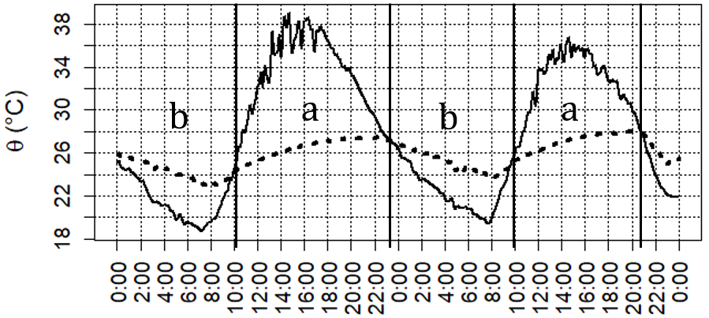  Figure 2: Indoor (dotted line) and outdoor air (solid line) temperatures from August 15th to 16th | 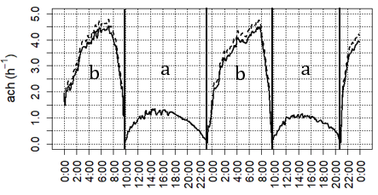  Figure 3: Air exchange rate for August 15th to 16th: theoretical (dashed line) and empirical (solid line) model
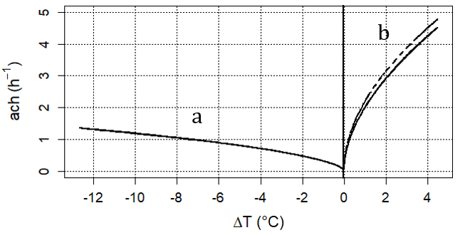  Figure 4: Air exchange rate and $ΔT=T_{\text{ia}}−T_{\text{oa}}$: theoretical (dashed lines) and empirical (solid lines) model, for August 15th. Zone a: openings closed. Zone b: openings opened | 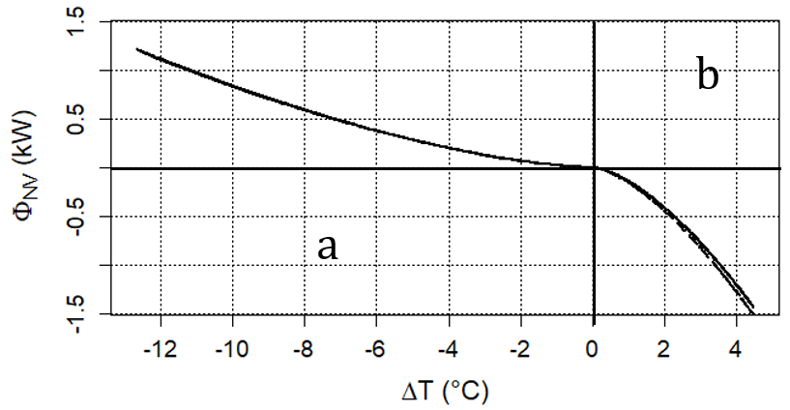  Figure 5: Ventilation power and $ΔT=T_{\text{ia}}−T_{\text{oa}}$: theoretical (dashed lines) and empirical (solid lines) model, for August 15th. Zone a: openings closed. Zone b: openings opened

Table 2: Averaged results for the air exchange rate per hour
 | Theoretical model |  | Empirical model |  | NF EN 12831
Date | $${\overline{\text{ach}}}_{\text{opened}}^{\text{th}}$$ | $${\overline{\text{ach}}}_{\text{closed}}^{\text{th}}$$ | $${\overline{\text{ach}}}_{\text{opened}}^{\text{emp}}$$ | $${\overline{\text{ach}}}_{\text{closed}}^{\text{emp}}$$ | opened | closed
15/08/16 | 3,43 ± 1,17 | 0,90 ± 0,34 | 3,20 ± 1,13 | 0,90 ± 0,34 | 4,48 ± 0,02 | 0,5664 ± 0,01
16/08/16 | 3,57 ± 0,92 | 0.79 ± 0,28 | 3,33 ± 0,89 | 0,79 ± 0,28 | 4,48 ± 0,02 | 0,5664 ± 0,01

Allard, F., and Ghiaus, C. (2005). Natural Ventilation in the Urban Environment: Assessment and Design, Earthscan, London.
Heiselberg, P., Svidt, K., and Nielsen, P.V. (2000). “Windows: measurements of air flow capacity”. Indoor Environmental Engineering, Vol. R0040, No. 115.
Météo France Sud-Ouest. (2016). Data for 2014-2017, http://www.sudouest-visite.com/meteo-france-sud-ouest/historique-meteo-sud-ouest-de-la-france.html, 06/26/17. (date accessed)
Penu, G. (2015). La thermique du bâtiment, 2rd edition, Dunod, Paris.
Zürcher, C., and Frank, T. (2014). Physique du Bâtiment : Construction et Energie, 1rd edition in french and 4rd edition in german, Hochschulverlag AG an der ETH, Zurich.

Authorization and Disclaimer
Authors authorize ESTEC to publish the paper in the conference proceedings. Neither ESTEC nor the editors are responsible either for the content or for the implications of what is expressed in the paper.

