Sixth Engineering, Science and Technology Conference “Tendencies and Challenges in Engineering, Science and Technology” (ESTEC 2017) October 11 - 13, 2017 Panama City, Panama.

Finding chemical pathways toward the valorization of automobile-service-station wastes

Janina Chauca
Universidad Agraria del Ecuador, Ing. Ambiental, Guayaquil, Ecuador, janina244@hotmail.es

María Rosales
Universidad Agraria del Ecuador, Ing. Ambiental, Guayaquil, Ecuador, maryangels1993@hotmail.com

Diego Muñoz
Universidad Agraria del Ecuador, Ing. Ambiental, Guayaquil, Ecuador, dmunoz@uagraria.edu.ec

Carlos Banchón
Universidad Agraria del Ecuador, Ing. Ambiental, Guayaquil, Ecuador, cbanchon@uagraria.edu.ec
Abstract
Automobile-service-station wastes make for an acute environmental concern because they contain polyaromatic hydrocarbons, heavy metals, surfactants, and other harmful elements. An eco-friendly way to treat and take advantage of these wastes is embodied in the concept called "valorization". In the present work, valorization is described as a chemical process to remove solids from contaminated water and to stabilize oily sludge into a saponified product. Electrocoagulation and coagulation with aluminum were applied to separate oil-water emulsions and removed 99.7% of turbidity. Both coagulation processes obtained approximately 0.85 kg of treated water and 0.027 kg of dried oily sludge per kg of wastewater. A saponification process with dosages of 10% NaOH stabilized the dried oily sludge. In hopes of finding pathways to valorize wastes, chemical treatments with aluminum and NaOH obtained a product that can be used as a surfactant or as an energy source.
Keywords: sludge, electrocoagulation, saponification, oil, wastewater
- Introduction
Worldwide, global oil consumption accounts for 4.7 billion tons per year, of which approximately 40 million tons of lubricants are used (IEA, 2017; Mang, 2007). In the last few years, around 1 million tons ended up as spillage in marine environments or as waste in landfills (Madanhire & Mbohwa, 2016; Mang, 2007; Sabir, 2015). The implications of this problem for humans and aquatic life are of great concern since one liter of benzene can negatively affect several million gallons of water (Sabir, 2015). In specific, the inadequate management of wastes in automobile service stations threatens the biodiversity of natural resources. This is because the used oil is composed of wear debris, surfactants, phenols, asphaltenes, paraffins, naphthas, dispersants, antirust agents, polycyclic aromatic hydrocarbons (PAH), and heavy metals such as Pb, Zn, Cr, Cu, and Cd (Chawaloesphosiya, Mongkolnauwarat, Prommajun, Wongwailikhit, & Painmanakul, 2015; Vanhanen et al., 2004). Oil wastes in contact with surfactants can emulsify and, therefore, boost bioaccumulation and toxic effects. Thus, treatment methods for oily wastes like skimming and filtration do not completely remove emulsified oil. Currently, the most commonly used methods to separate contamination are coagulation, natural adsorption, bioreaction, and ultrafiltration in reaching an oil and chemical oxygen demand (COD) removal efficiency of up to 98% (Annunciado, Sydenstricker, & Amico, 2005; Hanafy & Nabih, 2007; Yeber, Paul, & Soto, 2012; Yu, Han, & He, 2013). However, given the environmental problems generated by oily residues, separation technologies just move the problem to another matrix. Therefore, from an eco-friendly perspective, the following are the main contributions of the present research:
- a coagulation-flocculation process to remove oil from water by electrochemical means, and
- a chemical process to valorize automobile service station wastes by drying and caustic stabilization through saponification.
This research proposes not only the clarification of water but also chemical pathways to valorize oily sludge.
MATERIALS AND METHODS
The wastewater was collected at the grease trap effluent from an automobile-service-station located in Guayaquil (Ecuador). The valorization process started with the separation of the oil fraction from water by electro- and cationic coagulation. All coagulation processes consumed a total amount of 76 L of wastewater starting at a pH of 8.5. The batch electrocoagulation treatments combined two variables: the number of electrodes and the reaction time, according to Table 1. The anode electrode consisted of aluminum and cathode electrodes of iron. Each electrode was 3 cm wide and 25 cm long. The distance between each electrode was 2 cm, and the power source was 17 A and 24 V. For coagulation, a 15% (w/v) polyaluminum chloride (PAC) solution and 0.1% polyacrylamide polymer (PA) solution were used to treat 250 mL wastewater per batch (Banchon, Castillo, & Posligua, 2017). For 15% PAC and 0.1% PA, the dosages were 4, 8, and 16 mL/L and 3.2, 7.2, and 15.2 mL/L, respectively.

Table 1: Electrocoagulation treatments
Treatments | Reaction time  (hours) | Number of electrodes
E1 | 2 | 4
E2 | 2 | 10
E3 | 36 | 4
E4 | 36 | 10

The valorization process of the oily sludge consisted of its drying and saponification to produce a cheap fuel or a detergent to remove industrial grease. After coagulation, sludge was filtered from the treated water and then carefully dried at 150°C for two hours. Afterward, a dry sludge sample was fired on a flat surface to evaluate the degree of combustion. For the saponification, a dried sludge sample was reacted with different NaOH concentrations (1%, 5%, and 10%) in dosages of 50, 100, and 200 mL per gram of dried sludge. This reaction was carried out at 80°C, and after that, the product was evaluated by the appearance of foam and detergency effects.
- RESULTS AND DISCUSSION
Oily wastewater had an initial turbidity ranging from 481 to 800 NTU. According to literature, high turbidity is mainly due to the formation of an oil-in-water emulsion because of surfactant content due to car washing (Kabdaşlı, Arslan-Alaton, Ölmez-Hancı, & Tünay, 2012). Since high turbidity appears to be the first issue to solve, it was hypothesized that emulsified oil droplets had a net negative charge that aluminum could destabilize. Therefore, to test this hypothesis, four electrocoagulation treatments evaluated the optimal number of electrodes and reaction times while three coagulation treatments determined the optimal dosage of PAC and PA solutions. The results in Figure 1 confirmed the hypothesis that colloidal contamination had negative electrical charges and that aluminum destabilized this emulsion. The addition of 8 mL of 15% PAC per liter wastewater removed around 99.7% of turbidity while 16 mL of 15% PAC removed just 87.3%. This effect means that a high dose of PAC does not mean an optimal removal of colloidal contamination. This is because an excess of Al(OH)₃ could be responsible for the increase of turbidity of treated water because of poor sedimentation (Chawaloesphosiya et al., 2015). From results of Fig. 1 and 2, the best coagulation process was the one using chemical solutions. Thus, the following experiments focused on the drying of sludge and the following stabilization process thru drying and saponification.

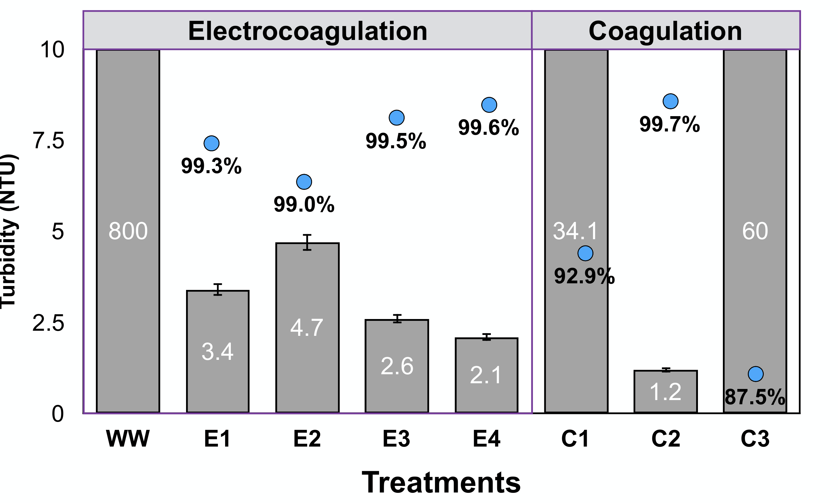

Figure 1: Turbidity in treatments using electrocoagulation and coagulation. Where, WW is wastewater, E1 to E4 are treatments according to Table 1 and C1 to C3 are coagulation treatments.

In Figure 2, the mean turbidity shows the interaction between the number of electrodes and reaction times during electrocoagulation. According to Fig. 2B, the greater the number of electrodes, the higher the removal of turbidity. Based on these findings, an optimization process was performed using ten electrodes (Fig. 2C). It was confirmed that increasing the electrocoagulation time does not greatly influence the turbidity removal results. Thus, a prolonged reaction time does not make sense since electrocoagulation is 96% effective in less than 40 minutes. Herein, all results agree with the earlier published literature with removal efficiencies as high as 99% (Adhoum, Monser, Bellakhal, & Belgaied, 2004). However, in series cell arrangement, a high potential difference is required for a given current to flow because cells connected in series have high resistance, and therefore in some point a less efficiency (Kabdaşlı et al., 2012).
The electrochemical process involves the dissolution of metal cations from Al electrodes, with the formation of hydroxyl ions and hydrogen gas (Kabdaşlı et al., 2012; Peng & Tian, 2010). In fact, hydroxide ions precipitate metals, and they adsorb colloidal contamination; on the other hand, hydrogen makes contamination oily sediments float (Adhoum et al., 2004). The direct current source supplied was 17 A and 24 V, and it produced the same effect using less Al when compared with chemicals in solution (Chawaloesphosiya et al., 2015). However, at the end of our experiments, white deposits were formed in the electrodes which can be recognized as electrode passivation. It is a calcium and magnesium precipitation phenomena, that affects the effectivity of the process.
According to results, the high removal of oily droplets is due to their proximity, which can be assumed because of the high turbidity (approx. 800 NTU). In the present case, the surfaces of the oil droplets are negatively charged, and thus the destabilization process occurs at lower doses of aluminum ions (Cañizares, Jiménez, Martínez, Sáez, & Rodrigo, 2007). Electrocoagulation is usually explained in terms of two mechanisms: (i) charge neutralization of negatively charged colloids by cationic hydrolysis, and (ii) incorporation of impurities in the amorphous hydroxide precipitate, which is called sweep flocculation (Mouedhen, Feki, Wery, & Ayedi, 2008).

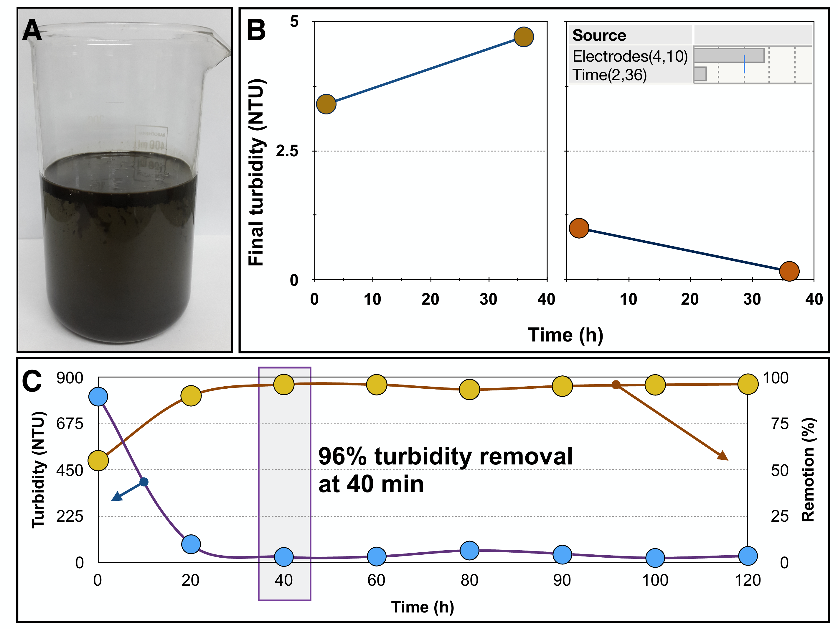

Figure 2: Turbidity changes during electrocoagulation. Where, (A) wastewater sample, (B) mean turbidity changes, and (C) optimization of electrocoagulation as a function of time.

In Figure 3, the final turbidity from the coagulation with PAC treatments is presented. The best coagulation process was the one using 15% PAC that produced 0.85 kg of treated water and 0.15 kg of sludge per kg of wastewater (Fig. 3B). The total petroleum hydrocarbons (TPH) were reduced from 140 to 6.4 mg/L; this means a 95.4% removal of TPH occurred. After the drying process (at 150°C for two hours), 0.18 kg of dried solid was produced per kg of oily sludge (Fig. 3C); this means that 18% of the sludge corresponds to a valuable product. In general, for every kg of wastewater, 2.7% consists of a dried solid with valuable characteristics that can serve either as a fuel or as an industrial detergent (Fig. 4B). For the saponification of a dried sludge sample, 10% NaOH at 80°C produced a substance with a foamy and detergent-like appearance (Fig. 4C). This foamy substance was tested and it removed grease on a solid surface positively.

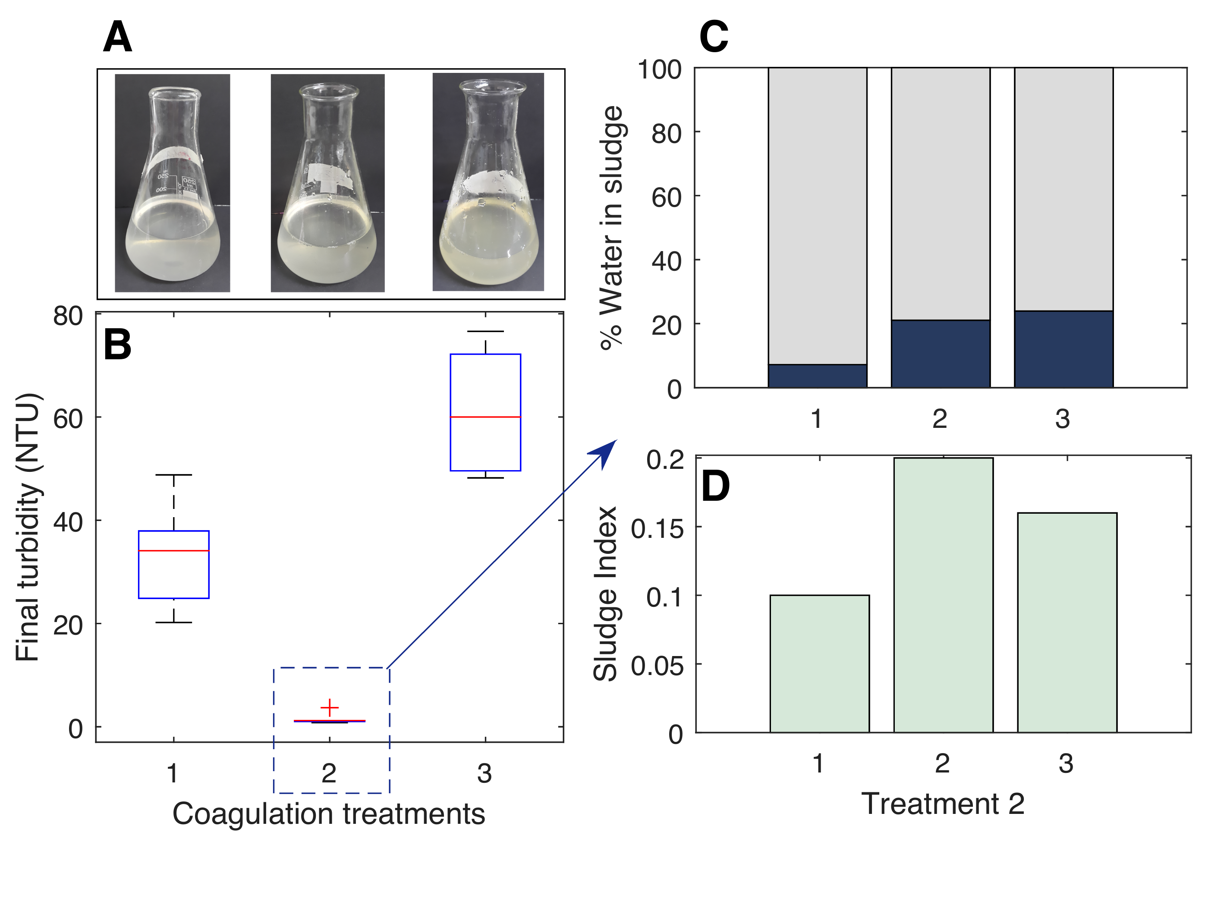

Figure 3: Coagulation treatments. Where (A) photos of every treatment, (B) final turbidity, (C) percent of water in the sludge and (D) sludge index in mL per liter wastewater.

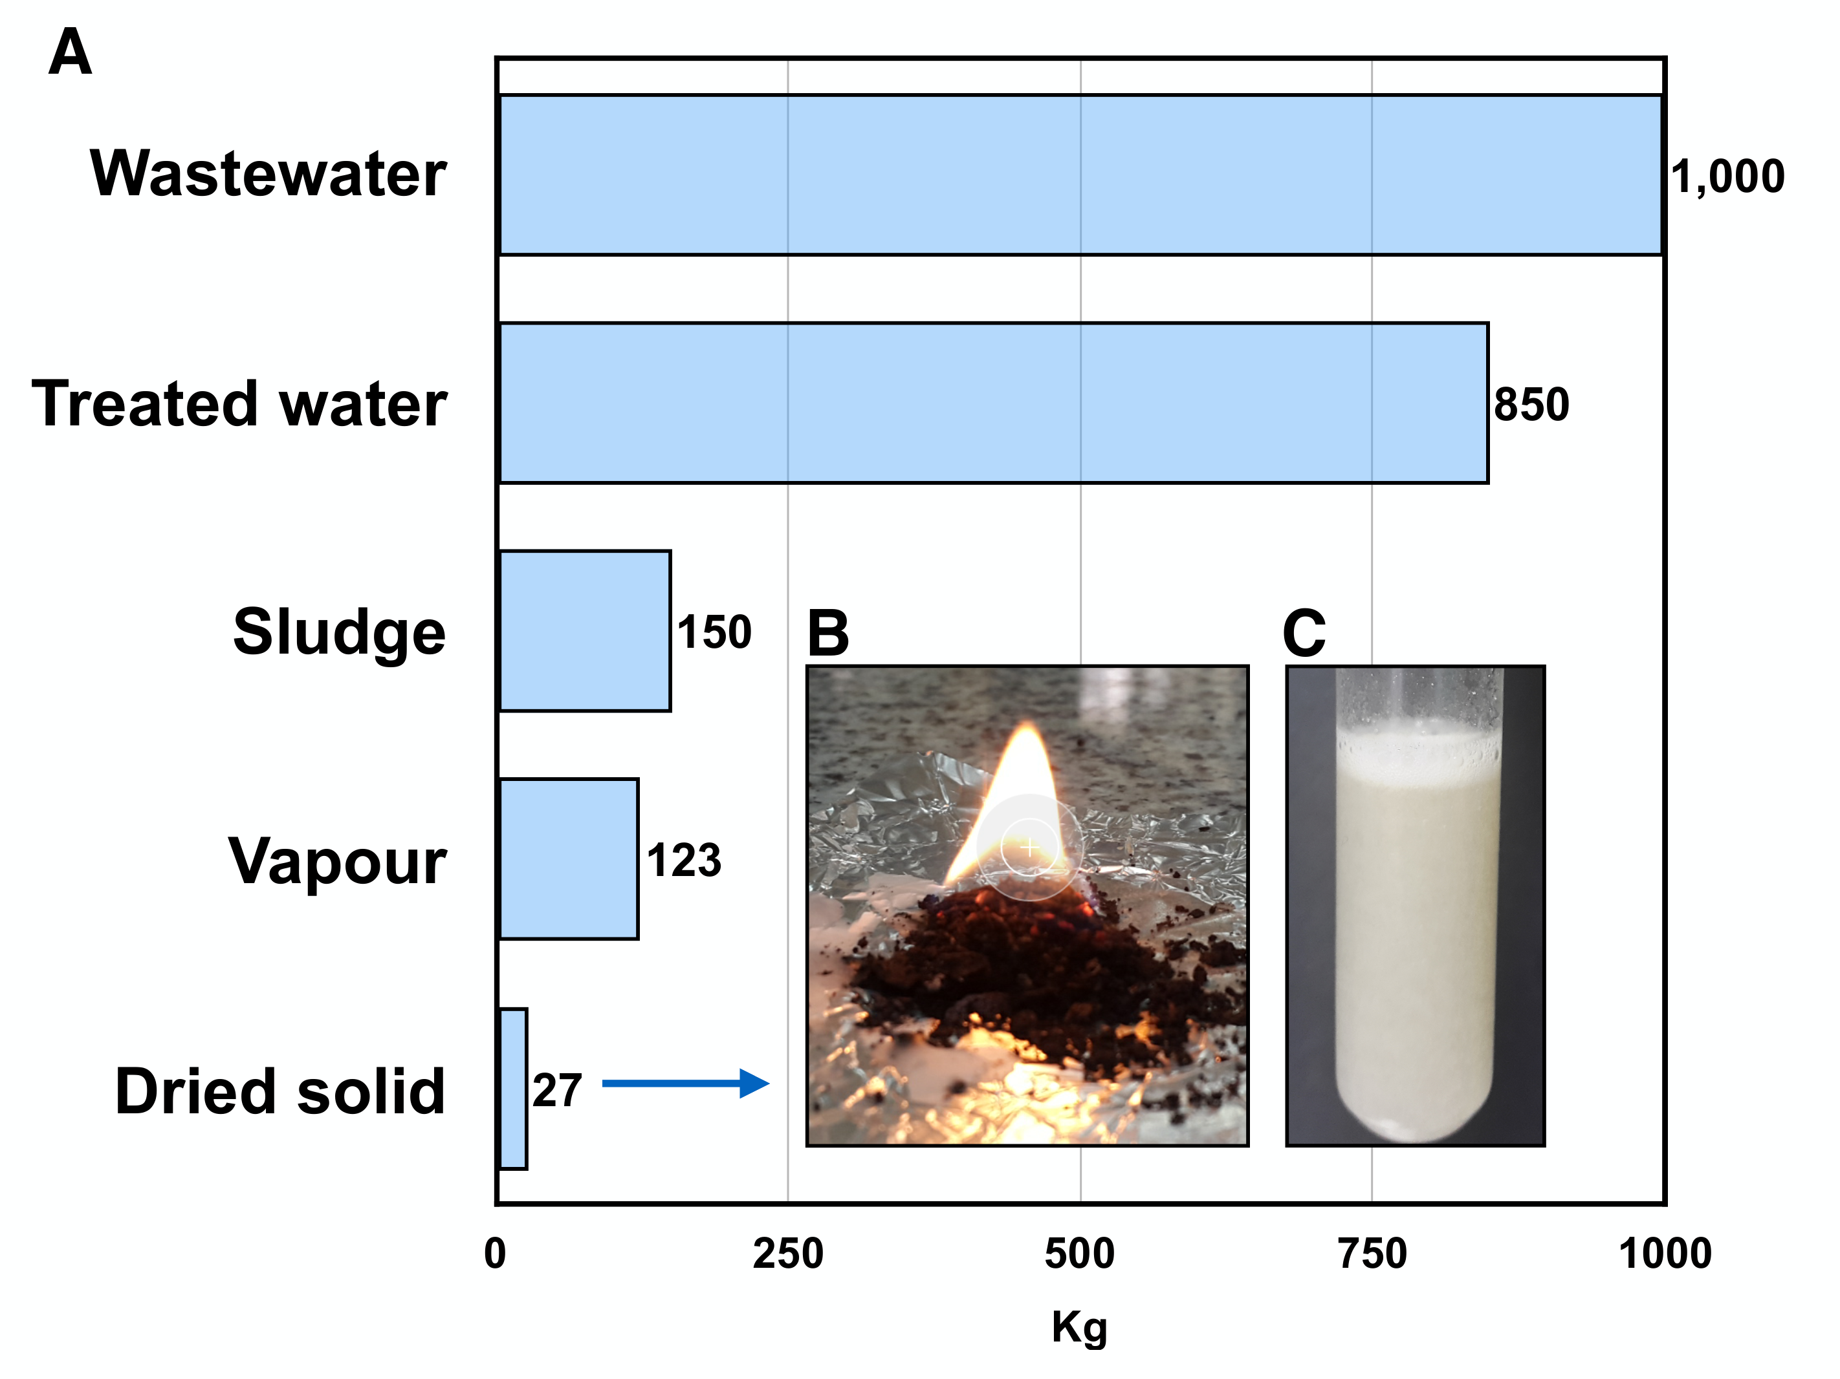

Figure 4: Eco-balance of the valorization process. Where, (A) mass balance of wastewater, sludge, and dried solid, (B) combustion of dried solid, (C) saponification with 10% NaOH of solid sample.

- Conclusions
Automobile-service-station wastes are an acute environmental concern because they form oil-water emulsions that cannot be removed by grease traps. An eco-friendly way to treat and take advantage of these wastes called valorization was herein evaluated. Firstly, water was clarified using electrocoagulation and coagulation with aluminum to separate oil-water emulsions. A total of 99.7% of turbidity was removed. The coagulation process obtained approximately 0.85 kg of treated water and 0.027 kg of dried oily sludge per kg of wastewater. A saponification process with dosages of 10% NaOH stabilized the dried oily sludge to obtain a product with valuable characteristics such as combustion potential and surfactant properties. In the aim of finding pathways to valorize wastes, chemical treatments with PAC and NaOH solutions obtained a substance that can be used as a surfactant or as an energy source. The perspective of these findings is to set up experimental conditions so as to improve efficiencies and to commercialize the oily dried solids.
- Authorization and Disclaimer
J. Chauca, M. Rosales, D. Muñoz and C. Banchón authorize ESTEC to publish this paper in the conference proceedings. Neither ESTEC nor the editors are responsible either for the content or for the implications of what is expressed in the paper.
- Acknowledgment
Authors thank Alba Medina for her collaboration thru all the experiments.
References
Adhoum, N., Monser, L., Bellakhal, N., & Belgaied, J. (2004). Treatment of electroplating wastewater containing Cu²⁺, Zn²⁺ and Cr(VI) by electrocoagulation. Journal of Hazardous Materials, 112(3), 207–213. https://doi.org/10.1016/j.jhazmat.2004.04.018
Annunciado, T. R., Sydenstricker, T. H. D., & Amico, S. C. (2005). Experimental investigation of various vegetable fibers as sorbent materials for oil spills. Marine Pollution Bulletin, 50(11), 1340–1346. https://doi.org/10.1016/j.marpolbul.2005.04.043
Banchon, C., Castillo, A., & Posligua, P. (2017). Chemical interactions to cleanup highly polluted automobile service station wastewater by bioadsorption-coagulation-flocculation. Journal of Ecological Engineering, 18(1), 1–10. https://doi.org/10.12911/22998993/66252
Cañizares, P., Jiménez, C., Martínez, F., Sáez, C., & Rodrigo, M. A. (2007). Study of the Electrocoagulation Process Using Aluminum and Iron Electrodes. Industrial & Engineering Chemistry Research, 46(19), 6189–6195. https://doi.org/10.1021/ie070059f
Chawaloesphosiya, N., Mongkolnauwarat, J., Prommajun, C., Wongwailikhit, K., & Painmanakul, P. (2015). Treatment of cutting-oily wastewater by electrocoagulation-flotation (ECF) process: Modeling approach. Environmental Engineering Research, 20(4), 392–396. https://doi.org/10.4491/eer.2015.085
Hanafy, M., & Nabih, H. I. (2007). Treatment of Oily Wastewater Using Dissolved Air Flotation Technique. Energy Sources, Part A: Recovery, Utilization, and Environmental Effects, 29(2), 143–159.
IEA. (2017). World oil demand (International Energy Agency - Oil market report 2017 - Web service). Retrieved from https://www.iea.org/oilmarketreport/omrpublic/
Kabdaşlı, I., Arslan-Alaton, I., Ölmez-Hancı, T., & Tünay, O. (2012). Electrocoagulation applications for industrial wastewaters: a critical review. Environmental Technology Reviews, 1(1), 2–45.
Madanhire, I., & Mbohwa, C. (2016). Lubricant Additive Impacts on Human Health and the Environment. In I. Madanhire & C. Mbohwa, Mitigating Environmental Impact of Petroleum Lubricants (pp. 17–34). Cham: Springer International Publishing. https://doi.org/10.1007/978-3-319-31358-0_2
Mang, T. (Ed.). (2007). Lubricants and lubrication (2., completely rev. and extended ed). Weinheim: Wiley-VCH.
Mouedhen, G., Feki, M., Wery, M. D. P., & Ayedi, H. F. (2008). Behavior of aluminum electrodes in electrocoagulation process. Journal of Hazardous Materials, 150(1), 124–135.
Peng, G., & Tian, G. (2010). Using electrode electrolytes to enhance electrokinetic removal of heavy metals from electroplating sludge. Chemical Engineering Journal, 165(2), 388–394.
Sabir, S. (2015). Approach of Cost-Effective Adsorbents for Oil Removal from Oily Water. Critical Reviews in Environmental Science and Technology, 45(17), 1916–1945.
Vanhanen, J., Rinkiö, M., Aumanen, J., Korppi-Tommola, J., Kolehmainen, E., Kerkkänen, T., & Törmä, P. (2004). Characterization of used mineral oil condition by spectroscopic techniques. Applied Optics, 43(24), 4718–4722.
Yeber, M., Paul, E., & Soto, C. (2012). Chemical and biological treatments to clean oily wastewater: optimization of the photocatalytic process using experimental design. Desalination and Water Treatment, 47(1–3), 295–299. https://doi.org/10.1080/19443994.2012.696413
Yu, L., Han, M., & He, F. (2013). A review of treating oily wastewater. Arabian Journal of Chemistry. https://doi.org/10.1016/j.arabjc.2013.07.020

Authorization and Disclaimer
Authors authorize ESTEC to publish the paper in the conference proceedings. Neither ESTEC nor the editors are responsible either for the content or for the implications of what is expressed in the paper.

