Sixth Engineering, Science and Technology Conference “Tendencies and Challenges in Engineering, Science and Technology” (ESTEC 2017) October 11 - 13, 2017 Panama City, Panama.

Experimental study of an air-PCM heat exchanger: Melting in a cylindrical container

Maria De Los Ángeles Ortega Del Rosario
Institute de Mécanique et Ingénierie de Bordeaux, Bordeaux, France, maria-de-los-angeles.ortega-del-rosario@u-bordeaux.fr
Technological University of Panama, Panama City, Panama, maria.ortega@utp.ac.pa

Denis Bruneau

Institute de Mécanique et Ingénierie de Bordeaux, Bordeaux, France, denis.bruneau@ensam.eu

Patrick Sébastian
Institute de Mécanique et Ingénierie de Bordeaux, Bordeaux, France, patrick.sebastian@u-bordeaux.fr

Jean-Pierre Nadeau

Institute de Mécanique et Ingénierie de Bordeaux, Bordeaux, France, jean-pierre.nadeau@ensam.eu

Alain Sommier
Institute de Mécanique et Ingénierie de Bordeaux, Bordeaux, France, alain.sommier@u-bordeaux.fr

Jêrome Lopez
Nobatek-Inef4, Talence, Bordeaux, France, jlopez@nobatek.com

Abstract
This paper presents experimental results of an air-PCM heat exchanger, with an in-line arrangement of cylindrical containers. The objective is to highlight the physical phenomena occurring in a single container during the phase change. Temperature and airflow measures were carried out. These values were used to find the heat exchanges on the container. The experimental heat values were compared and validated with the theoretical heat stored obtained from the material properties. An only conduction 1D radial model is proposed to describe the melting front in the container.
Keywords: phase change materials, thermal storage unit, cylinder, latent heat, radial conduction.
- Introduction
Due to the attractive features of phase change materials (PCM), their use as thermal energy storage (TES) for buildings has increased during the last years. They allow to store a large amount of energy in reduced volumes. When their use is matched with the peak load periods, they can contribute to the reduction of the primary energy consumption related to cooling applications. There are, of course, some disadvantages. The low thermal conductivity of the material can be easily the major one, because, it can lead to poor charge and discharge rates (especially for the organic based materials).
The main designing parameter for a TES system is the melting point of the PCM. It plays a major role because, if it is not selected correctly, the TSU will not work under the building conditions. The next two most important are the geometry of the PCM container and the thermal and geometric parameters of the exchanger. The heat transfer and storage phenomena are directly related to them, and therefore, the TSU performance. During the designing stages, these parameters can be studied in order to optimize the system. For these reasons, it is of interest the study of the physical phenomena related to a single container in a TSU.
Our study focuses on an air-PCM heat exchanger composed of cylindrical containers. The selection of the container geometry was based on previous studies (Ortega et al.) carried by the research group. Cylindrical containers present a good surface area per volume ratio, which allows a better heat transfer performance. Several industrial applications for heat exchangers use this geometrical configuration, hence if an industrial development of these type of configuration is desired, further understanding is needed.
A series of tests were developed to give us an understanding of the physical phenomena. A test bench was designed to ensure certain inlet conditions in the exchanger. An in-line arrangement was selected as the geometrical distribution. Some instruments were placed on the bench for measuring. The PCM properties were also available through differential scanning calorimeter (DSC) tests. These experiments were conducted with the aim of providing some guidelines during the designing process, the architectural integration in buildings or the performance prediction of air-PCM exchangers with vertical cylindrical containers.
The simplest way to achieve these guidelines is through the modeling of the phenomena. These models should be simple enough in a way that they can be easily integrated to a simulation, but at the same time, they must be consistent with the physical phenomena. Simplification, when modeling an air-PCM heat exchanger, is common. A realistic model of the phenomena occurring in a single container could ensure to describe a realistic performance, but the computational time required to predict it could be excessive. Therefore, 1D models for the containers are desirable.
The objective of this paper is to propose an analysis of the experimental results of a single container, regarding the heat exchanges and storage capacity, and, to compare them to the performance expected, according to the PCM properties. This analysis could allow us further consideration of the main phenomena conducting the phase change, and then proper assumptions could be made when modeling of the exchanger.
- Physical Phenomena Overview
The physical phenomena on an exchanger can be analyzed as the overall heat exchanger and a single container of the exchanger. They cannot be fully understood without the other one, but separate them in this way, ease the comprehension of the phenomena. Usually, the cylindrical containers are horizontally or vertically arranged, regarding the airflow direction. The effects of gravity, the diameter size and the heat exchanges will give different melting patterns and performances. For vertically arranged cylinders, the performance of each container is dependable on the behavior of the one located on the previous line.
Convection is considered the main heat transfer phenomenon between the air and the cylinders containing the PCM. At the interior, it is more complicated to define by simple observation, all the phenomena involved. In the literature, one can find some previous works related to this matter, where most of the works show experimental, analytical, and numerical results for single tubes, isothermally heated or by a supply of a constant heat flux on the side of the tube, all sides, from the bottom or a combination of these. (Agyenim et al.).
Three governing mechanisms are possible during phase change: conduction controlled, convection controlled, and conduction-convection controlled phase change. Given the possibilities presented, melting results on a multidimensional phenomenon, which varies in space and time, and a simplification of a one-dimensional problem could lead to an incorrect performance prediction. The phase change also accounts for the non-linear moving boundary problem. One of the major inconvenient when modeling phase change is that the location of the melting front is also unknown and variable during time. In addition, most of the commercial PCM are not pure substances. Therefore, the phase change is not an isothermal process, and then, sensible heat could also appear during storage.
- Experimental Setup
The test bench has been designed with the aim of controlling the input parameters, i.e., the inlet temperature and the airflow velocity. The bench is composed of a fan (94 W, 0,4 A, RD 160L), coupled with a rheostat, which allows to vary the inlet airflow values. A heating coil has been placed right after the fan, with the objective of regulate the inlet temperature through a PID (±1,0 °C). If the solidification is not completely achieved during the night, a mobile air conditioner is available to regenerate the PCMs. To assure a well-mixed airflow, a diffuser was located at the beginning of the bench and a nozzle at the outlet. Figure 1 shows a scheme of the test bench installed in the laboratory.
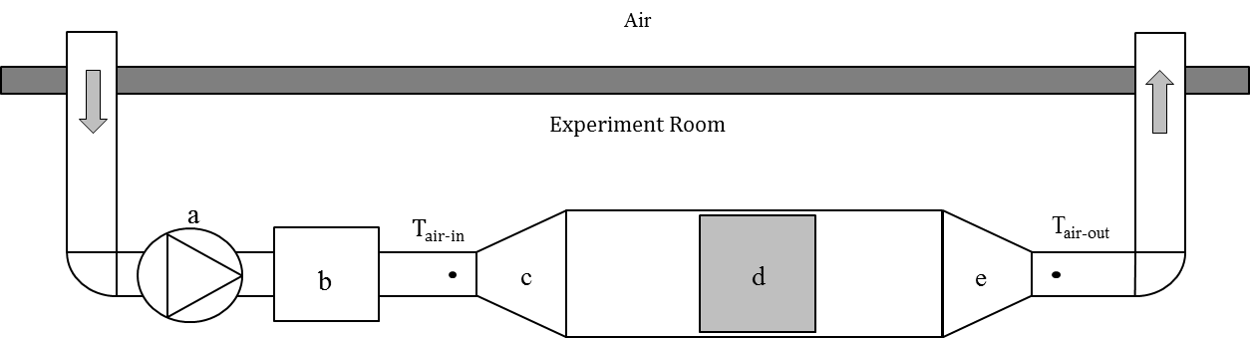

Figure 1: Test bench scheme: fan (a), heating coil with PID / air conditioning (b), diffuser (c), heat exchanger (d), nozzle (e).
  - Instruments, materials and devices
The temperature and velocity measurements can be used to find the heat transfer coefficients. Hence, they were measured with the aid of a hotwire anemometer, KIMO® AMI 300 (±3% of reading ±0,03 ms⁻¹), and a propeller anemometer, KIMO® AMI 300 (±3% of reading ±0,03 area[cm²]). The first one was used to find the local velocity of the air and, the latter, the global airflow of the bench. As the air velocity inside a rectangular conduct is not homogeneous, a cartography of 25 points was carried out for each airflow value. These results, allowed us to describe the airflow as a function of the rheostat position of the fan.
The temperature measurements reveal the evolution in time of the exchanges occurring in the test bench. To obtain the global performance of the exchanger, the inlet and outlet temperature are required. Moreover, a single container is under the forced convection effects at its wall and in the interior, is under the phase change effects. The temperature was measured using K type thermocouples. They were placed at the inlet and outlet position of the exchanger. Four containers were selected to be instrumented. A group of thermocouples were located to measure the air temperature in four points: near the wall, the outside and inside side of a single point of the wall and the PCM temperature in the middle point. The purpose of this arrangement was to be able to describe a thermal resistance arrangement of the heat flow from the air (by convection) to the PCM core.
The PCM material used for the experiment was Rubitherm® RT 28 HC (Rubitherm®, 2017), an organic paraffin with high thermal storage capacity and a melting point around 28 °C. The material properties were obtained by previous DSC tests performed in the laboratory (Rouault, 2014). The thermal conductivity is 0,2 W m⁻¹ K⁻¹, the ΔT_{pcm} is around 1,0 °C and the latent heat storage capacity measured is 215 kJ kg⁻¹.
  - Testing protocol
For this experiment, the exchanger was composed of 99 cylinders distributed vertically in 11 rows. The containers were placed in an in-line arrangement, with a range of optimal pitch between the tubes for compact exchangers of 33,0 mm. The external diameter of the cylinder is 24,5 mm, with a wall thickness of 1,0 mm. The effective height in contact with the PCM is 210 mm. The thermocouples located in the interior of the tube are held by a ring of a slightly lower diameter and with a thermal conductivity near the one of the PCMs (0,25 W m⁻¹ K⁻¹). The experiments were carried out with an initial temperature below the melting point (22 °C) and a final temperature above the melting point (34 °C). The airflow was fixed at 195 m³h⁻¹. At the same time, visual measurements were performed with the aim of observe the melting patterns of the PCM during the phase change.
- Experimental Analysis
  - Melting patterns in a single container
The figure 2, shows the different melting patterns found during the experiment. Previous regeneration of the PCM was held. Thus, the upper section of the PCM is not flat, but concave downward due to the volume contraction that occurs during solidification. At early stages, heat transfer is mainly controlled by conduction and the PCM remains solid. A few moments later, liquid PCM starts to appear and bubbles formation begins, as shown in the first image. Two kinds of melting patterns can be observed in the second image of the figure 2. The first one is a rapid melting of the uppermost solid PCM, which form a liquid layer above the solid phase. The second one is an annular melting, due to the upward motion of the molten PCM, product of the PCM volume increase associated with melting.
When natural convection gains control, it accelerates melting in both directions. As a result, a conic form of the solid PCM appears, until the PCM is mostly in its liquid phase. Now, convection is controlling the phase change. At this stage, the solid PCM cannot maintain its position, and then a buckling occurs. The solid PCM touches the wall, and irregular patterns are formed. These phenomena can be observed in the third and last image of figure 2. The results seem to be consistent with early studies presented by (Farid, 1989), where similar melting patterns are found for vessels with a large diameter. However, in this experiment, hollow cylinders were used and the melting patterns observed differs from those presented by (Katsman et al., 2007) for cylinders of small diameter. They suggested that when the diameter is under 2,0 cm, the main heat transfer mechanism is one dimensional radial conduction. It can, therefore, be assumed that further analysis of the melting behavior in a single tube is necessary to define if an only conduction 1D model will be suitable enough for describing the exchanger performance.

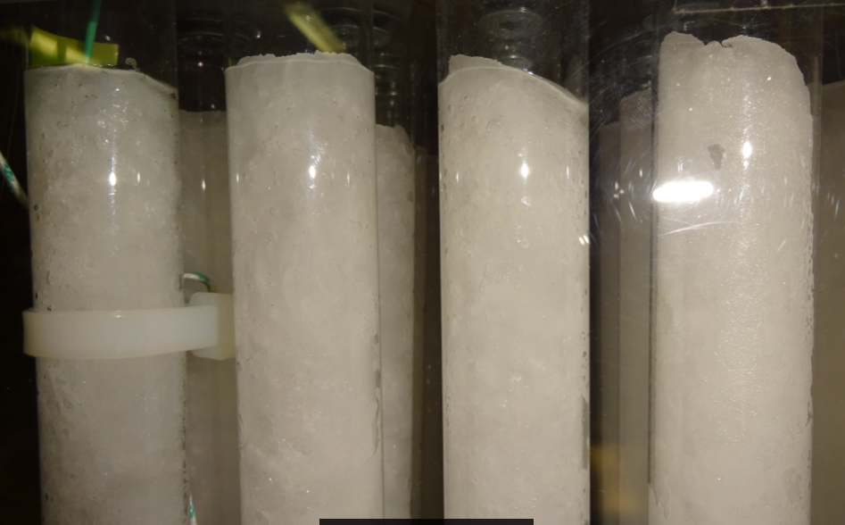  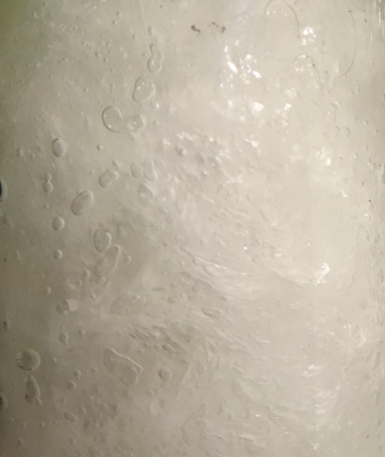 | 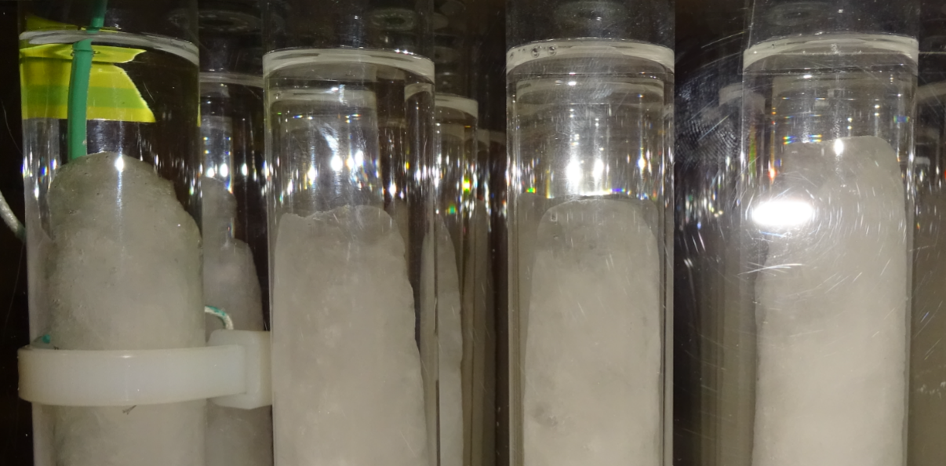 | 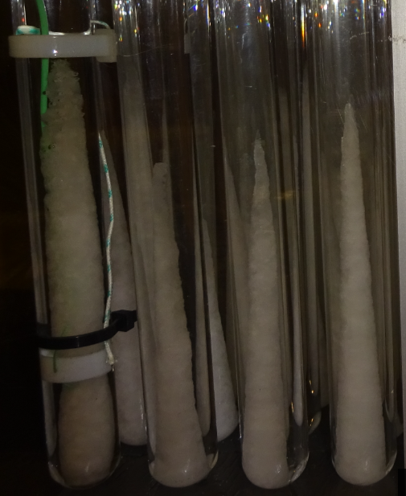 | 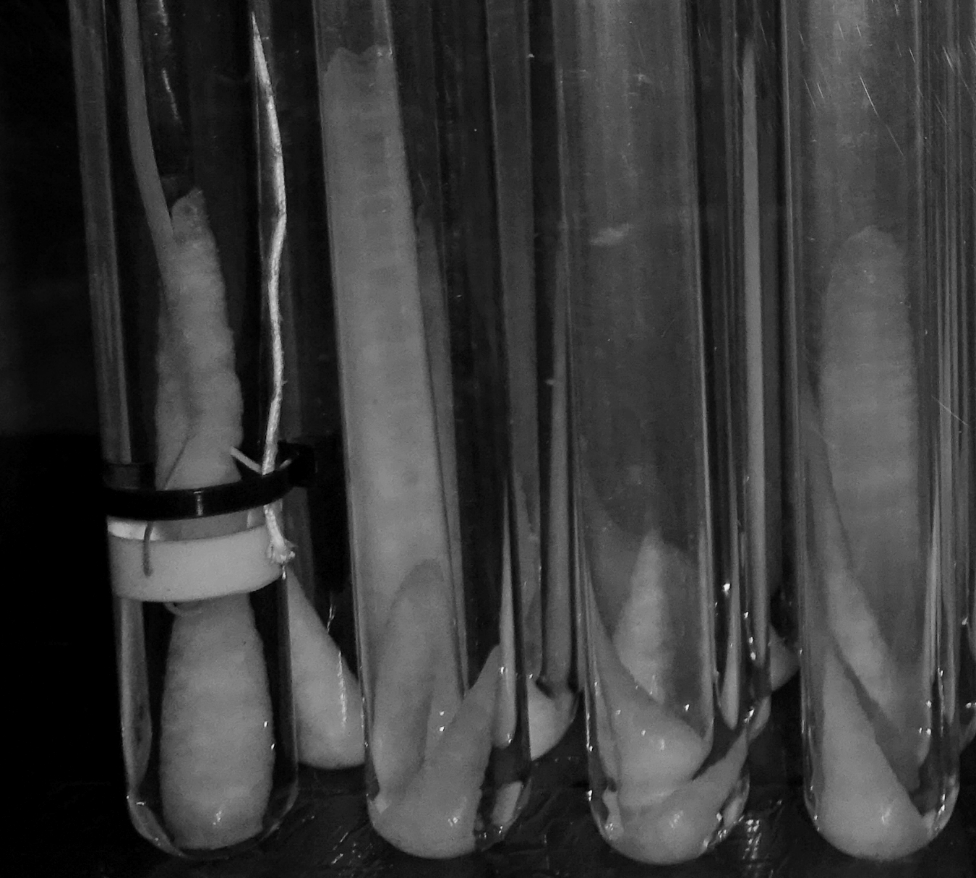

Figure 2: Melting patterns of the PCM in cylindrical containers in an air-PCM heat exchanger.
  - Energy Storage for a single container
The exact solution for phase change problems are reserved for a small collection of problems, i.e. semi-infinite problems with constant parameters in each phase and constant initial and imposed temperature (Alexiades and Solomon, 1993). For more realistic problems, some approximative solutions need to be used. Therefore, to proceed with the analysis of the experimental results, some assumptions were necessary.
The main assumptions made for the analysis can be summarized as follows:
- The radiation, gravitational, elastic and electromagnetics effects are neglected.
- The thermophysical properties of the PCM remain constants, for simplicity, except for conductivity.
- Only latent heat storage occurs during phase change (Ste ≈0), and the value of the specific latent heat is constant during the cycle and the energy storage in the container is neglected.
- A quasi-stationary state is assumed. Therefore, the PCM is assumed to have a negligible heat capacity, and only the phase change stages of the cycle are considered.
- An imposed convective heat flux is assumed at the frontier between the cylinder wall and the air.
- The air and the PCM during the cycle are assumed to behave as incompressible flows (Ma≤0,3).
- To avoid movement of the material, the density is assumed to be constant.
- Losses are neglected.

For the analysis, the amount of energy store during phase change depends only on the amount of mass, $m_{\text{pcm}}$ and the specific latent heat of the PCM, L. Then:
$E_{\text{pcm}}=m_{\text{pcm}}L$(1)
The mass contained in a single cylinder is a known value, then the amount of energy stored at the end of the cycle can be calculated. The heat exchanges in each row are variables, but at the end of the cycle, the energy stored should remain the same in each tube, regardless of the heat flow. Therefore, the heat flow measurements could be validated if they match the amount of energy expected to be stored. The heat flow, $q_{\text{pcm}}$ necessary to melt the PCM, can be represented as the change of latent energy on the PCM over time as:
$q_{\text{pcm}}=\frac{{\text{dE}}_{\text{pcm}}}{\text{dt}}=\frac{L⋅{\text{dm}}_{\text{pcm}}}{\text{dt}}$(2)
The melting fraction of the PCM, $f_{m}$, represents the amount of PCM that already changed its phase, and can be related with the remaining potential of cooling of the tube. It can be written in terms of volume as:
$f_{m}=1−\frac{V_{{\text{pcm}}_{\text{solid}}}}{V_{{\text{pcm}}_{\text{total}}}}$(3)
If a 1D approximation is made, the volume variation will be only dependant on the radius of solid PCM, $r(t)$. This value also represent the melting front position for this model. The eq. 3 can be rewritten as:
$f_{m}=1−{\left(\frac{r(t)}{r_{\text{pcm}}}\right)}^{2}$(4)
The heat flow in a tube cannot be measured directly because of the small diameter, but temperature measures were foreseen. The quasi-steady state assumption (QS-1D), was established using thermal resistances in the volume to find the heat value. As the heat transfer between the air and the tube can be fully described by forced convection, and this amount of heat will be responsible for the melt of the PCM inside the tube, then we have that:
$q_{\text{pcm}}(t)=q_{{\text{air}}_{\text{ow}}}(t)=\frac{T_{\text{air}}(t)−T_{\text{ow}}(t)}{R_{\text{air}}}$(5)
The thermal resistance between the air (air) and the cylinder surface (ow), has been found using analytical correlations for convective heat transfer in tube bundle exchanger developed by (Kahn, 2006). The wall conductivity is usually neglected because the thermal conductivity of this material is large compared to the PCM, but in here, it is not the case. The global exchanges for a single container can be describes as:
$q_{\text{pcm}}(t)$$=\frac{T_{\text{air}}−T_{\text{pcm}}}{R_{\text{air}}+R_{\text{wall}}+R_{\text{pcm}}(t)}$(6)
Thus, the measures of temperature and heat flow can be validated if they match the amount of energy capable of been stored by a single container as:
$\int_{t=0}^{t=t_{\text{cycle}}}{\frac{T_{\text{air}}(t)−T_{\text{pcm}}(t)}{R_{\text{air}}+R_{\text{wall}}+R_{\text{pcm}}(t)}\text{dt}=}ρ_{\text{pcm}}L⋅V_{\text{pcm}}$(7)
- Results and Discussion
The melting front was tracked with the results from eq. 4. Figure 3 shows the result for the liquid fraction (segmented line) and the solid PCM radius position $r(t)$, (continuous line). Different methods were used to evaluate the heat flows. The experimental energy values were compared to the theoretical heat that could store one single container (eq. 7). Table 1 shows the comparison between the theoretical values and the energy obtained from the heat flow considering only the external forced convection (eq. 5). The results for four tubes located in the fifth line (5) and the eighth line (8a, 8b, 8c), may suggest that accounting the external heat transfer could quantify the heat flow in a container.
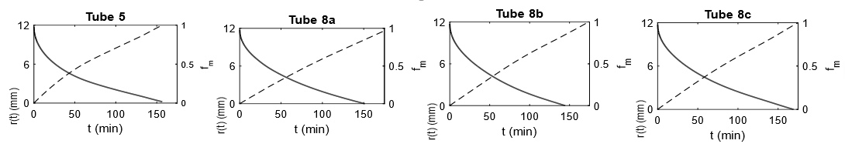

Figure 3: Melting front tracking for cylinders in an air-PCM heat exchanger.

Table 1: Comparison between the theoretical and measured energy stored.
Tube | Measured energy from the convective heat flow (kJ) | Theoretical Energy (kJ) | Relative Error (%)
5 | 14,52 | 16,77 | 13,40
8a | 17,73 | 16,77 | 5,74
8b | 17,77 | 16,77 | 5,93
8c | 15,54 | 16,77 | 9,11

Table 2 shows the comparison between the theoretical energy and the energy obtained from heat flow measurements considering only the external forced convection (eq. 3), the external and internal exchanges (eq. 6) and with the 1D conduction radial model for the tube 5. The better results regarding the energy stored in a tube were obtained when it the theoretical value was compared to the value obtained from the experiment considering the wall effect (eq. 6). From the results of the comparison with the 1D-QS model, it seems that this model could provide an adequate overall response for the phase change phenomena in a single tube regarding the time of the cycle (figure 3) and the value of the stored energy (table 2).

Table 2: Comparison of different methods to obtain the energy stored during phase change for tube 5.
 | Energy stored from heat flow (kJ) | Error with theoretical value (%)
Only external forced convection (eq. 3) | 14,52 | 13,40
Including wall effects(eq.6) | 16,87 | 0,59
QS-1D radial modeling (eq. 4) | 17,98 | 7,21
To describe the internal phenomena, a comparison between the thermal resistance of the PCM obtained from the heat flow measures and the 1D model was made. Figure 4 shows the thermal resistance of the PCM, R_{pcm}(t) calculated from the experiments (continuous line) and from the model (segmented line). It seems that the model could not be used to predict the thermal resistance of the PCM during the final stages. A possible explanation for this might be that the 1D model works only for values of $r(t)$>0. Therefore, it is expected that the model does not predict the thermal resistance of the PCM at the final stages of melting. In the other hand, convection heat transfer is expected to be the dominant mechanism at these stages enhancing the exchanges.
This model could under-predict the performance of the tube, if the effects of the thermal resistance are significant for the heat flow. High values of errors of the thermal resistance between the model and the experiment, can be observed during this final stage. Despite this fact, the error on the overall amount of energy for this model is relatively low (table 2), that could imply that even if the model does not fit the experiments during this final stage, it could fit the overall experiment.
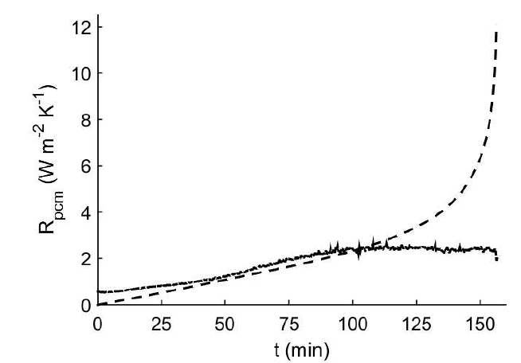

Figure 4: Thermal resistances of the PCM calculated from the experiments (continuous line) and from the 1D-QS model (segmented line).
- Conclusions and Perspectives
The present study presented an experimental analysis for a cylindrical container in an air-PCM heat exchanger. The melting patterns found through visual tests, highlighted the different stages during melting. These observations may suggest that natural convection should be acknowledge, when a model for the exchanger is proposed. The comparisons between the energy obtained from the experimental heat flows using a quasi-steady approach, a 1D radial model, and the theoretical heat stored in the tubes, could imply that the overall heat transfer in a tube can be explained by simple 1D only conduction modeling. However, this model may not be suitable for describing the internal heat transfer coefficients. This is an important issue for future research.
Experimental analysis for internal natural convection is proposed as a future research line in this work, in the pursuit of an equivalent heat transfer coefficient that accounts both, conduction, and convection during phase change. The effects measured and analyzed in this present study, do not include the effect of a single container in the global performance of the exchanger. Therefore, once the heat transfer coefficients could be described, a global performance of the heat exchanger including the effects of a single container could be considered.
References
Ortega, M.D.L.A., Nadeau, J.-P., Bruneau, D., Sébastian, P., Sommier, A., Lopez, J. (2016). “Design and optimization of PCM-air heat exchangers”, Proceedings of Virtual Concept Workshop on Major Trends in Product Design, Bordeaux, France.
Agyenim, F., Hewitt, N., Eames, P., and Smyth, M. L., (2010). “A review of materials, heat transfer and phase change problem formulation for latent heat thermal energy storage systems (LHTESS)”. Renewable and Sustainable Energy Reviews, Vol. 14, No. 2, pp 615-628.
Rouault, F. (2014). “Air-cooling integrated system in building using phase change material”, Ph.D. thesis, Ecole Nationale Supérieure des Arts et Métiers, Bordeaux, France.
Farid, M., Atsushi, K., (1989). “Thermal Performance of a Heat Storage Module using PCM’s with different melting temperatures: Mathematical Modeling”. Transactions of the ASME, Vol. 111, pp 152-157.
Katsman, L., Dubovsky, V., Ziskind, G. and Letan, R., (2007). “Experimental investigation of solid-liquid phase change in cylindrical geometry”, ASME-JSME Thermal Engineering Summer Heat Transfer Conference, HT2007-32354.
Alexiades, V. and Solomon, A. (1993). Mathematical Modeling of Melting and Freezing Processes, Hemisphere Publishing Corporation, USA.
Kahn, W.A., Culham, J.R., and Yovanovish, M.M.., (2006). “Convection heat transfer from tube banks in crossflow: Analytical approach”. International Journal of Heat and Mass Transfer, Vol. 49, pp 4831-4838.

Authorization and Disclaimer
Authors authorize ESTEC to publish the paper in the conference proceedings. Neither ESTEC nor the editors are responsible either for the content or for the implications of what is expressed in the paper.

