Sixth Engineering, Science and Technology Conference “Tendencies and Challenges in Engineering, Science and Technology” (ESTEC 2017) October 11 - 13, 2017 Panama City, Panama.

Development of A Practical Straightening Simulation for Welded Structures using Inherent Strain Method

Ruiz Hector
Osaka University, Suita, Osaka, Japan, Hector_Ruiz@naoe.eng.osaka-u.ac.jp
Universidad Tecnológica de Panamá, Ciudad de Panamá, Panamá

Osawa Naoki
Osaka University, Suita, Osaka, Japan, naoki_osawa@naoe.eng.osaka-u.ac.jp

Murakawa Hidekazu
Joining and Welding Research Institute, Osaka University, Suita, Osaka, Japan, murakawa@jwri.osaka-u.ac.jp

Rashed Sherif
Joining and Welding Research Institute, Osaka University, Suita, Osaka, Japan, sherif-rashed@hcc5.bai.ne.jp

Abstract
Welding is the most widely used assembly method available to industries in the construction of metal structures, ships, and offshore platforms. However, this method always produces a certain amount of distortion that will not only degrade the performance but also increase the building cost of the structure, and it should be straightened. Murakawa [1] developed a thermal elastic plastic based and inherent strain based welding simulation FE code JWRIAN. Coarse shell FE models are usually used in the inherent strain based JWRIAN elastic analyses. This drastically reduces the manpower needed for modeling and computer resources needed for the calculation. However, it is not easy to perform straightening analysis using JWRIAN because gas heating’s inherent strain distributes over a range much smaller than element sizes of the shell model.
RUIZ [2] modified JWRIAN’s code so that the inherent strain equivalent nodal forces along the heating line are calculated and applied in the elastic shell analysis. However, a discrepancy between 3-dimensional thermal-elastic-plastic analysis and elastic analysis was observed. This is mainly because of the nature of solid and shell elements. RUIZ [3] proposed a linearized inherent strain and applied it to both 3-d and 2d analysis, getting matching results between solid and shell element models. In this study, as a working example, a thin plate panel with an opening is considered utilizing the developed system at the same time a friendly user interface for staffs and workers on a production site is developed.
Keywords: Inherent strain, straightening, finite element method, Gauss-Legendre quadrature
- Introduction
Welding is the most widely used assembly method available to industries in the construction of metals structures, ships, and offshore platforms. However, this method always produces a certain amount of distortion that will not only degrade the performance but also increase the building cost of the structure, and it should be straightened. Straightening is performed by mechanical or thermal techniques. The principal mechanical technique is pressing, but it is difficult to apply it to 3-D structures such as a ship block. Therefore, mainly thermal techniques are adopted. These techniques create irreversible strain (inherent strain) into the heated component. This is achieved by locally heating the material to a temperature where the heated material with lower yield stress expands against the surrounding cold, higher yield stress material, causing compressive plastic strain in the hot material. When the component is cooled, the heated area shrinks and inherent strain is generated. Spot, line or wedge-shaped heating techniques are usually applied in thermal straightening.
In order to optimize the straightening process, it is necessary to predict the distortion due to straightening. Numerical simulation is now reliable and fast allowing the efficient study of many cases. Further, it does not have the scatter usually found in physical testing. Murakawa [1] developed a thermal elastic plastic based and inherent strain based welding simulation FE code JWRIAN. Coarse shell FE models are usually used in the inherent strain based JWRIAN elastic analyses. This drastically reduces the manpower needed for modeling and computer resources needed for calculation, and practical application of welding simulation in production shop floor has been realized. However, it is not easy to perform straightening analysis using JWRIAN because gas heating’s inherent strain distributes over a range much smaller than element sizes usually used in shell models intended for elastic analysis using JWRIAN.
In recent studies, Ruiz [2] modified the Osaka University’s inherent strain based welding simulation code JWRIAN so that inherent strain’s equivalent nodal forces are accurately calculated in cases where the inherent strain is confined within a narrow region whose size is smaller/narrower than element size. The validity of the method and the developed software were examined by comparing rectangular plate’s angular distortion due to gas line heating calculated by three-dimensional thermal-elastic-plastic analysis and that calculated by the developed system. However, a difference was obtained, a part of the difference is due to edge effect RUIZ [3], and the other part is due to the different natures of solid element models and shell element models. In this study, the developed system JWRIAN-SHP is modified to account for such difference of nature of solid element models and shell element models, and used a working example, performing welding and straightening analysis on a thin plate simplified deck house with a window opening on one of its walls. Furthermore, a friendly user interface for staffs and workers on a production site is developed.
- ELASTIC FE-BASED ON INHERENT STRAIN
Normally coarse shell FE elements are used in inherent strain based JWRIAN analyses, four node shell elements are used, Fig. 1. To carry out analysis of deformation caused by straitening using the inherent strain method, there is a need to develop a numerical technique which can calculate the initial strain force due to straightening inherent strain that is confined within a narrow region. In this study, a JWRIAN’s subsystem is developed which can calculate the initial strain force due to straightening heating.
In the developed code by RUIZ [2], the initial strain force vector and element stiffness matrix’s non-linear term which includes stress components are integrated using higher order (e.g. 20 x 20 x 6 for 4-nodes shell elements) Gauss-Legendre quadrature while other quantities are evaluated by using ordinary order (2 x 2 x 2) quadrature.
This makes it possible to accurately assess the contribution of narrowly confined inherent strain and inhibit shear locking of shell element. In JWRIAN, the element stiffness matrix and the equivalent nodal force due to inherent strain are calculated by the following equations:

(1)

(2)

where, [K_{JL}] is the element stiffness, [B] the nonlinear displacement-strain matrix of Mindlin plate for large deflection problems, [D] the stress-strain matrix, N_{J} and N_{L} the shape function, x _{i} the coordinates, σ_{ij} the three in-plane stress component ε_{inh} the inherent strain and {F_{inh}} equivalent nodal force due to inherent strain. In the developed code, the second term of Eq. (1)’s RHS and Eq. (2)’s RHS are calculated using higher order Gauss-Legendre quadrature (see Fig. 2) while other quantities are evaluated by using ordinary order (2 x 2 x 2) quadrature (see Fig. 1).
A 3-dimensional thermal-elastic-plastic FE analysis of the line heating process of a rectangular thick steel plate is performed, and the calculated 3-dimensional plastic strain components (ε_{xx} and ε_{yy}) on the cross section are given to the shell integration points. This means that the out-of-plane and shear components (ε_{zz}, ε_{xy}, ε_{xz} and ε_{yz}) are neglected in the Elastic Analysis.
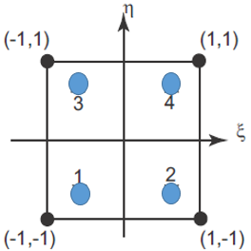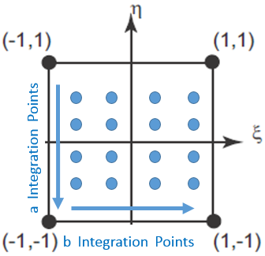

Fig. 1. Shell Element (2x2 Gauss Integ. Point) Fig. 2. Shell Element (High Order Integ. Point)
- NUMERICAL ANALYSIS
Thermal-Mechanical Behavior during welding and heat straightening are analyzed using uncoupled thermal/mechanical formulation, Ueda, and Yamakawa [4]. However, the uncoupled formulation considers the contribution of the transient temperature field to strains and stresses through thermal expansion and temperature-dependent physical and mechanical properties. The solution procedure consists of two stages. Firstly, transient temperature distribution history is computed using FE heat transfer analysis. Then, the transient temperature distribution obtained from the heat transfer analysis is employed as thermal loads in a subsequent Thermal-Elastic-Plastic-Mechanical Analysis. Displacements, stresses, and strains are computed.
These algorithms are already available and well verified against test results (Ueda [5], Wang [6] and Blandon [7]), and are all incorporated in the in-house code JWRIAN (Joining and Welding Research Institute Analysis) program.
- THERMAL ELASTIC-PLASTIC ANALYSIS
The first stage of this research consists of computing the distortion of a flat plate caused by a straightening process using a single line heating. A three-dimensional thermal elastic plastic FE analysis with fine hexahedron brick elements is used. With a plate dimension of (500x500x13) mm. Fig.3 shows this model.
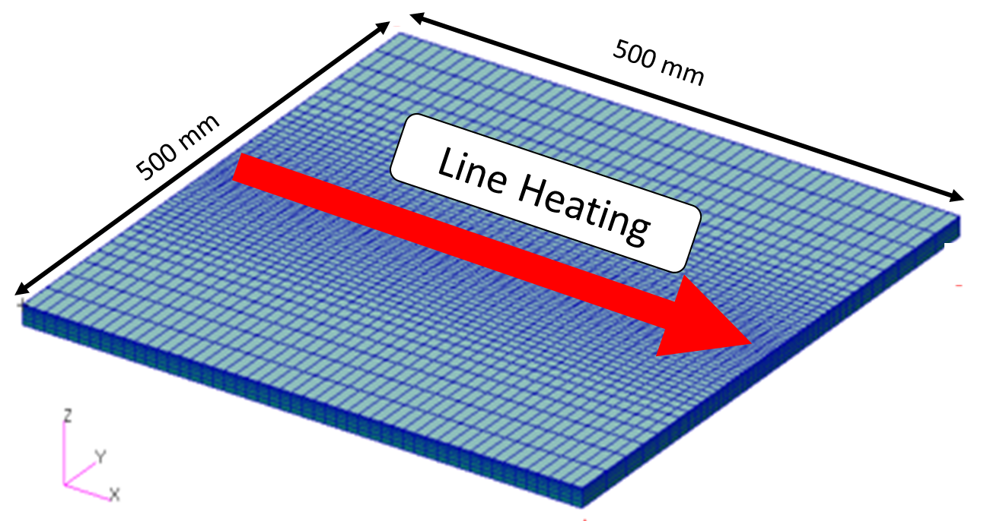

Fig. 3. FEM model
4.1 THERMAL ANALYSIS
The heat input during gas heating is analyzed using a local heat source model proposed by Osawa [8].
4.2 MECHANICAL ANALYSIS
To obtain the distortion of the plate due to line heating, a transient mechanical analysis is carried out. Fig. 4 shows the boundary conditions represented by red arrows. These boundary conditions restrain only the rigid body motion of the flat plate. Fig. 5 shows Von Mises Strain contours obtained by applying the transient temperature distribution obtained from the heat transfer analysis as a thermal load.
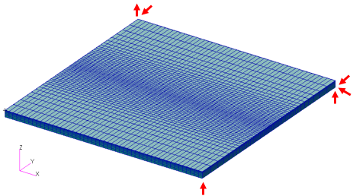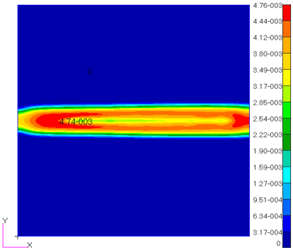

Fig. 4. Boundary Conditions Fig. 5. Von Misses Strain
- LINEARIZED STRAIN DISTRIBUTION
Once completed the mechanical analysis, in-plane components of inherent strain (εxx and εyy), are taken from the center of each element. Fig. 6 shows the inherent strain distribution εxx in the cross-section normal to the heating line at mid-length of the plate. These in-plane inherent strain components are mapped (interpolated) over a shell model of the plate in X and Y directions, and through the thickness, and applied as initial strain in an elastic analysis using the inherent strain method. Comparison of Z (out of plane) displacement obtained by thermal-elastic-plastic analysis and by elastic analysis did not show very good agreement [2]. The reason is that shell element formulation assumes a linear stress distribution through the thickness. This is incompatible with the nonlinear distribution obtained by mapping. Assuming a simple linear strain distribution through the thickness, a linearized inherent strain is proposed by RUIZ [3]. Fig. 7 shows the linearized inherent strain.
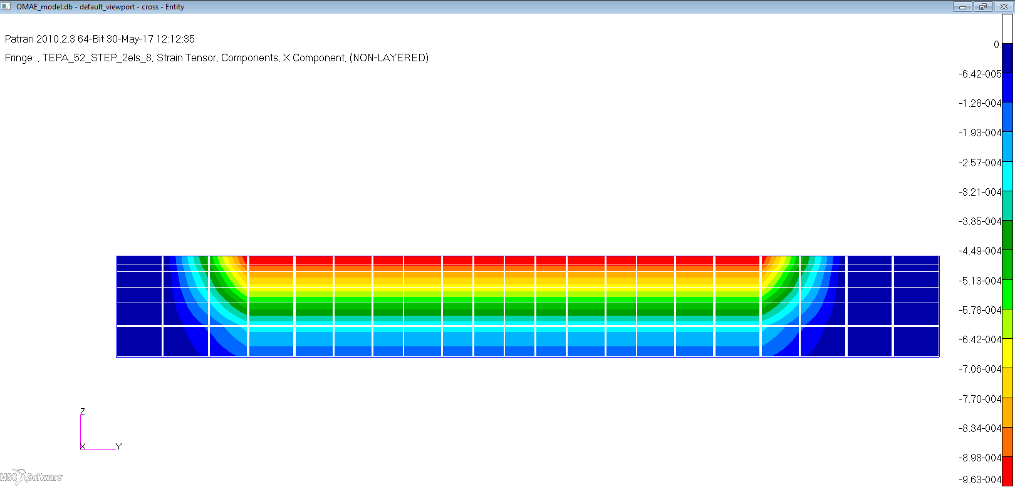
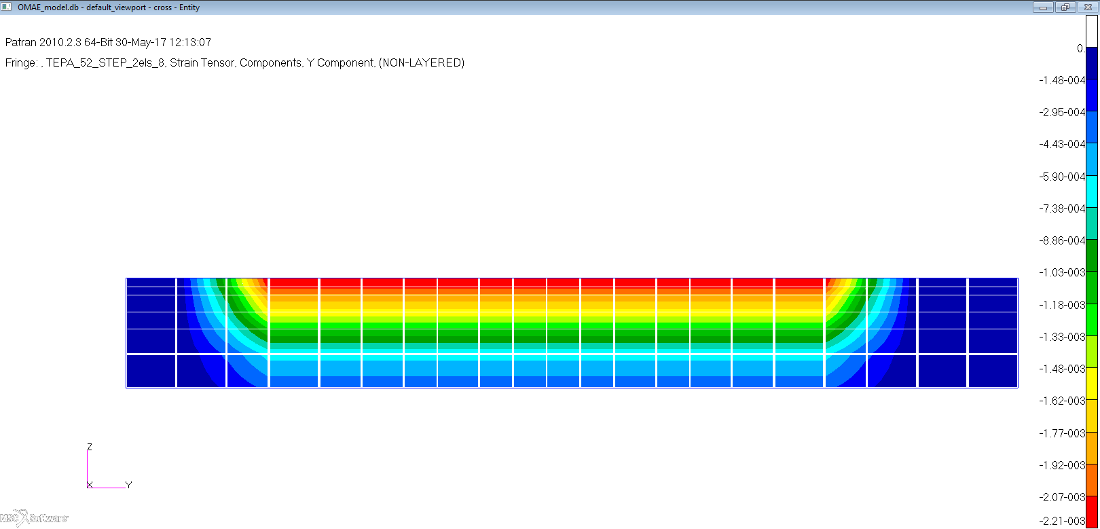

Fig. 6. Inherent Strain in xx direction Fig. 7. Linear Inherent Strain distribution
- 2-D INTERPOLATION OF THE INHERENT STRAIN
The linearized inherent strain components are interpolated to give values at integration points of the shell elements which are in way of the heating line. A higher order Gauss-Legendre quadrature (possible up to 30x30x30 points for 4nodes shell elements) is adopted. Fig. 8 shows the inherent strain interpolation from the solid elements to a shell element of 50x50x13mm, for Gauss integration points arrangement of 4x4x4 points.
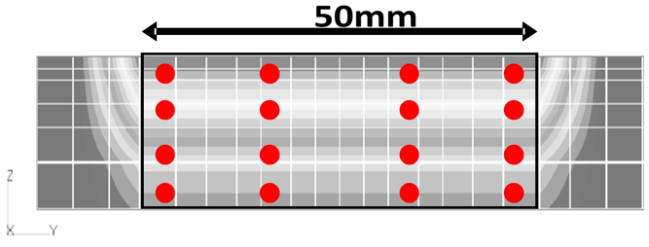
Fig. 8. Using 4x4x4 Gauss-Legendre Quadrature Points
- ELASTIC ANALYSIS
The second stage of this research is to obtain the z-displacement by using the linearized inherent strain interpolated values that were calculated in the previous section, applying it in the same position where the line heating was applied in the 3-dimensional simulation. Only in-plane components of inherent strain (ε_{xx} and ε_{yy}) are considered. Different shell element sizes were used in this analysis as shown in Table 1. Fig. 9 shows the Z-displacement distribution obtained using model 1.
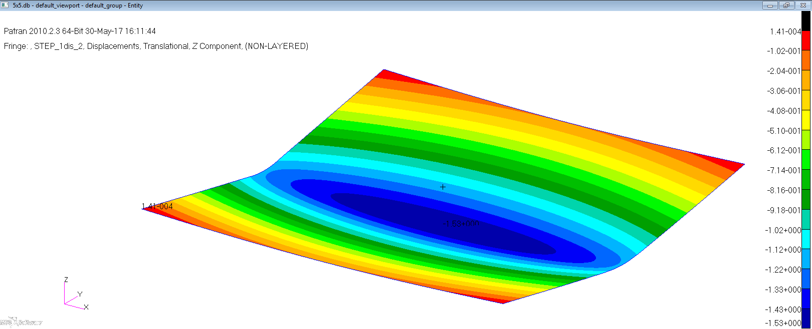
 | Model 1 (50x50x13)mm | Model 2 (5x5x13)mm
Nodes | 121 | 10201
Elements | 100 | 10000
Table 1. Nodes and Elements for model Fig. 9. Displacement in Z-direction (5x5x13) mm
- COMPARISON OF ANGULAR DEFORMATION BETWEEN 3-D AND 2-D ANALYSIS
In Fig. 10, the Z-Displacements along the transverse centerline obtained for the 2 shell models are compared to the displacement obtained by the linearized 3-D thermal elastic-plastic analysis.

Fig. 10. Z-Displacement Comparison
In the 2-d cases shown in fig. 10, the angle theta (θ) is calculated as shown in fig. 11. These angles are shown in table 2 and they are compared with the linearized 3-dimensional result, getting a difference of about 0.4%, in the case of the finest shell element size used, 5x5mm.
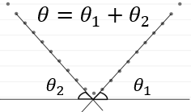
Fig. 11. Method to calculate theta (θ)

 | Displacement (mm) | Theta (degree) | Diff %
3-D linearized | -1.290 | 0.635 | 2.863
2-D linearized 5x5 | -1.332 | 0.638 | 0.400
2D linearized 50x50 | -1.372 | 0.695 | 9.433

Table 2. The difference between linearized cases in %.
- EXCEL-BASED EASY-TO-USE USER INTERFACE
The developed system is used to calculate welding and/or straitening displacements. It can be operated from an EXCEL worksheet. Staffs and workers can easily use it on a production site without any special training. All it takes is choosing joined parts, welding sequence, heat input, etc., all are variables readily available to staff and workers. Straightening heating lines are defined by giving the coordinates of heating line’s start/end points.
- WORKING EXAMPLE
In this chapter, a working example of JRIWAN-SHP straightening analysis is showed. The analysis target is the opening wall of a deck house with a thin plate. The thickness is (t=7mm) for the opening plate. Fig. 12 shows very badly distorted with buckling in the as-welded condition. In order to improve the angular distortion around the window, using different pattern local heating is performed. Fig. 13 shows the angular distortion after the local heat treatment for one pattern case. This analysis takes only 3 minutes by using Core i5 Windows PC. This demonstrates the developed system’s applicability to fabrication job.
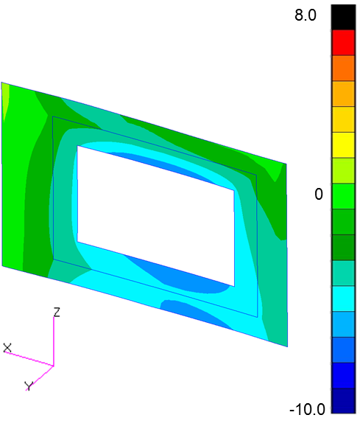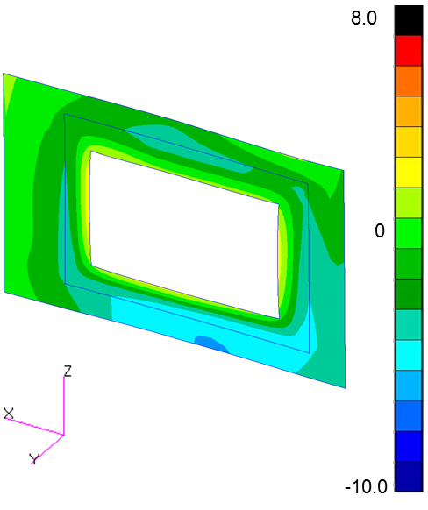
Fig. 12. Angular Disp. As-Welded (θ) Fig. 13. Angular Disp. by Local Heating (θ)
- CONCLUSIONS
1) An inherent-strain based ultra-high-speed straightening simulation system JWRIAN-SHP has been developed.
2) The different straightening techniques used on shipyards have been reproduced successfully with the developed JWRIAN-SHP.
3) The working example shows the applicability of JWRIAN-SHP, to perform analysis of welding and local heating giving useful results.
4) Performing analysis of buckling and shrinkage caused by local heating is easy with JWRIAN-SHP, once the welding and heating conditions are known by workers.
- REFERENCES
[1] Murakawa H, “Concept of inherent strain, inherent stress, inherent deformation and inherent force for prediction of welding distortion and residual stress” et al. Trans. JWRI, 39, 2, pp. 103-105 (2010).
[2] Ruiz H, Osawa N, Murakawa H, Rashed S, “Prediction of Distortion produced in welded structures During Straightening Process using the Inherent Strain Method” Proceedings of the ASME 2016 35th International Conference on Ocean, Offshore and Arctic Engineering, OMAE2016, June 19-24, 2016, Busan, South Korea.
[3] Ruiz H, Osawa N, Murakawa H, Rashed S, “Prediction of Welded Structures due to Straightening using Linear Inherent Strain Method” Annual Assemble & International Conference, IIW2017, June 25th – 30th 2017, Shanghai, China.
[4] Ueda Y and Yamakawa T, “Thermal Stress Analysis of Metals with Temperature Dependent Mechanical Properties”, Transactions of JWRI, 2, No 2, pp.90-100 (1971).
[5] Ueda Y, Murakawa H, Rashwan, A.M, Neki I, Kamichika R, Ishiyama M and Ogawa J, “Development of Computer Aided Process Planning System for Plate Bending by Line-Heating (Report IV): Decision Making on Heating Conditions, Location and Direction (Mechanics, Strength & Structural Design),” Transactions of JWRI, 22, 2, pp.305-313 (1993).
[6] Huang, T.D, et al (2003) “Residual Stresses and Distortions in Lightweight Ship Panel Structures,” Northrop Grumman Technical Review-Journal, Spring/Summer, pp.1-26 (2003).
[7] Blandon J, Osawa N, Masanoru, Sano and Takaba S (2013), “Optimization of U-shaped Rib Bending Process Using Line Heating” Proceedings of the 27th Asian-Pacific Technical Exchange and Advisory Meeting on Marine Structures (TEAM2013), pp.362-369 (2013).
[8] Osawa N, “Numerical Estimation of Torsional Deformation of a Ship Longitudinal Frame Formed by Gas Heating” Proceedings of the Sixteenth International Offshore and Polar Engineering Conference, pp.309-316. (2006).

